C868 – Software Capstone Project Summary

Task 2 – Section C

|  |  |
| --- | --- |
| Capstone Proposal Project Name: | http://www.idevnews.com/views/images/uploads/general/wgu_logo.png  CCC SAYOP Registrar – Mobile Application |
| Student Name: | Greg Westmoreland |

Table of Contents

Table of Contents 2

Task 2 Part C – C868 Software Development Capstone 3

Application Design and Testing 3

Design Document 3

Class Design 3

UI Design 6

Unit Test Plan 9

Introduction 14

Purpose 14

Overview 23

Test Plan 23

Items 23

Features 23

Deliverables 24

Tasks 24

Needs 24

Pass/Fail Criteria 24

Specifications 25

Procedures 26

Results 26

C4. Source Code 28

C5. Link to Live Version 28

User Guide 29

Introduction 29

Installation and Using the Application 29

Login and Signup (An example) 40

Classes Error! Bookmark not defined.

Create a New Class **Error! Bookmark not defined.**

Reports Error! Bookmark not defined.

**Task 2 Part C – C868 Software Development Capstone**

# Application Design and Testing

# 

# Design Document

## Class Design

There are four database tables that are part of the CCC SAYOP Registrar Mobile Application Version 2. The application uses the Room Persistent Library to make all the database queries with SQLite that will be installed on the end user’s device. The Entity Relationship Design (ERD) has been provided to show the relationship between the four database tables:

* users_table (1:1) with relationship with Users Data Access Object
* terms_table (1:1) with relationship with Terms Data Access Object
* courses_table (1:1) with relationship with Courses Data Access Object
* assessments_table (1:1) with relationship with Assessments Data Access Object
* terms_table (1:M) with relationship with the courses_table
* courses_table (1:M) with relationship with the assessments_table

There are twelve main classes that are part of the CCC SAYOP Registrar Mobile Application Version 2. These classes consist of:

* Main_Activity_Log_In_Page
* Main_Activity_Home_Page
* Reports_Page
* List_Terms
* Edit_Existing_Term
* Add_New_Term
* List_Courses
* Edit_Existing_Course
* Add_New_Course
* List Assessments
* Edit_Existing_Assessment
* Add_New_Assessment

The Main_Activity_Log_In_Page includes a log in screen for authentication using a username and password to access the application. Once logged in, the user is taken to the Main_Activity_Home_Page. The user can select one of four options:

* List_Terms
* List_Courses
* List_Assessments
* Reports_Page.

If the user wants to view the terms, they will select the List_Terms navigational button. On this page the user can Add_A_New_Term, Edit_Existing_Term, or return to Main_Activity_Home_Page. If the user navigates to Add_A_New_Term, they would be able to create a new term. After saving, the user would be redirected back to List_Terms page.

If the user navigates to Edit_Existing_Term, they would be able to edit the term, delete the term, delete a course associated with the term, or navigate to Add_New_Course. If the user edits the term, they will be redirected back to List_Terms page. If the user deletes the term, they will be redirected back to List_Terms page. If the user deletes an existing course associated with that term, the user will remain on Edit_Existing_Term page. If the user navigates to Add_A_Course, after saving the course the user, will be redirected back to Edit_Existing_Term page.

From the Main_Activity_Home_Page if the user selects to view courses, they will click the List_Courses navigational button. On this page the user can Edit_Existing_Course or return to Main_Activity_Home_Page. If the user selects Edit_Existing_Course, they would be able to edit the course, delete the course, delete an assessment associated with that course, or add a new assessment. If the user edits the course, they will be redirected back to List_Courses page. If the user deletes an assessment, the user will remain on Edit_Existing_Course page. If the user navigates to Add_New_Assessment page, after saving the assessment, the user will be automatically redirected back to Edit_Existing_Course page.

From the Main_Activity_Home_Page, if the user wants to view assessments, they will select the List_Assessments navigational button. On this page the user can Edit_Existing_Assessment or return to the Main_Activity_Home_Page. If the user selects to Edit_Existing_Assessment, they will be able to edit the assessment or delete the assessment. If the user edits the assessment, they will be redirected back to the List_Assessments page. If the user deletes the assessment, they will be redirected back to List_Assessments.

The Unified Modeling Language (UML) diagram has been provided for the major classes below:



## 

## UI Design

The User Interface (UI) consists of twelve screens that coincide with the twelve java classes mentioned in the UML diagram. The Main_Activity_Log_In_Page is the first page the user will see when they launch the program from the Android Phone or Tablet. They will be prompted for a username and password for authentication to access the mobile app. Each student will have a unique username and password generated by C.C.C. The demo model credentials are as follows:

* Username: admin / Password: admin
* Username: student / Password: password

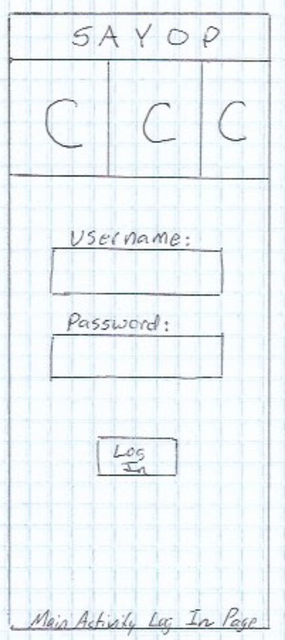 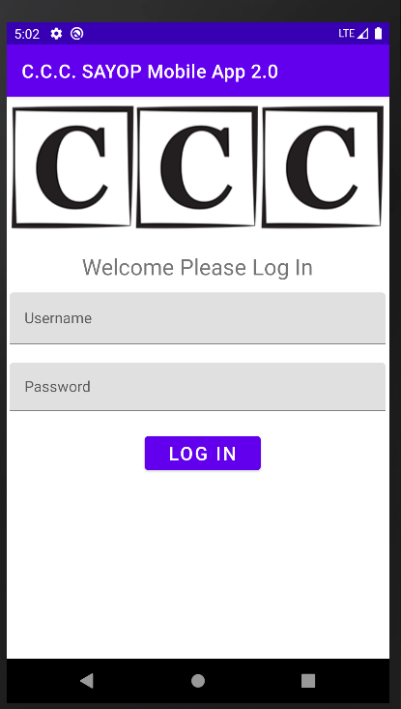

Figure 1: Low Fidelity

Figure 2: High Fidelity

Once a user logs in, they will be taken to the Main_Activity_Home_Page. The user can select to view Terms, Courses, Assessments, or Reports.

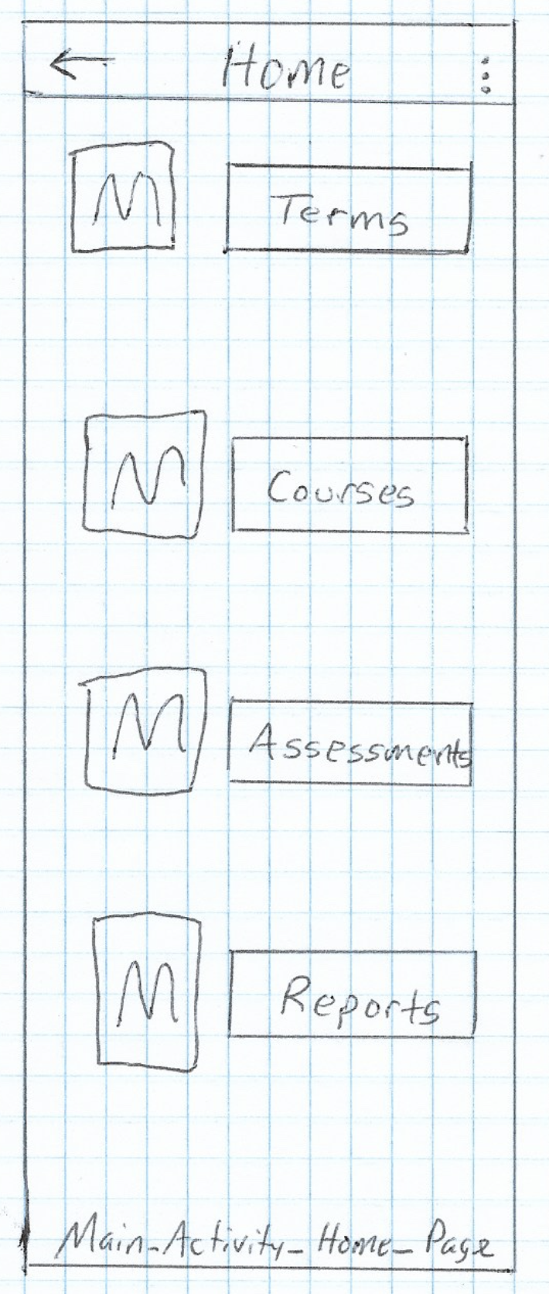 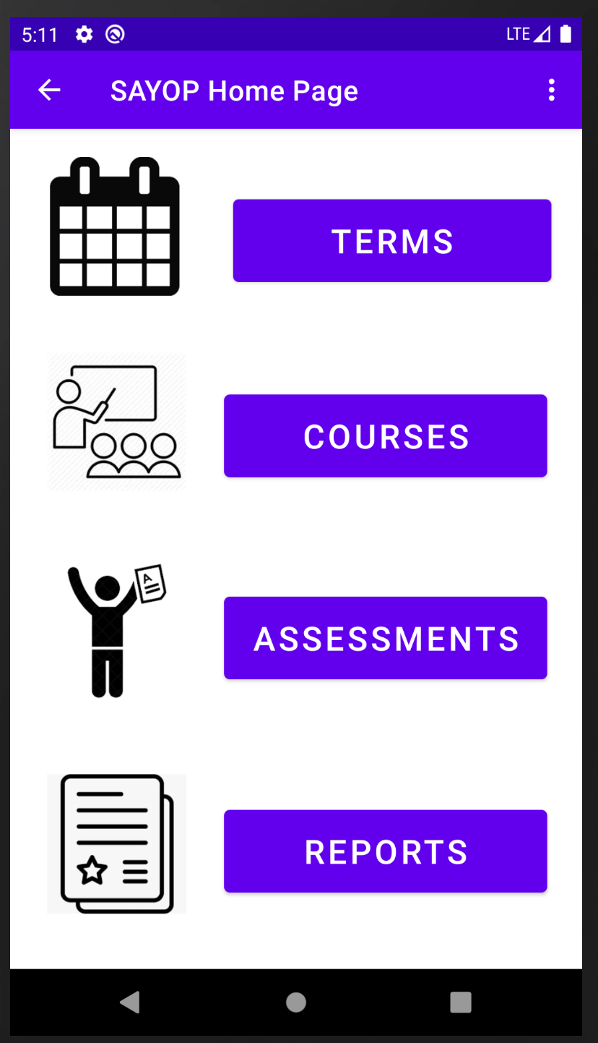

Figure 4: High Fidelity

Figure 3: Low Fidelity

Selecting the TERMS button will navigate to the List_Terms page. On this page, the user will see all of the existing terms. This page will list the term name, start date, and end date. The user will be able to search the terms list, refresh the terms list, add a new term, edit a term, or return to Main_Activity_Home_Page.

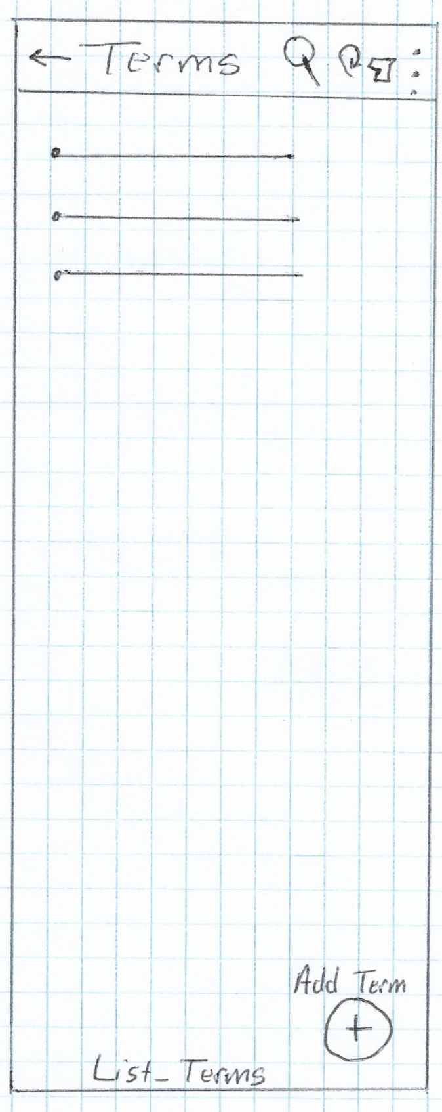 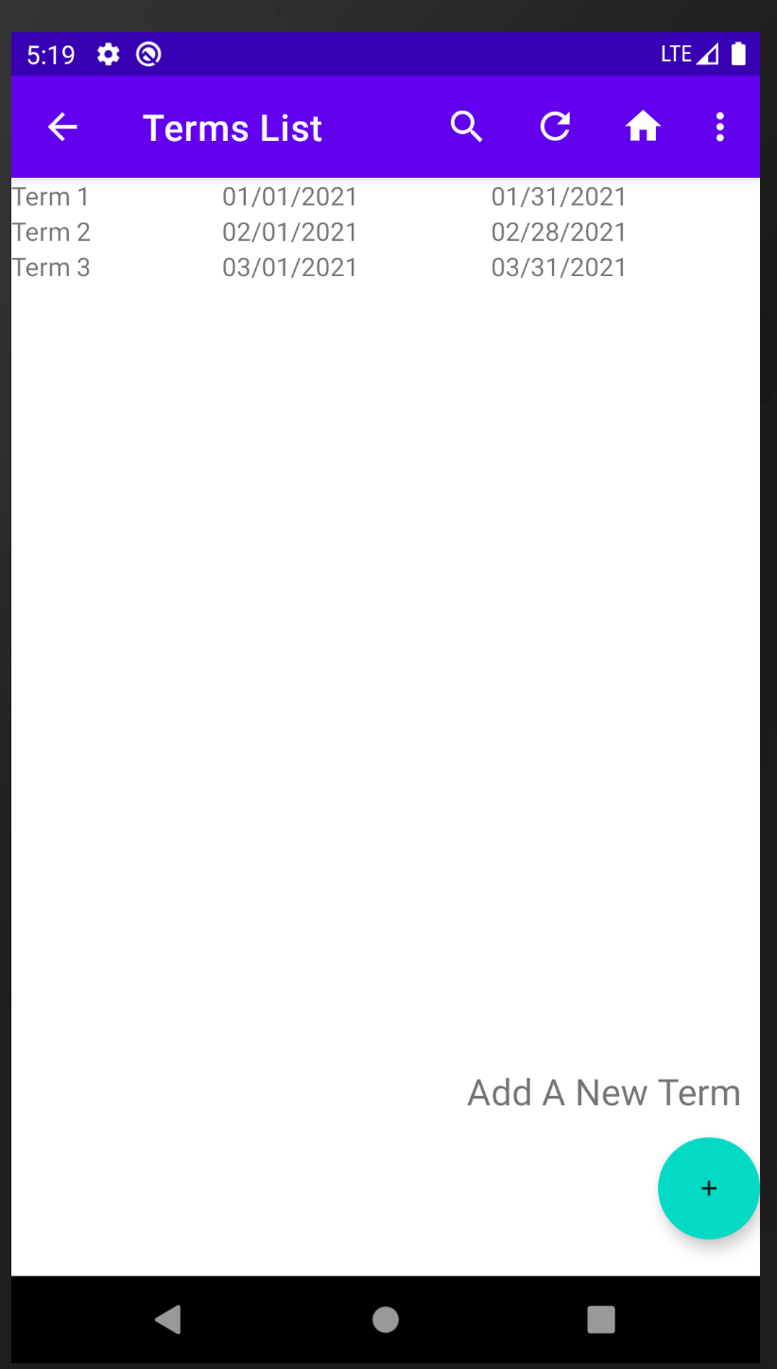

Figure 6: High Fidelity

Figure 5: Low Fidelity

If the user decids to edit an existing term, they will click on the term name in the list. This will take them to the Edit_Existing_Term page. The user can update the term name, start date, and end date before saving. If the user wants to add a new course or delete an associated course, this would be done from the Edit_Existing_Term page. The user can send out a notification via SMS Text or Email with information about the Term. The user is able to delete the term, provided no associated courses are showing. The user is be able to navigate back to Main_Activity_Home_Page.

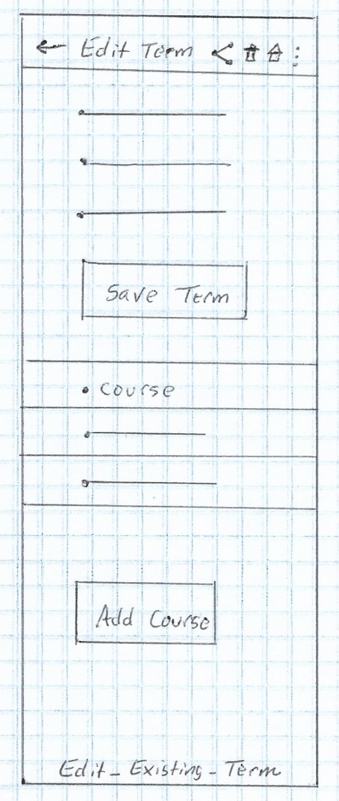 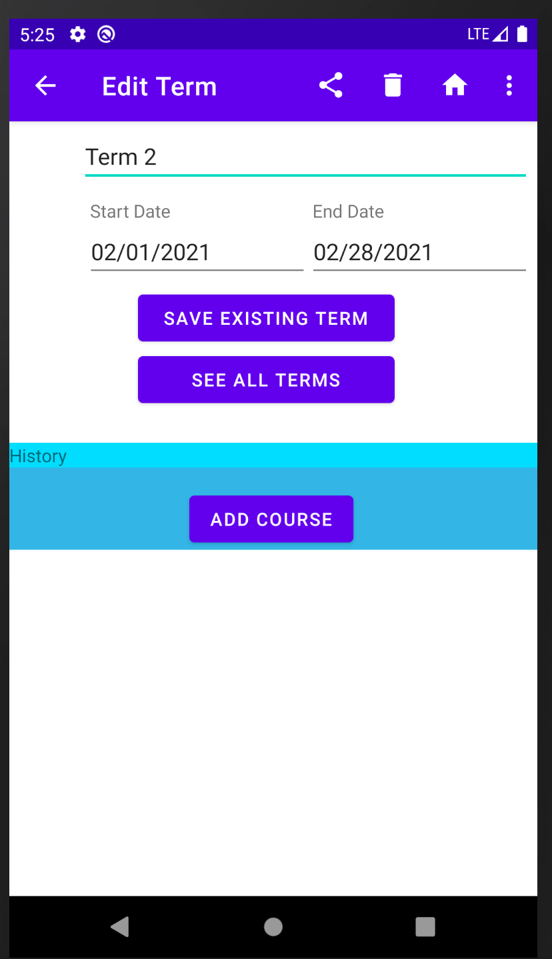

Figure 8: High Fidelity

Figure 7: Low Fidelity

If the user decides to add a new course to an existing term, they would click the add course navigational button. The user would be able to add a course name, start date, end date, status, instructor name, instructor phone, instructor email, and course note.

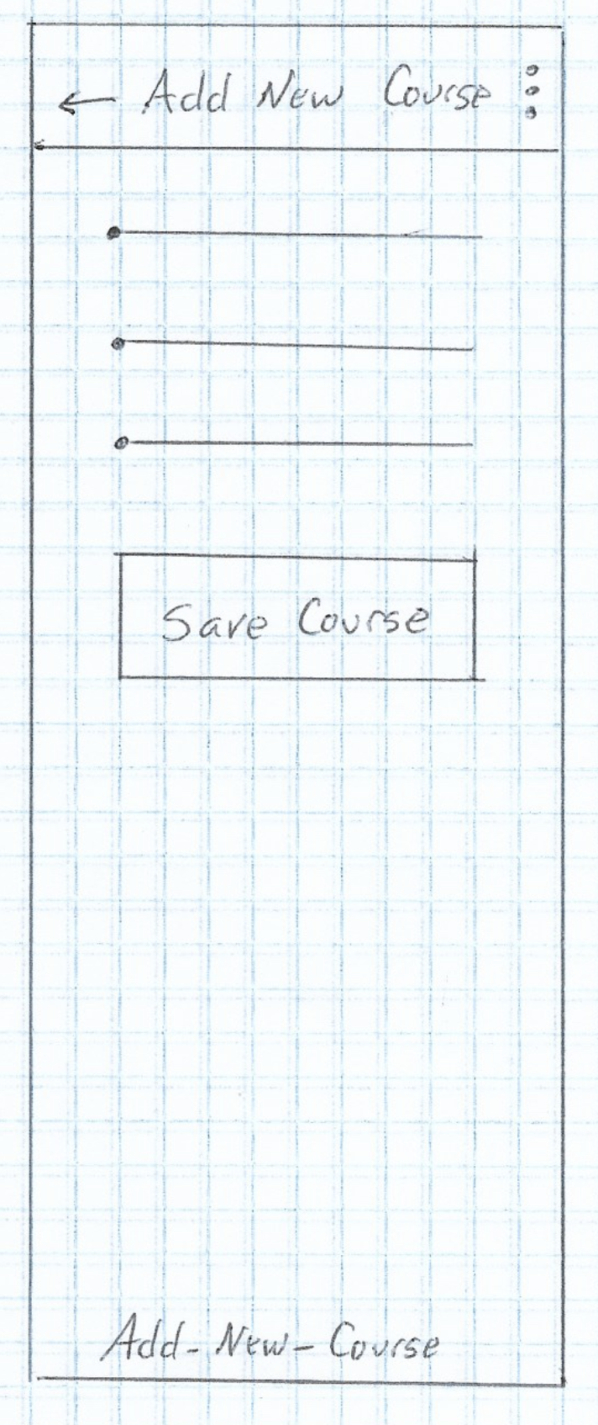 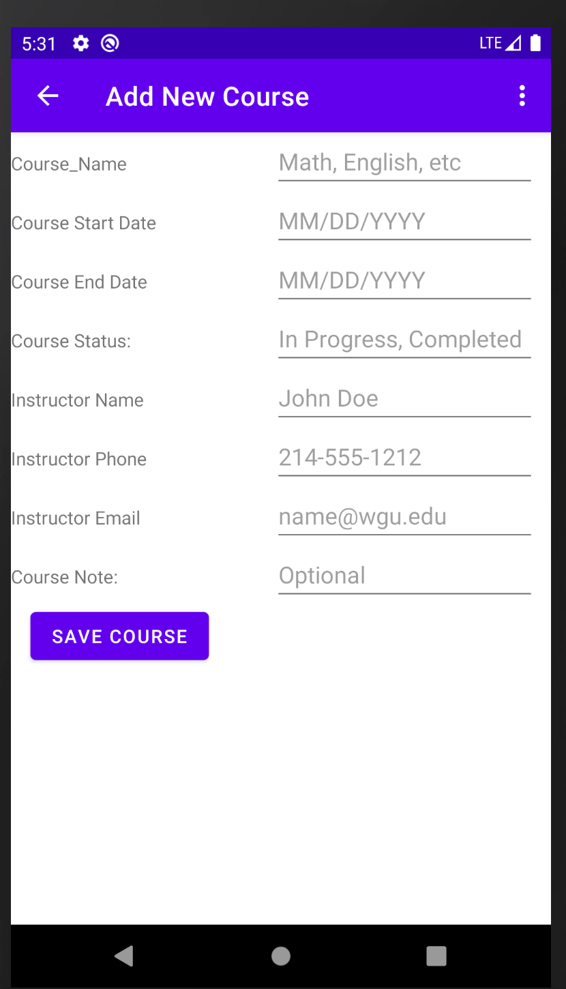

Figure 10: High Fidelity

Figure 9: Low Fidelity

From the List_Terms screen, if the user decides to add a new term, they will click on the floating action plus button to add the new term. This action would take them to the Add_New_Term screen. The user would add a term name, start date, and end date.

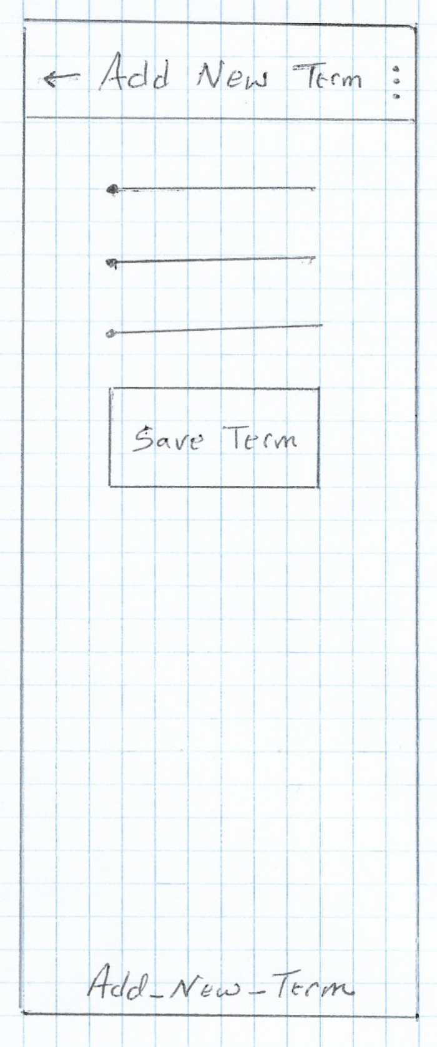 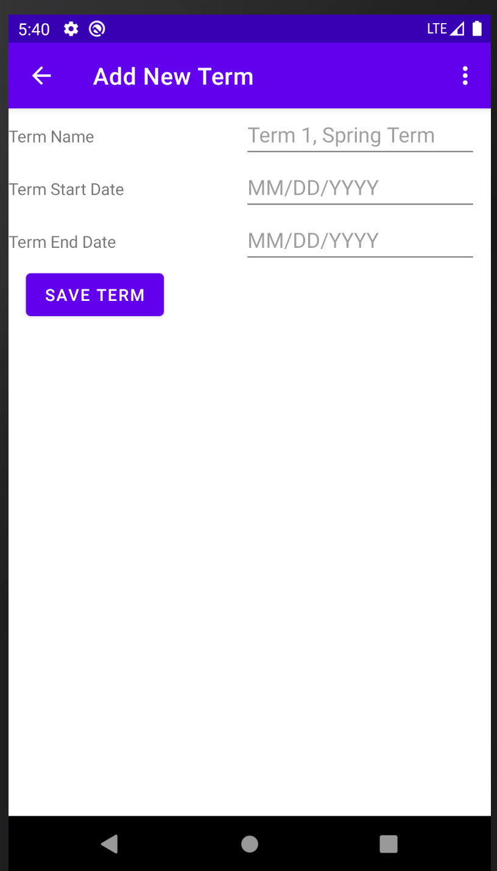

Figure 12: High Fidelity

Figure 11: Low Fidelity

From the Main_Activity_Home_Page, if the user decides to view all courses, they would click the Courses navigational button, which would take them to List_Courses screen. On that page, they would be able to edit a course by clicking on the course name. From the menu, they would be able to search through the course list by name. They would be able to refresh the courses list or return to Activity_Main_Home_Page screen.

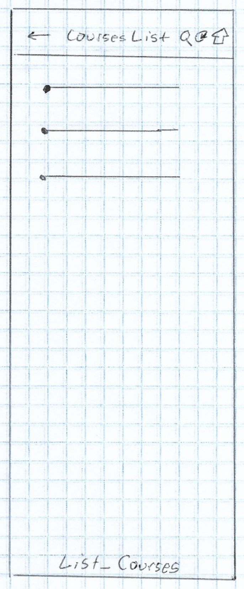 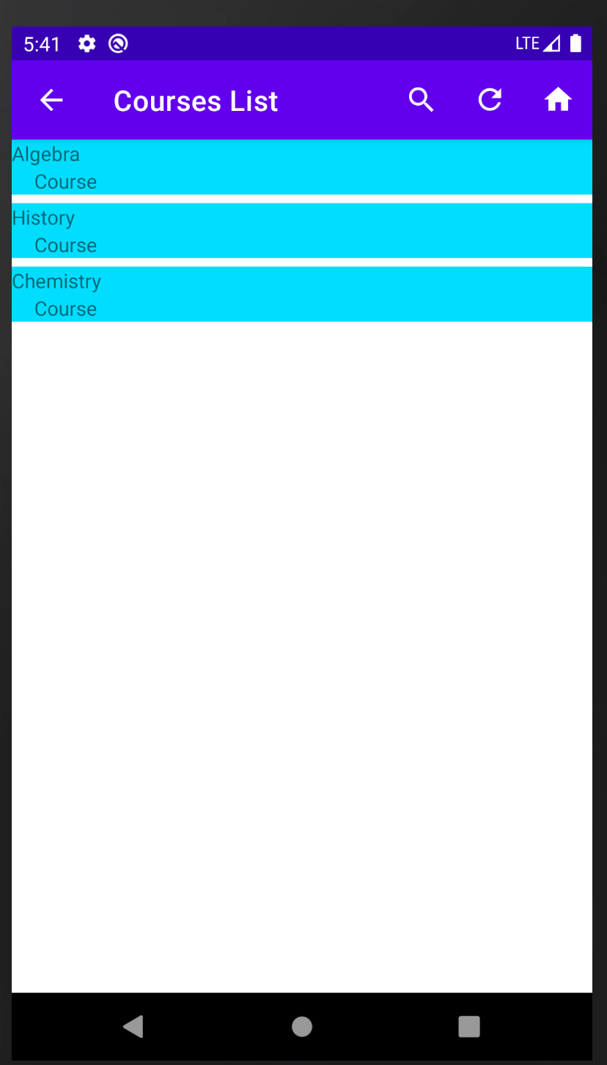

Figure 14: High Fidelity

Figure 13: Low Fidelity

From the Edit_Existing_Course page, the user wants to edit the course name, status, start date, end date, instructor name, instructor phone, instructor email, and course note. The user would be able to share course information via SMS Text or Email. They would be able to delete the course, provided no associated assessments are part of the course. The user would also be able to navigate to the home screen. They would be able to delete an associated assessment for that course in addition to adding a new assessment to the course.

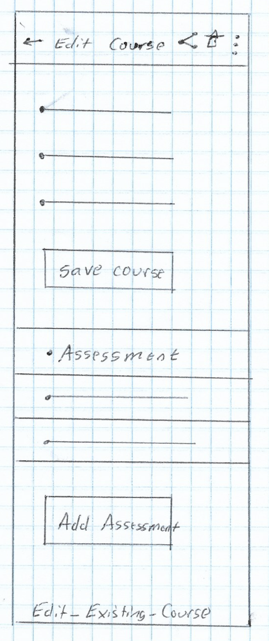 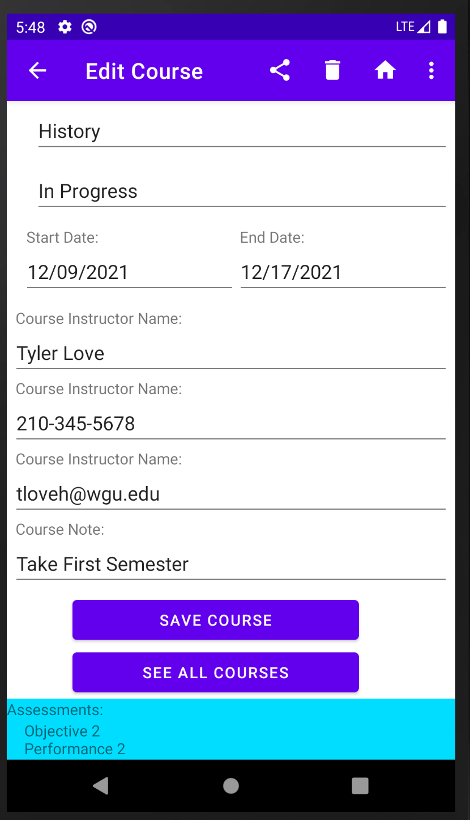

Figure 16: High Fidelity

Figure 15: Low Fidelity

From the Edit_Existing_Course screen, if the user wanted to add a new assessment, they would click the add new assessment navigational button to be taken to the Add_New_Assessment page. On this screen, the user would add an assessment name, type, start date, and end date.

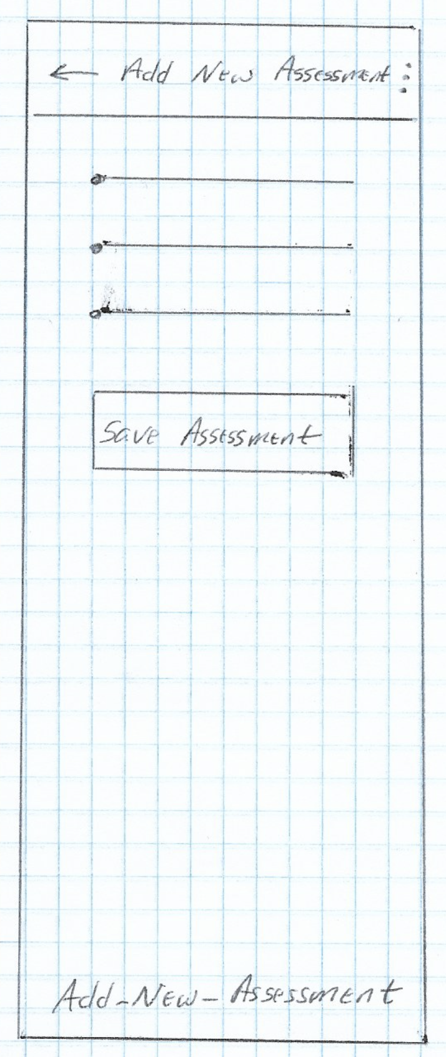 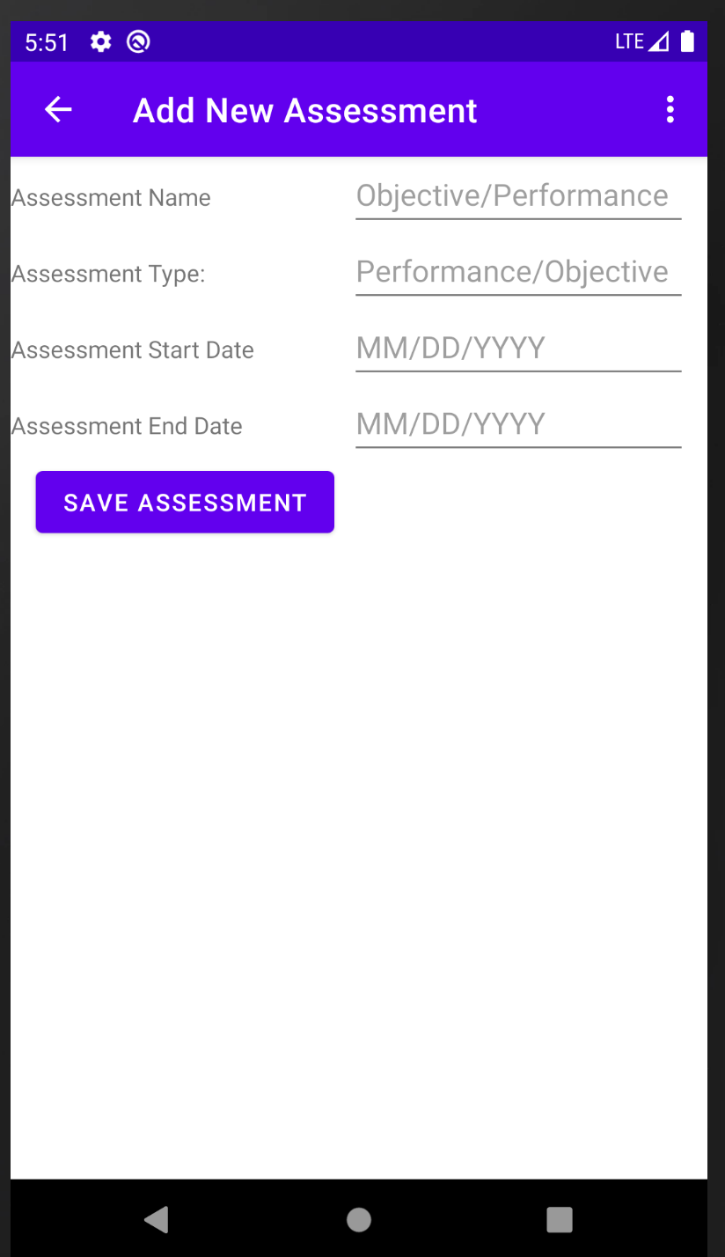

Figure 18: High Fidelity

Figure 17: Low Fidelity

From the Main_Activity_Home_Page, if the user wants to view all assessments, they would click the Assessment navigational button to be taken to List_Assessments page. On this screen, the user would edit an assessment, search through the list of assessments by name, refresh the assessments list, or return to Main_Activity_Home_Page.

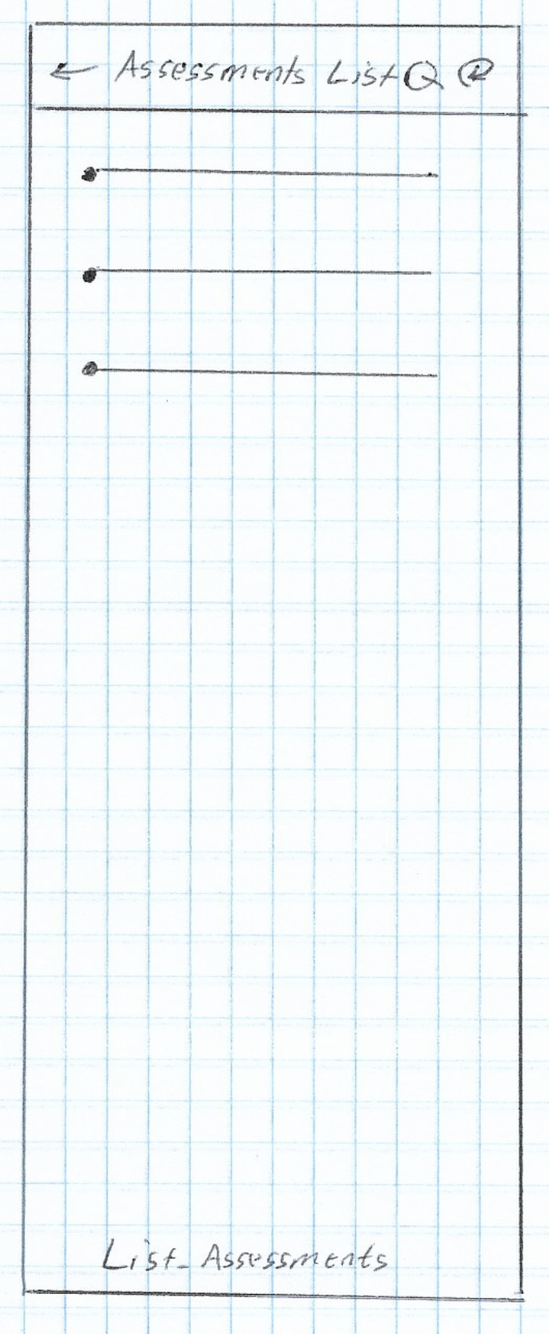 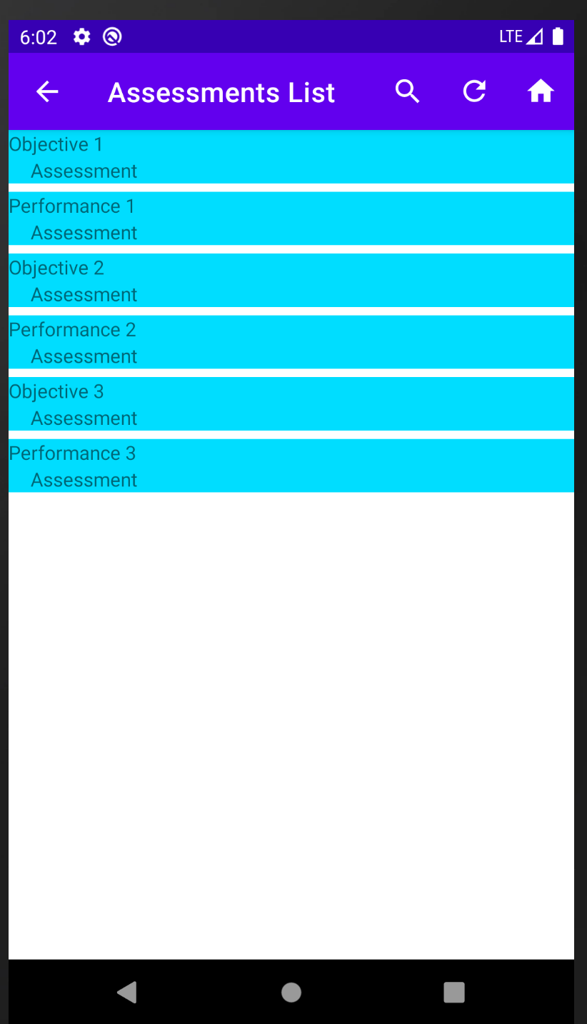

Figure 20: High Fidelity

Figure 19: Low Fidelity

If the user wants to edit an assessment, they will click on an assessment name from the list to be taken to Edit_Existing_Assessment page. The user would be able to update the assessment name, type, start date, and end date. The user would also be able to share information about the assessment via SMS Text or Email. They would be able to delete the assessment or navigate to Main_Activity_Home_Page.

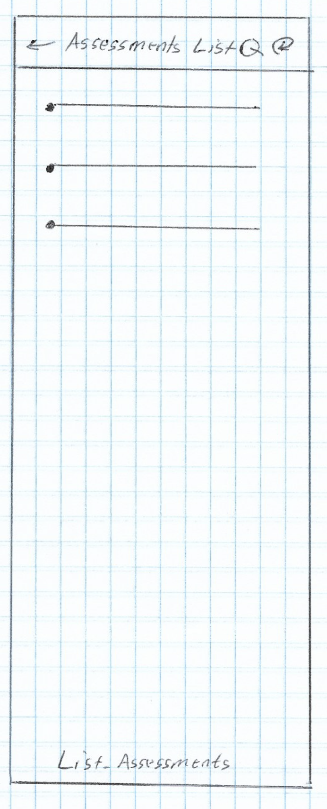 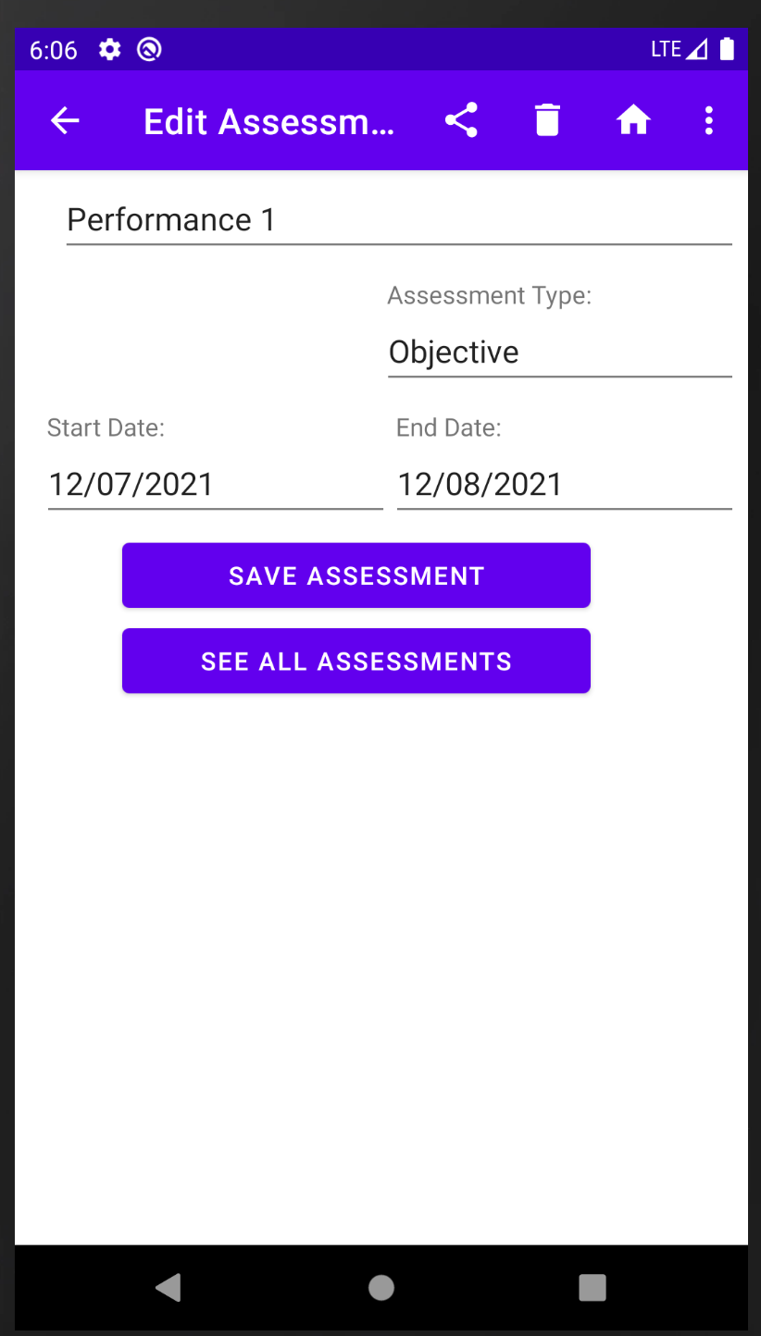

Figure 22: High Fidelity

Figure 21: Low Fidelity

From the Main_Activity_Home_Page, if the user wants to generate reports, such as Terms List, Courses List, Assessments List, or Instructors List, they would click the Reports navigational button to navigate to the Reports_Page.

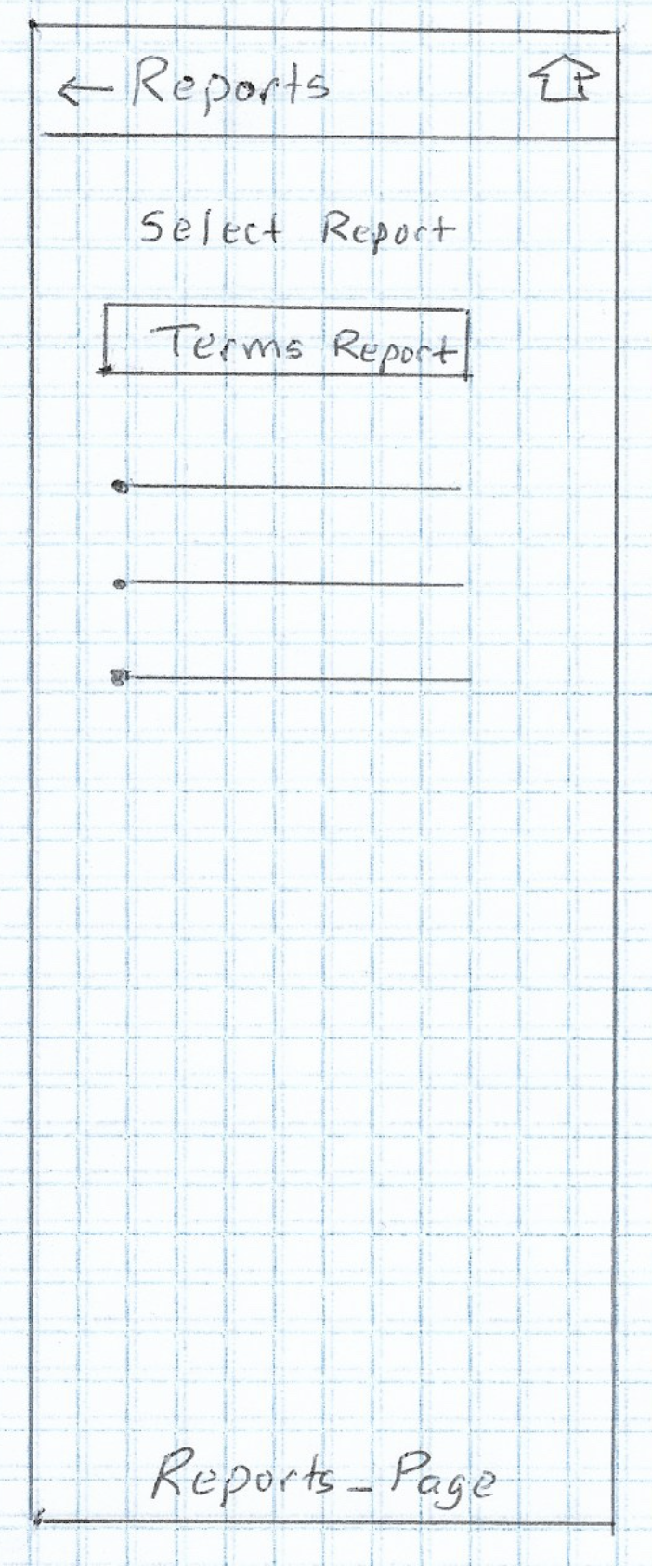 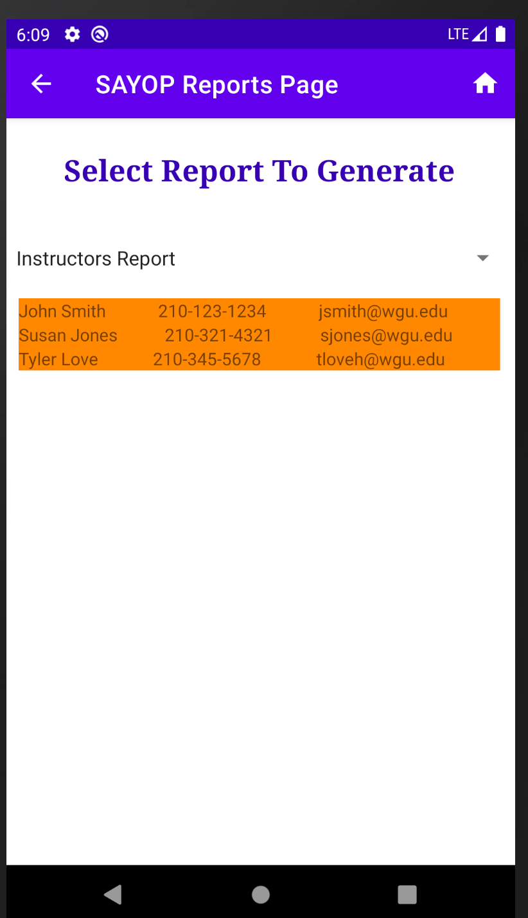

Figure 24: High Fidelity

Figure 23: Low Fidelity

# Unit Test Plan

## Introduction

### Purpose

Manual testing of the mobile app from the user interface was used to verify the program’s expected functionality and error handling. Each test case was written into the application as a unit test and integrated at each point in the application’s development process, as each method was written by the developer.

Unit tests were incorporated into the CICD (Continual Integration, Continual Delivery) pipeline using Jenkin’s Automation tooling, where full testing of all the Unit Tests is being constantly ran. Every time code was committed to the developer’s branch for integration and when testing was done by quality engineers, a full sweep of unit test checks are completed. Additional times when all of the unit tests are ran is before a development branch will be released into the staging branch and once more before the staging branch is released as part of the beta release. Listed below is the comprehensive list of unit test cases written and tested with automated unit tests.

|  |  |  |  |  |  |
| --- | --- | --- | --- | --- | --- |
| Test Case Number | Description | Data | Expected Results | Actual Results | Pass / Fail |
| 1 | Login Attempt | User: student  Pass: password | Login success | Login success | Pass |
| 2. | Login Attempt | User: null  Pass: null | Login Fail, Error Message | Login Fail, Error Message | Pass |
| 3 | Login Attempt | User: null  Pass: password | Login Fail, Error Message | Login Fail, Error Message | Pass |
| 4 | Login Attempt | User student  Pass: null | Login Fail, Error Message | Login Fail, Error Message | Pass |
| 5 | Login Attempt | User: something Pass: 1234 | Login Fail, Error Message | Login Fail, Error Message | Pass |
| 6 | Logout Attempt | Select logout | Logout | Return to Login Screen | Pass |
| 7 | See Terms | seeAllTerms() | Get a list of all terms | Returned result of term names, start and end dates | Pass |
| 8 | See Courses | seeAllCourses() | Get a list of all courses | Returned result with course names | Pass |
| 9 | See Assessments | seeAllAssessments() | Get a list of all assessments | Returned result with assessment names | Pass |
| 10 | See Reports | Generate Terms Report | Get a list of all Terms | Terms Report Generated | Pass |
| 11 | See Reports | Generate Courses Report | Get a list of all Courses | Courses Report Generated | Pass |
| 12 | See Reports | Generate Assessments Report | Get a list of all Assessments | Assessments Report Generated | Pass |
| 13 | See Reports | Generate Instructors Report | Get a list of all Instructors | Instructor’s Report Generated | Pass |
| 14 | Add New Term | Term Name: test Start Date: 01/01/21 End Date: 01/02/21 | Create new term | New Term Created | Pass |
| 15 | Add New Term | Term Name: test Start Date: 01/02/21 End Date: 01/01/21 | Error Message | End date cannot be before start | Pass |
| 16 | Add New Term | Term Name: test Start Date: 01/01/21 End Date: 02/15/21 | Error Message | Term cannot be longer than 30 days | Pass |
| 17 | Add New Term | Term Name: test Start Date: 01/01/21 End Date: 01/01/21 | Error Message | Term start and end date cannot be the same | Pass |
| 18 | Add New Term | Term Name: null Start Date: 01/01/21 End Date: 01/01/21 | Error Message | Term name cannot be empty | Pass |
| 19 | Add New Term | Term Name: test Start Date: null End Date: 01/01/21 | Error Message | Term start date cannot be empty | Pass |
| 20 | Add New Term | Term Name: test Start Date: 01/01/21 End Date: null | Error Message | Term end date cannot be empty | Pass |
| 21 | Edit Term | Term Name: test Start Date: 01/01/21 End Date: 01/01/21 | Save Term | Save Term | Pass |
| 22 | Edit Term | Term Name: test Start Date: 01/02/21 End Date: 01/01/21 | Error Message | End date cannot be before start | Pass |
| 23 | Edit Term | Term Name: test Start Date: 01/01/21 End Date: 02/15/21 | Error Message | Term cannot be longer than 30 days | Pass |
| 24 | Edit Term | Term Name: test Start Date: 01/01/21 End Date: 01/01/21 | Error Message | Term start and end date cannot be the same | Pass |
| 25 | Edit Term | Term Name: null Start Date: 01/01/21 End Date: 01/01/21 | Error Message | Term name cannot be empty | Pass |
| 26 | Edit Term | Term Name: test Start Date: null End Date: 01/01/21 | Error Message | Term start date cannot be empty | Pass |
| 27 | Edit Term | Term Name: test Start Date: 01/01/21 End Date: null | Error Message | Term end date cannot be empty | Pass |
| 28 | Edit Term | Delete Term | Success | Success | Pass |
| 29 | Edit Term | Delete Term | Error Message | Cannot delete a term with associated courses | Pass |
| 30 | Edit Term | Remove Course from Term | Success | Success | Pass |
| 30 | Add New Course | Course Name: test  Start Date: 01/01/21  End Date: 01/31/21  Status: test  Instructor Name: test  Instructor Phone: 111-111-1111  Instructor Email: test@domain.com  Note: test | Success | Success | Pass |
| 31 | Add New Course | Course Name: test  Start Date: 01/02/21  End Date: 01/01/21  Status: test  Instructor Name: test  Instructor Phone: 111-111-1111  Instructor Email: test@domain.com  Note: test | Error Message | End date cannot come before start date | Pass |
| 32 | Add New Course | Course Name: test  Start Date: 01/01/21  End Date: 01/01/21  Status: test  Instructor Name: test  Instructor Phone: 111-111-1111  Instructor Email: test@domain.com  Note: test | Error Message | Start date and end date cannot be the same | Pass |
| 33 | Add New Course | Course Name: test  Start Date: 01/01/21  End Date: 02/15/21  Status: test  Instructor Name: test  Instructor Phone: 111-111-1111  Instructor Email: test@domain.com  Note: test | Error Message | Start date and end date cannot be greater than 30 days | Pass |
| 34 | Add New Course | Course Name: null  Start Date: 01/01/21  End Date: 01/31/21  Status: test  Instructor Name: test  Instructor Phone: 111-111-1111  Instructor Email: test@domain.com  Note: test | Error Message | Course name cannot be empty | Pass |
| 35 | Add New Course | Course Name: null  Start Date: Pass  End Date: 01/31/21  Status: test  Instructor Name: test  Instructor Phone: 111-111-1111  Instructor Email: test@domain.com  Note: test | Error Message | Course start date cannot be empty | Pass |
| 36 | Add New Course | Course Name: test  Start Date: 01/01/21  End Date: null  Status: test  Instructor Name: test  Instructor Phone: 111-111-1111  Instructor Email: test@domain.com  Note: test | Error Message | Course end date cannot be empty | Pass |
| 37 | Add New Course | Course Name: test  Start Date: 01/01/21  End Date: 01/31/21  Status: null  Instructor Name: test  Instructor Phone: 111-111-1111  Instructor Email: test@domain.com  Note: test | Error Message | Course status cannot be empty | Pass |
| 38 | Add New Course | Course Name: test  Start Date: 01/01/21  End Date: 01/31/21  Status: test  Instructor Name: null  Instructor Phone: 111-111-1111  Instructor Email: test@domain.com  Note: test | Error Message | Course instructor name cannot be empty | Pass |
| 39 | Add New Course | Course Name: test  Start Date: 01/01/21  End Date: 01/31/21  Status: test  Instructor Name: test  Instructor Phone: null  Instructor Email: test@domain.com  Note: test | Error Message | Course instructor phone cannot be empty | Pass |
| 40 | Add New Course | Course Name: test  Start Date: 01/01/21  End Date: 01/31/21  Status: test  Instructor Name: null  Instructor Phone: 111-111-1111  Instructor Email: null  Note: test | Error Message | Course instructor email cannot be empty | Pass |
| 41 | Edit Course | Course Name: test  Start Date: 01/01/21  End Date: 01/31/21  Status: test  Instructor Name: test  Instructor Phone: 111-111-1111  Instructor Email: test@domain.com  Note: test | Save Course | Success | Pass |
| 42 | Edit Course | Course Name: test  Start Date: 01/02/21  End Date: 01/01/21  Status: test  Instructor Name: test  Instructor Phone: 111-111-1111  Instructor Email: test@domain.com  Note: test | Error Message | End date cannot come before start date | Pass |
| 43 | Edit Course | Course Name: test  Start Date: 01/01/21  End Date: 02/15/21  Status: test  Instructor Name: test  Instructor Phone: 111-111-1111  Instructor Email: test@domain.com  Note: test | Error Message | Course cannot be greater than 30 days | Pass |
| 44 | Edit Course | Course Name: test  Start Date: 01/01/21  End Date: 01/01/21  Status: test  Instructor Name: test  Instructor Phone: 111-111-1111  Instructor Email: test@domain.com  Note: test | Error Message | Start date and end date cannot be the same | Pass |
| 45 | Edit Course | Course Name: null  Start Date: 01/01/21  End Date: 01/31/21  Status: test  Instructor Name: test  Instructor Phone: 111-111-1111  Instructor Email: test@domain.com  Note: test | Error Message | Course name cannot be empty | Pass |
| 46 | Edit Course | Course Name: test  Start Date: null  End Date: 01/31/21  Status: test  Instructor Name: test  Instructor Phone: 111-111-1111  Instructor Email: test@domain.com  Note: test | Error Message | Course start date cannot be empty | Pass |
| 47 | Edit Course | Course Name: test  Start Date: 01/01/21  End Date: null  Status: test  Instructor Name: test  Instructor Phone: 111-111-1111  Instructor Email: test@domain.com  Note: test | Error Message | Course end date cannot be empty | Pass |
| 48 | Edit Course | Course Name: test  Start Date: 01/01/21  End Date: 01/31/21  Status: null  Instructor Name: test  Instructor Phone: 111-111-1111  Instructor Email: test@domain.com  Note: test | Error Message | Course status cannot be empty | Pass |
| 49 | Edit Course | Course Name: test  Start Date: 01/01/21  End Date: 01/31/21  Status: test  Instructor Name: null  Instructor Phone: 111-111-1111  Instructor Email: test@domain.com  Note: test | Error Message | Course instructor name cannot be empty | Pass |
| 50 | Edit Course | Course Name: test  Start Date: 01/01/21  End Date: 01/31/21  Status: test  Instructor Name: null  Instructor Phone: null  Instructor Email: test@domain.com  Note: test | Error Message | Course instructor phone cannot be empty | Pass |
| 51 | Edit Course | Course Name: test  Start Date: 01/01/21  End Date: 01/31/21  Status: test  Instructor Name: test  Instructor Phone: 111-111-1111  Instructor Email: null  Note: test | Error Message | Course instructor cannot be empty | Pass |
| 52 | Edit Course | Delete Course | Success | Course Deleted | Pass |
| 53 | Edit Course | Delete Course | Error Message | Course cannot be deleted with associated assessments | Pass |
| 54 | Edit Course | Remove Assessment from Course | Success | Success | Pass |
| 55 | Add New Assessment | Assessment Name: test Type: test Start Date: 01/01/2022 End Date: 01/31/2022 | Success | Success | Pass |
| 56 | Add New Assessment | Assessment Name: test Type: test Start Date: 02/01/2022 End Date: 01/31/2022 | Error Message | Assessment End date cannot be before Start date | Pass |
| 57 | Add New Assessment | Assessment Name: test Type: test Start Date: 01/01/2022 End Date: 02/15/2022 | Error Message | Assessment cannot be more than 30 days. | Pass |
| 58 | Add New Assessment | Assessment Name: test Type: test Start Date: 01/01/2022 End Date: 01/01/2022 | Error Message | Assessment Start date and End date cannot be the same date. | Pass |
| 59 | Add New Assessment | Assessment Name: null Type: test Start Date: 01/01/2022 End Date: 01/31/2022 | Error Message | Assessment name cannot be empty | Pass |
| 60 | Add New Assessment | Assessment Name: test Type: null Start Date: 01/01/2022 End Date: 01/31/2022 | Error Message | Assessment type cannot be empty | Pass |
| 61 | Add New Assessment | Assessment Name: test Type: test Start Date: null End Date: 01/31/2022 | Error Message | Assessment Start date cannot be empty | Pass |
| 62 | Add New Assessment | Assessment Name: test Type: test Start Date: 01/01/2022 End Date: null | Error Message | Assessment End date cannot be empty | Pass |
| 63 | Edit Assessment | Assessment Name: test Type: test Start Date: 01/01/2022 End Date: 01/31/2022 | Success | Success | Pass |
| 64 | Edit Assessment | Assessment Name: test Type: test Start Date: 01/01/2022 End Date: 02/01/2022 | Error Message | Assessment End date cannot be before Start date | Pass |
| 65 | Edit Assessment | Assessment Name: test Type: test Start Date: 01/01/2022 End Date: 02/15/2022 | Error Message | Assessment cannot be more than 30 days | Pass |
| 66 | Edit Assessment | Assessment Name: test Type: test Start Date: 01/01/2022 End Date: 01/01/2022 | Error Message | Assessment Start date and End date cannot be the same | Pass |
| 67 | Edit Assessment | Assessment Name: null Type: test Start Date: 01/01/2022 End Date: 01/31/2022 | Error Message | Assessment name cannot be empty | Pass |
| 68 | Edit Assessment | Assessment Name: test Type: null Start Date: 01/01/2022 End Date: 01/31/2022 | Error Message | Assessment type cannot be empty | Pass |
| 69 | Edit Assessment | Assessment Name: test Type: test Start Date: null End Date: 01/31/2022 | Error Message | Assessment Start date cannot be empty | Pass |
| 70 | Edit Assessment | Assessment Name: test Type: test Start Date: 01/01/2022 End Date: null | Error Message | Assessment End date cannot be empty | Pass |

### Overview

Developers have each unit test during the coding phase. They have continually participated in regression testing as each new feature was added to the mobile application. Any new bugs were documented with an expected result and actual result inside a new JIRA ticket. Based on severity and priority, that bug was either repaired in the development branch it was discovered in, or it was dealt with in a new branch. If the bug was placed in a new branch, the existing issue was placed on hold with a “depends on” link as so the original issue and bug were released at the same time into the staging environment.

## Test Plan

### Items

An emulator and/or a physical android device will be needed to run each test.

### Features

* Add a new term
* Edit a term
* Delete a term
* Add a new course to a term
* Delete a course to a term
* Edit a course
* Delete a course
* Add a new assessment to a course
* Edit an assessment
* Delete an assessment
* Run a terms list report
* Run a course list report
* Run an assessment list report
* Run an instructor list report

### Deliverables

Please view the 70-unit tests in the table marked under section test cases and results.

### Tasks

* Follow each test case
* Document actual results and expected results
* Any new bugs introduced were documented and sent back to the developer for rework or to be handled in a separate issue.
* Complete the test case and mark the issue as pass or fail

### Needs

The following is needed for each test case to be properly tested:

* JIRA Project Management Software
* GitHub repository
* Confluence Documentation Software
* Android Studio or IntelliJ Integrated Development Environment Software
* Laptop or Desktop
* Emulator or Physical Android Testing Device

### Pass/Fail Criteria

A pass would be placed on an individual issue if the quality engineer performed their test and the result of the test matched that which is documented by the developer in the testing instructions. If the expected result is not reached, the quality engineer reattempts the testing steps a second time, carefully following all of the steps to verify nothing was missed in the first attempt. If the results from the second attempt do not match the expected results, the quality engineer will reach out to the developer through email or instant messenger.

The developer will then work with the quality engineer, one-on-one, to verify that all the testing environment is configured correctly and that the testing instructions are clearly understood by the tester. If there is confusion, misunderstanding, or interpretation that was misconstrued by the quality engineer, the developer will rewrite the testing instructions to be clearer. If the developer can verify the actual results are different from the expected results, the quality engineer will mark the issue as failed, and send the issue back to the developer for rework or correction to be made in a new issue.

## Specifications

Screen shot for add a new term:

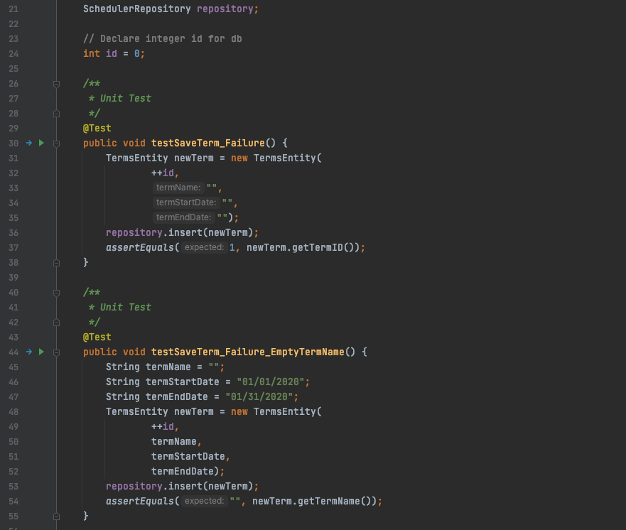

Screen shot for add a new assessment:

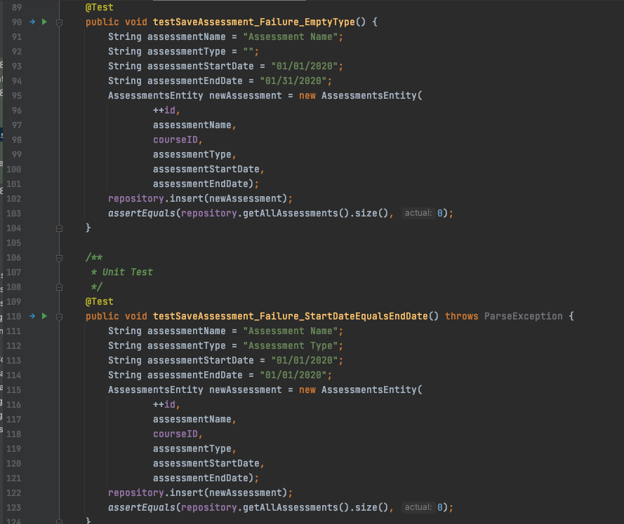

## Procedures

The unit tests run when the following actions take place:

* A new development branch is created
* A development branch with new code is pushed to peer review status
* A testing environment is created for the quality engineer
* A release branch is created when all issues are integrated together for testing
* A final check is done before all issues are released into the staging branch for beta testing

## Results

Here are the passing results for the unit test examples mentioned above:

Add a new term unit test result:

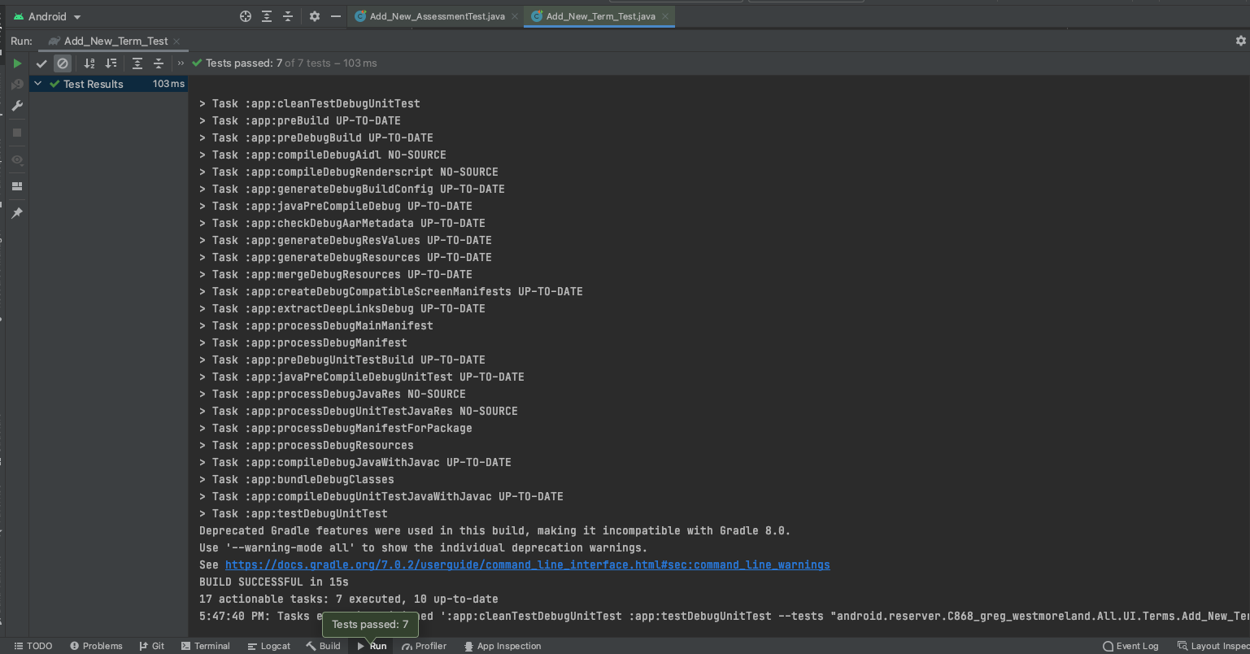

Add a new assessment unit test result:

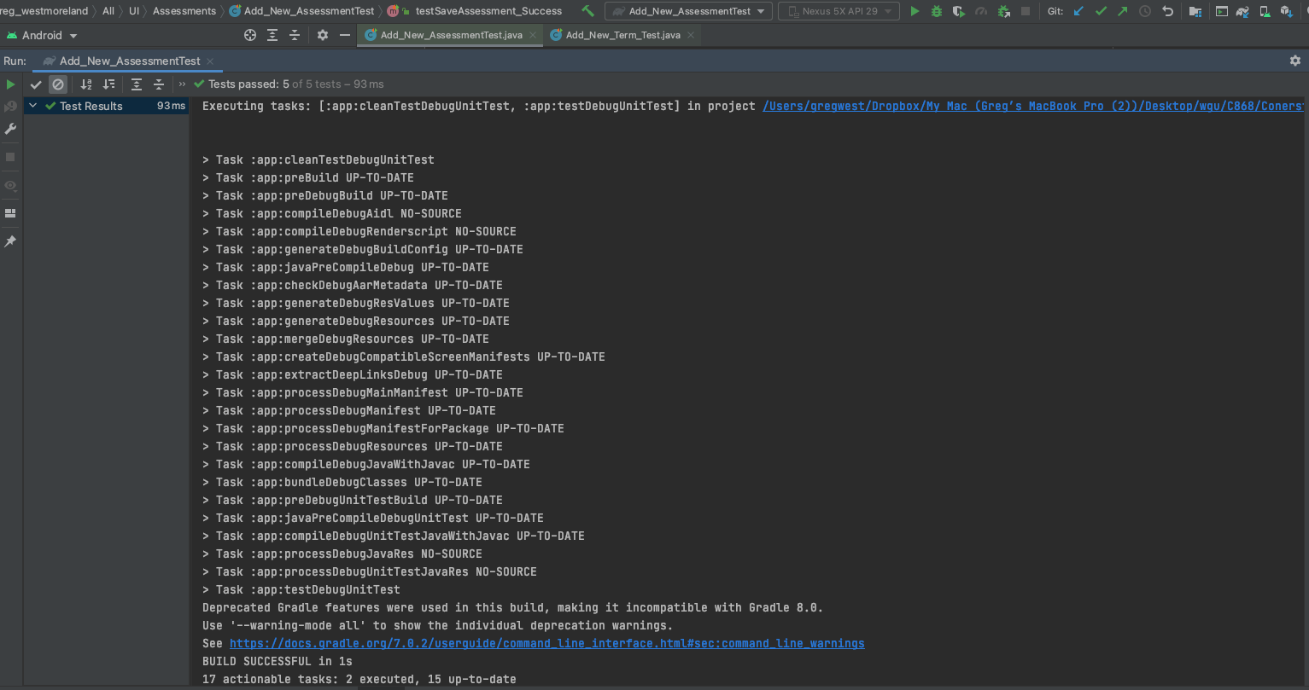

# Source Code

All source code can be found in the application zip file that will be included with this submission. It will be in the ~/src/main/java folder. Viewing and running the code on an emulator is recommended using Android Studio IDE with target Android (Version 12) SDK 31 and minimum Android (Version Oreo) SDK 26.

# Link to Live Version

No live version of this currently exists.

# User Guide

## Introduction

This user guide includes instructions on how to install Android Studio for a Windows or Mac system. It includes how to open the project, instructions on how to launch an emulator, and how to start the mobile application. After the mobile app is running, the user’s guide will walk you through every aspect of the app, including Adding/Editing/Deleting a term, course, and assessment. It will also guide you through the navigational improvements, search options, notifications, sharing, and report generation.

## Installation and Using the Application

* Navigate to the following URL <https://developer.android.com/studio/?gclid=CjwKCAiA_omPBhBBEiwAcg7smbEDRvGwvqFvYpWYCNjI3w80mwgn_sAIIPwEg-HNxsAK33bW_NJ66RoCCvQQAvD_BwE&gclsrc=aw.ds#downloads>
  + Select android-studio-2020.3.1.26-windows.exe if you will be installing Android Studio on a Windows platform.
  + Select android-studio-2020.3.1.26-mac.dmg if you will be installing Android Studio on a Mac OS X platform.
* Install the Android Studio IDE onto your device.
* After Android Studio IDE is installed, you will now need to locate the .zip files included with this submission and extract the file to a desired location on your device.
  + The name of the zipped filed included with this submission is called Cornerstone Community College Student Register - Android App.zip
  + Right click the file and select unzip the file with your default unzip software on your system.
    - The Unarchiver is recommended for Mac OS X - download [here](https://apps.apple.com/app/id1127253508)
    - WinZip is recommended for Windows – downloaded [here](https://www.winzip.com/en/download/winzip/)

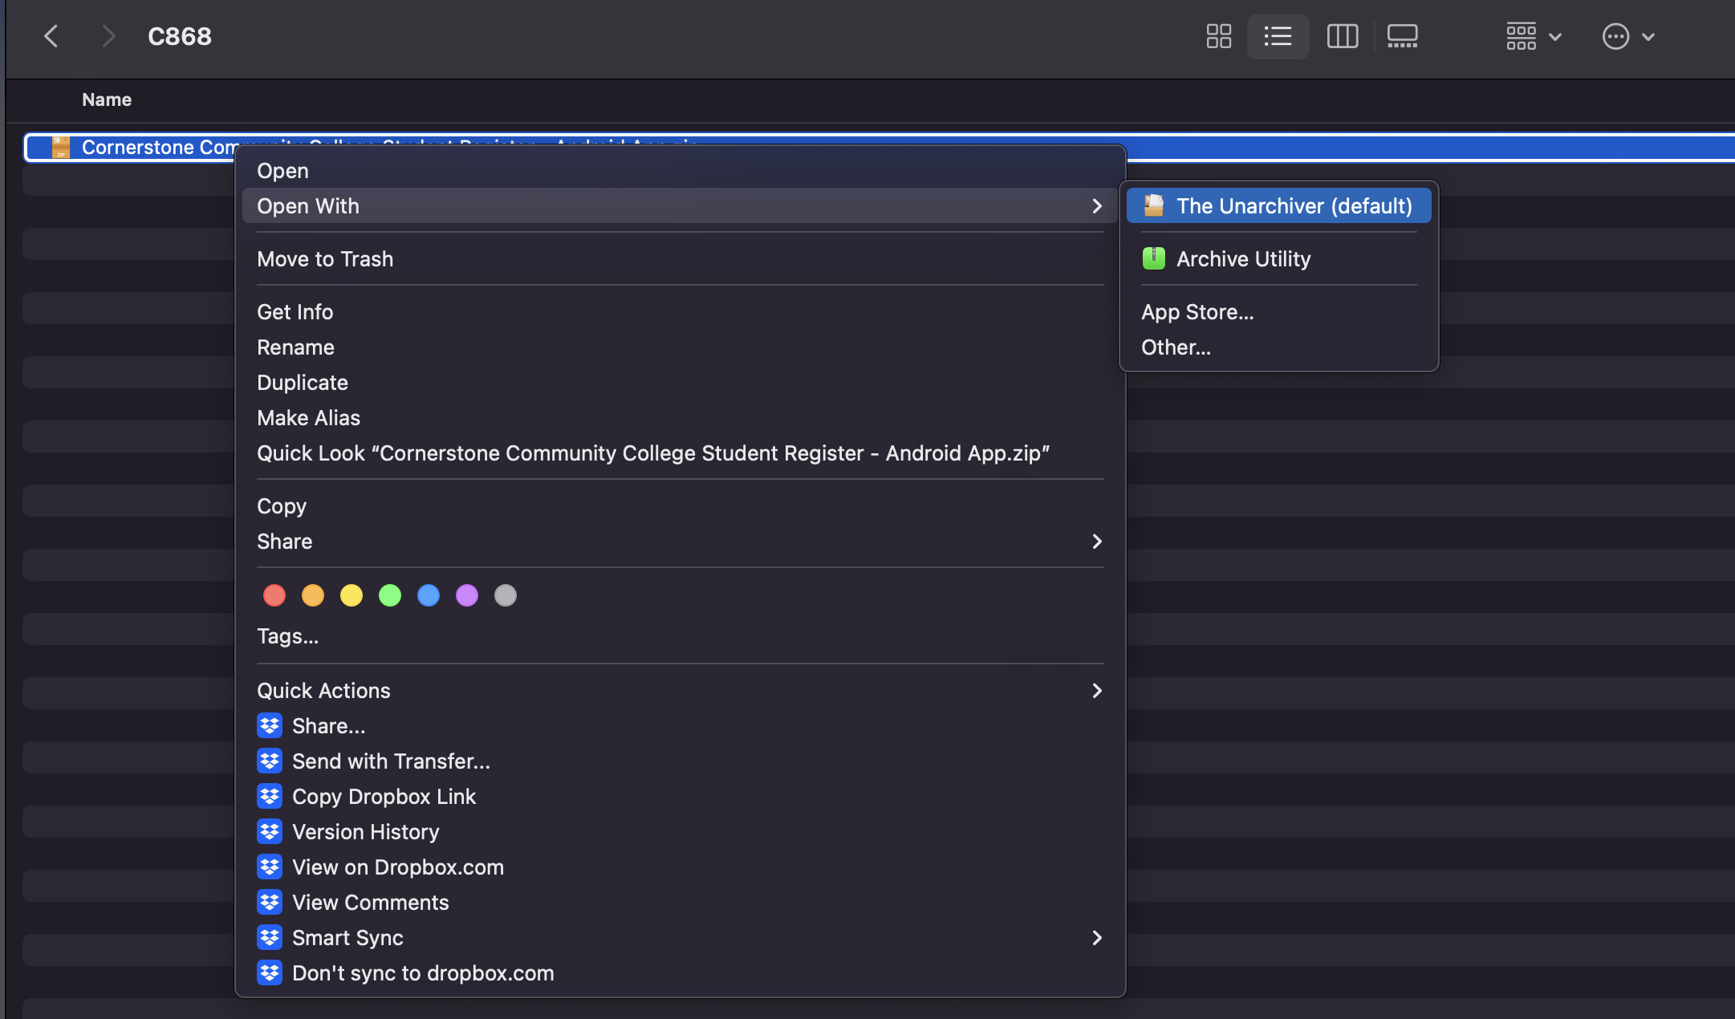

* Once unzipped it will look like this

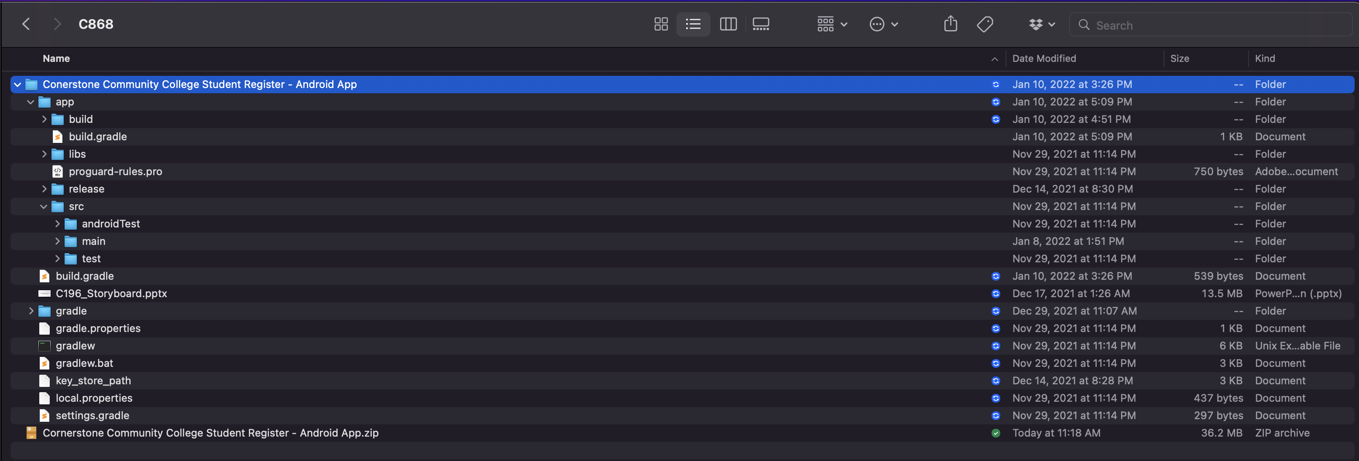

* Open Android Studio IDE



* Select Open

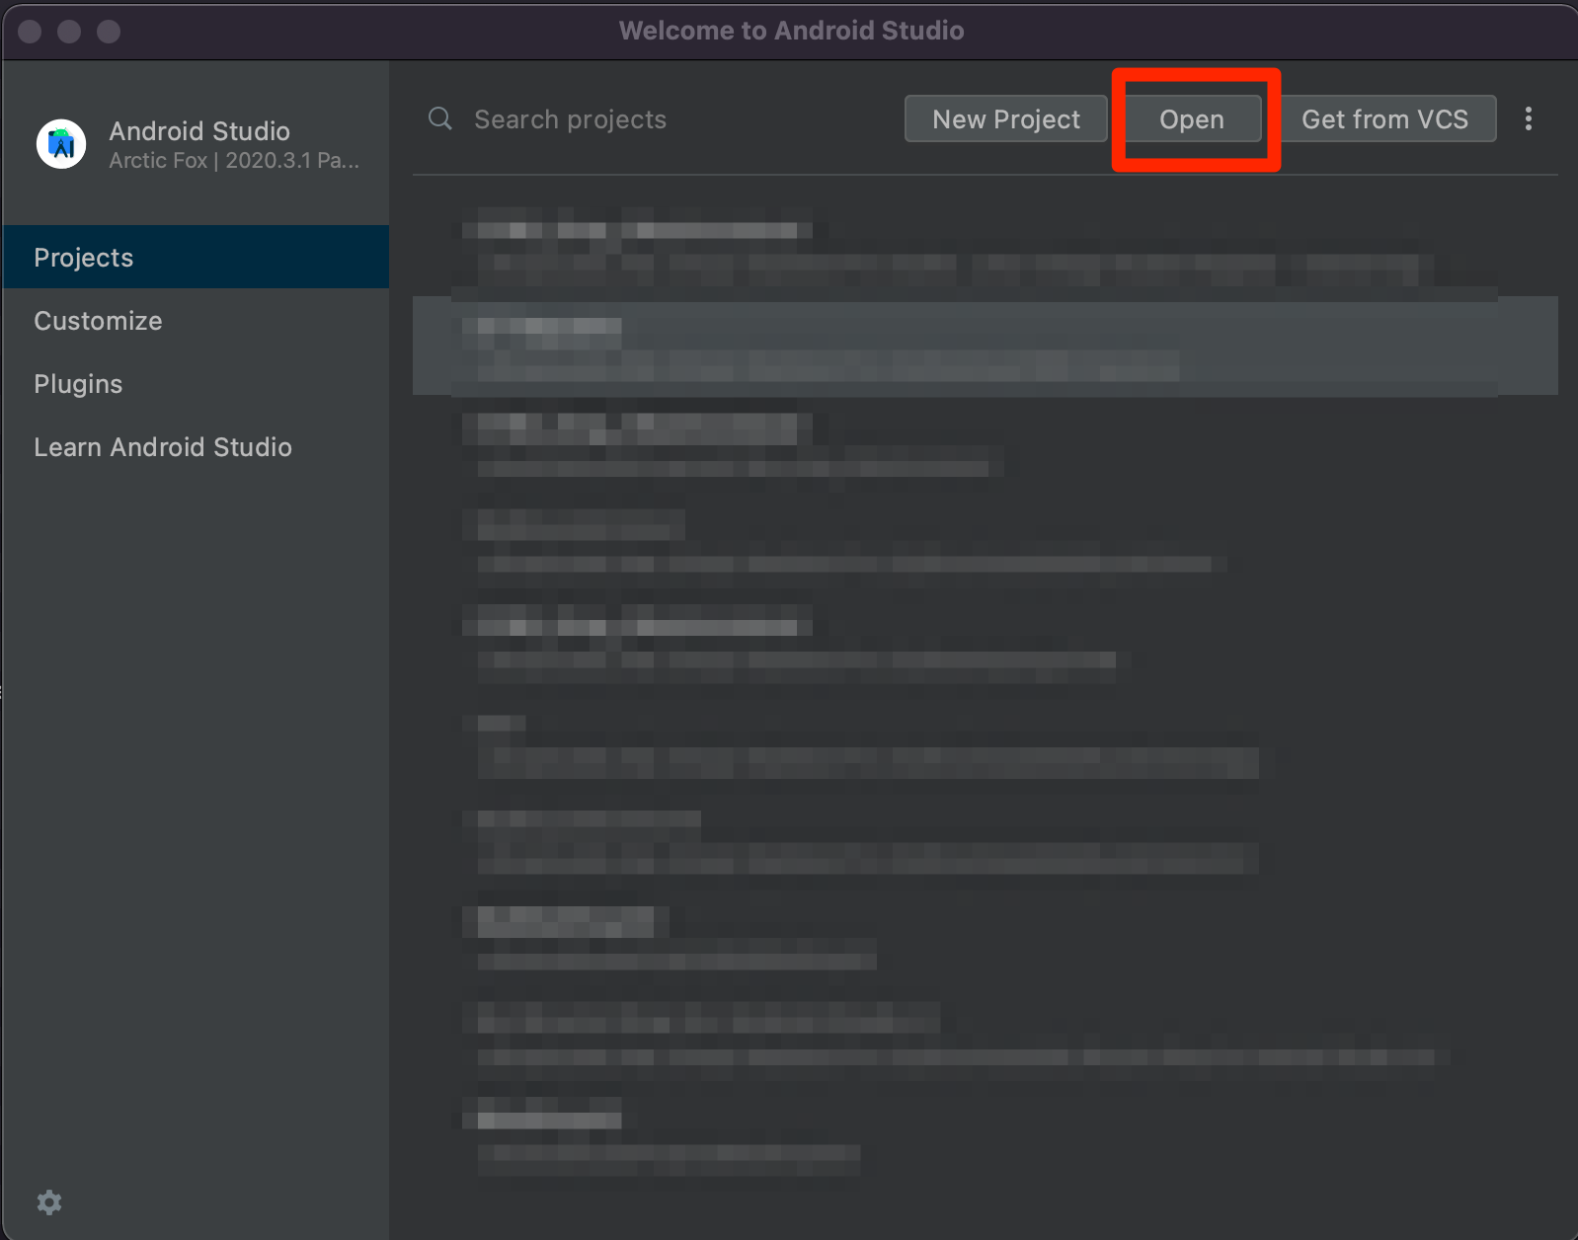

* Navigate to the location of the file where you unzipped your files, select the file, then select open

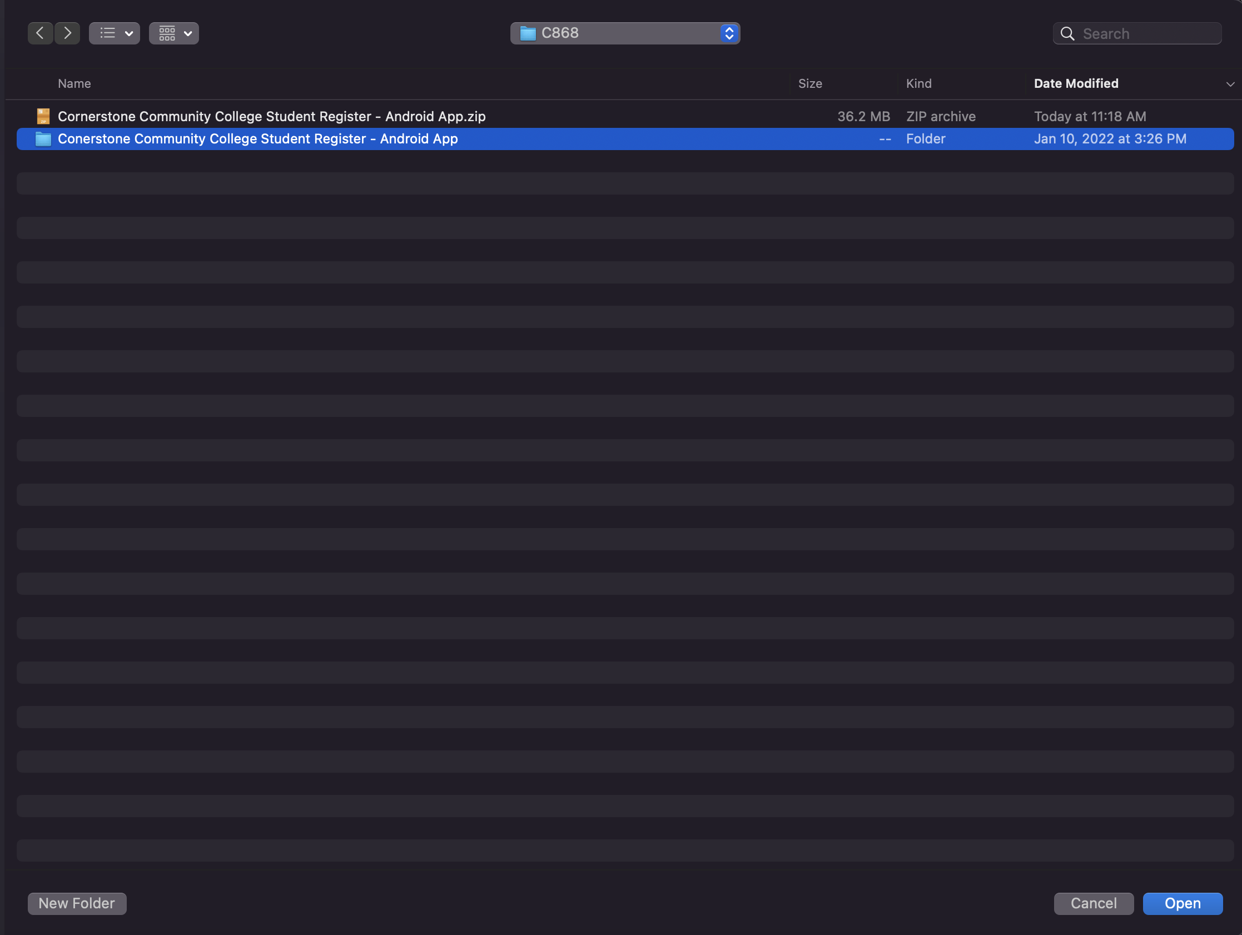

* Once opened, navigate on the left pane of the IDE by expanding the java 🡪 android.reserver.C868_greg_westmoreland.All 🡪UI 🡪 Main 🡪 Main_Activity_Log_In_Page so it will be highlighted in blue

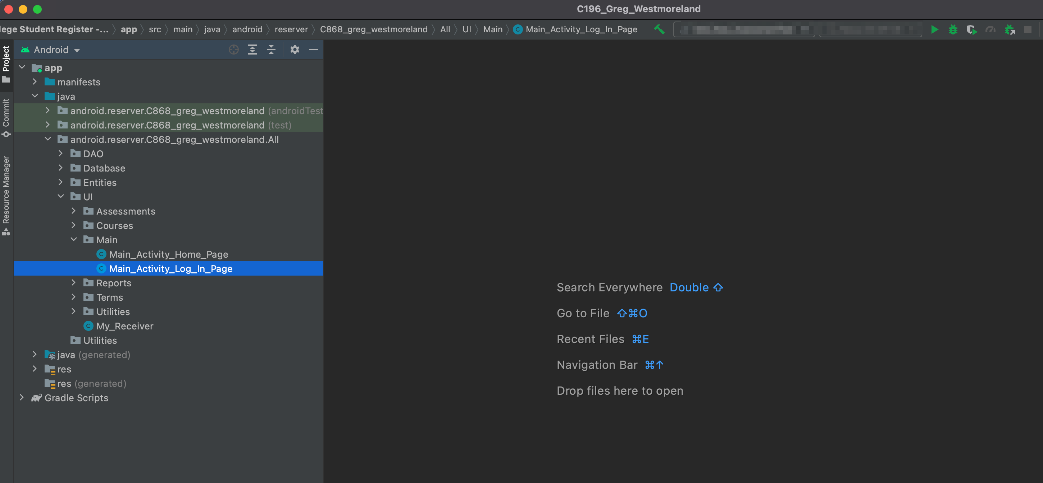

* Begin to set up your emulator.
* Select AVD Manager in the top right corner

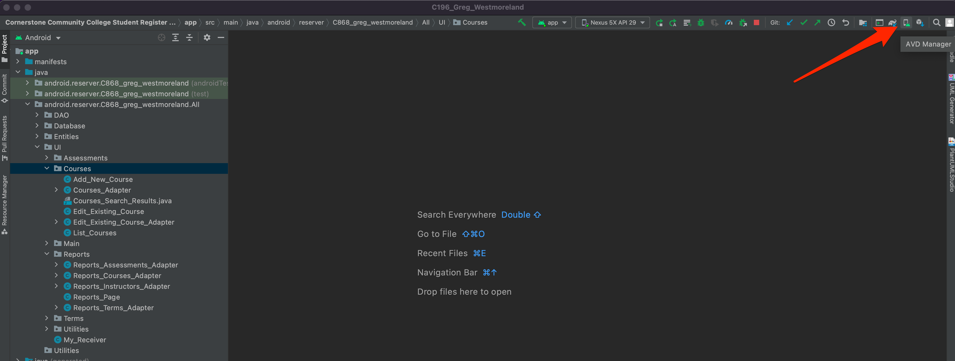

* Select + Create Virtual Device

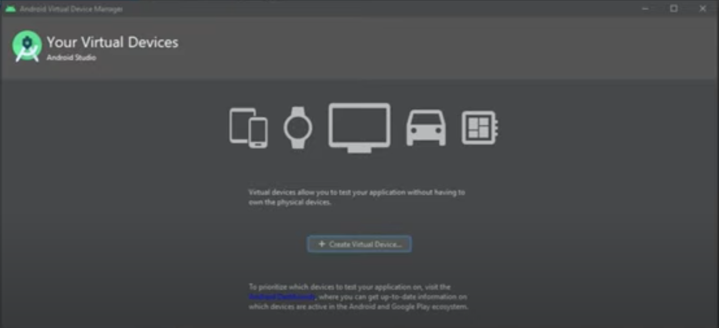

* For category make sure phone is highlighted, from the list scroll down and select Nexus 6 then click Next

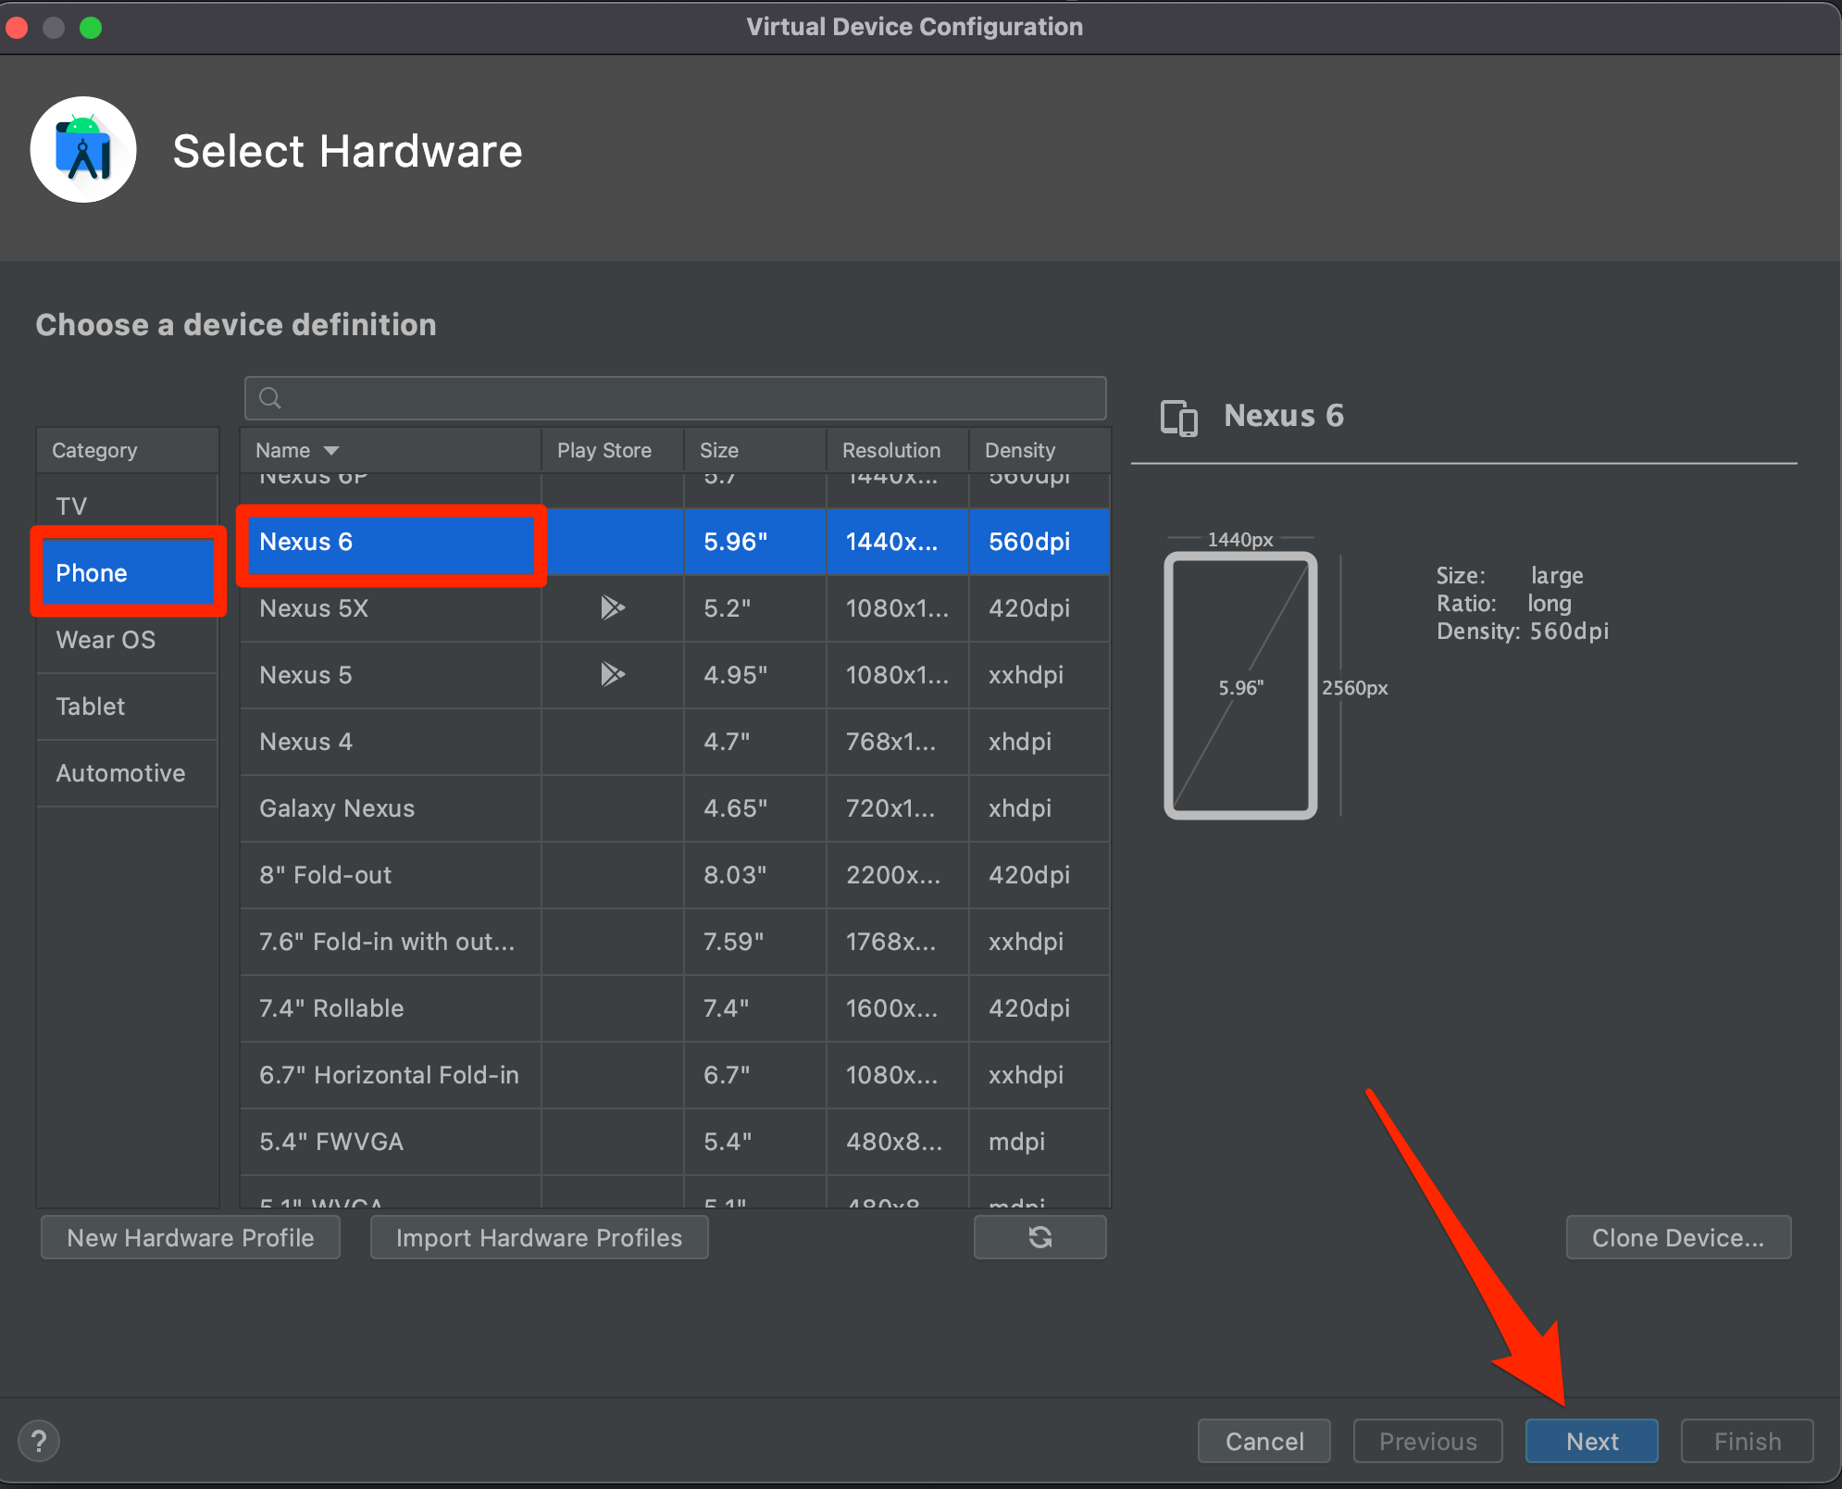

* Select Q API Level 29 then click download

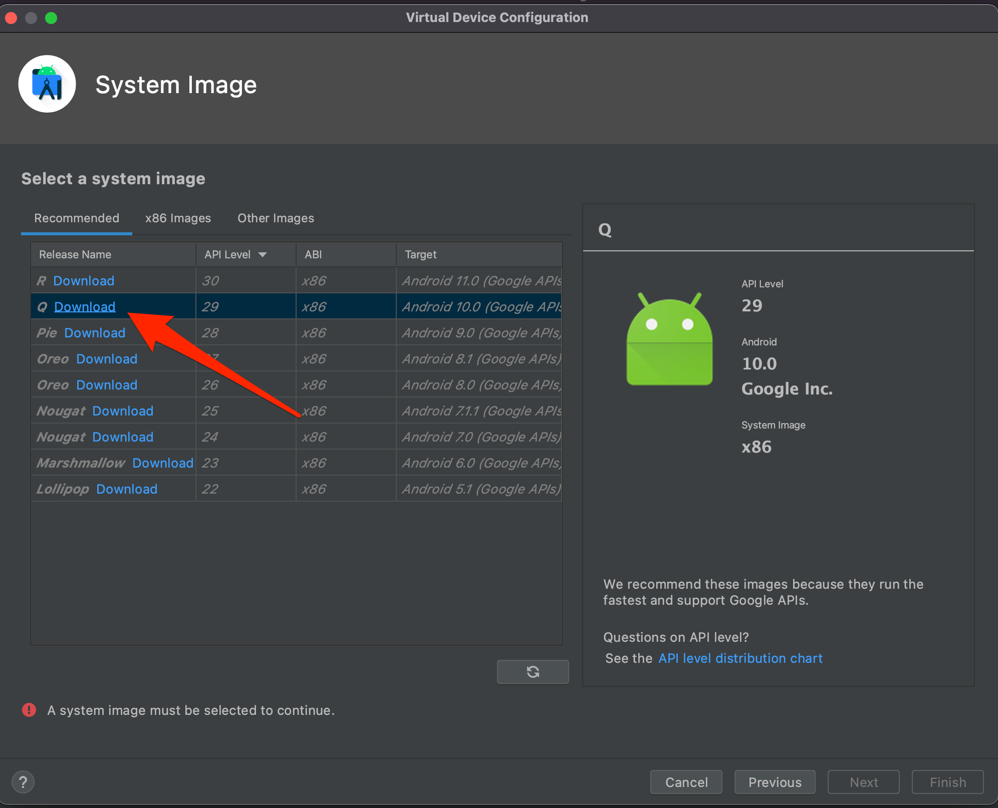

* This will install the component to be used as the Emulator

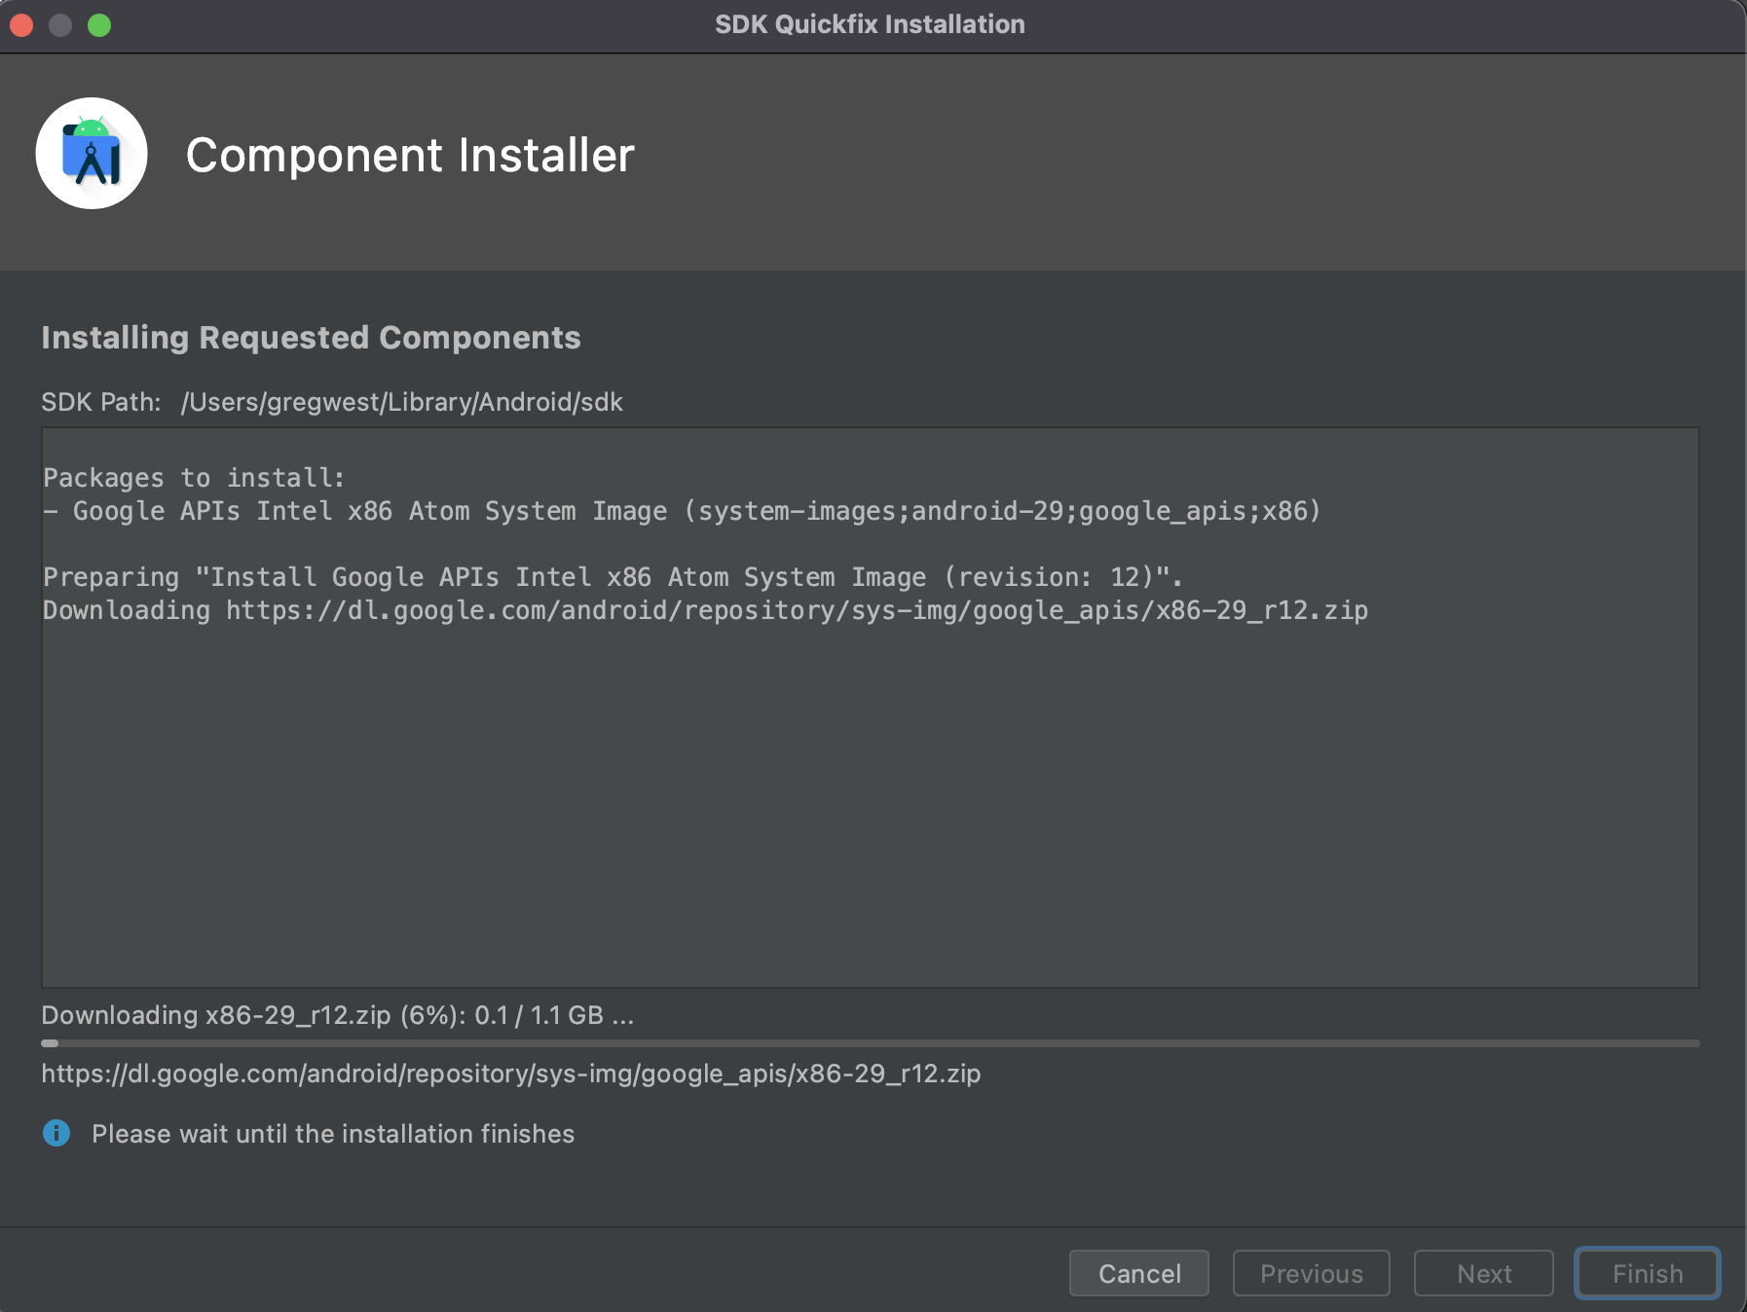

* After it downloads, click the Finish button.

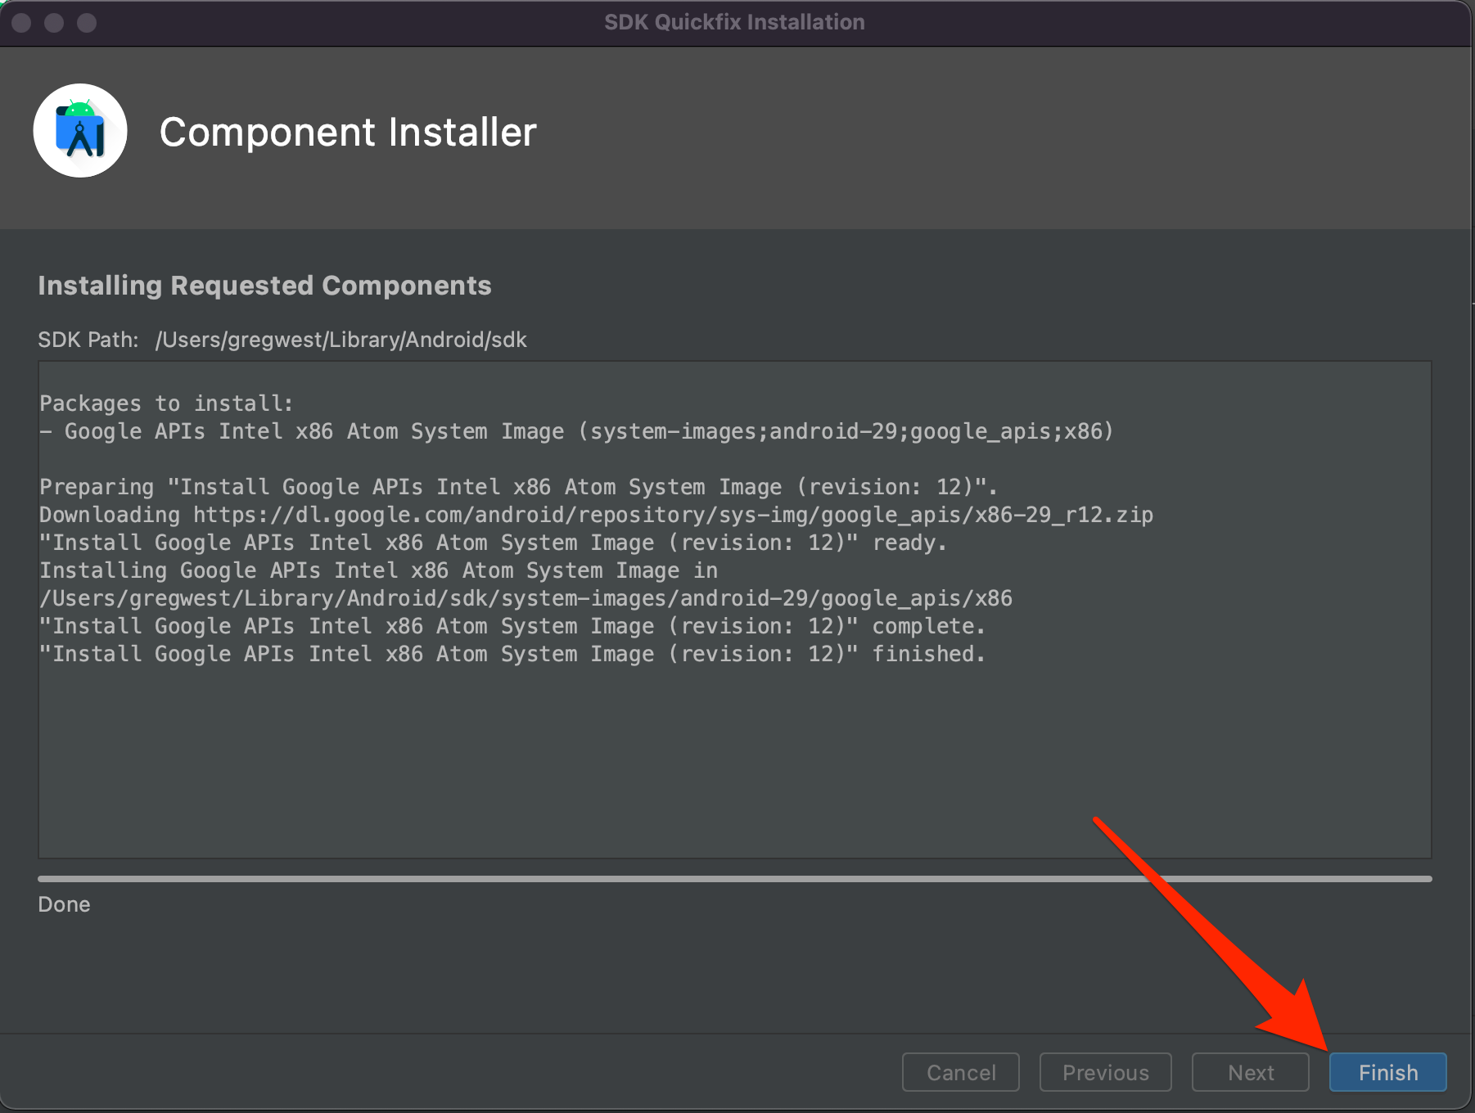

* On the System Image screen, highlight the downloaded API Level System Image you just downloaded, click Next.

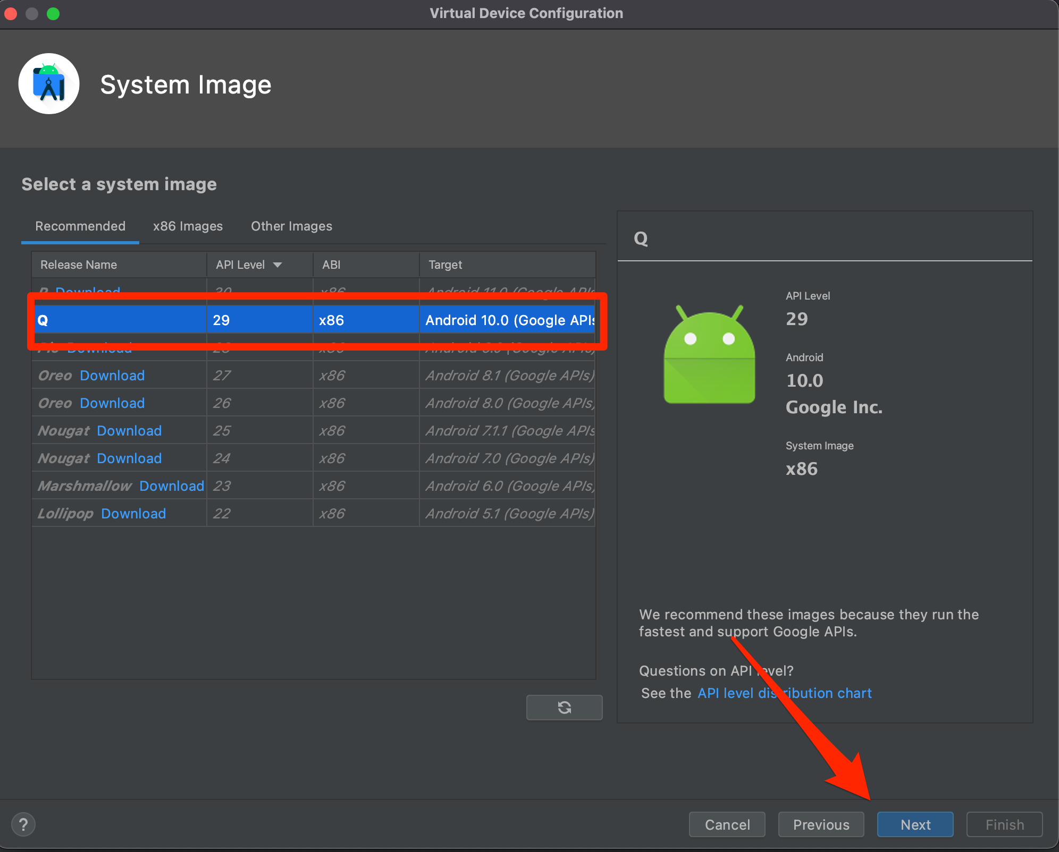

* You can rename the AVD device name or you can keep the default name Nexus 6 API 29. Verify Portrait mode is selected for the Start Up Orientation, then select the Finish button.

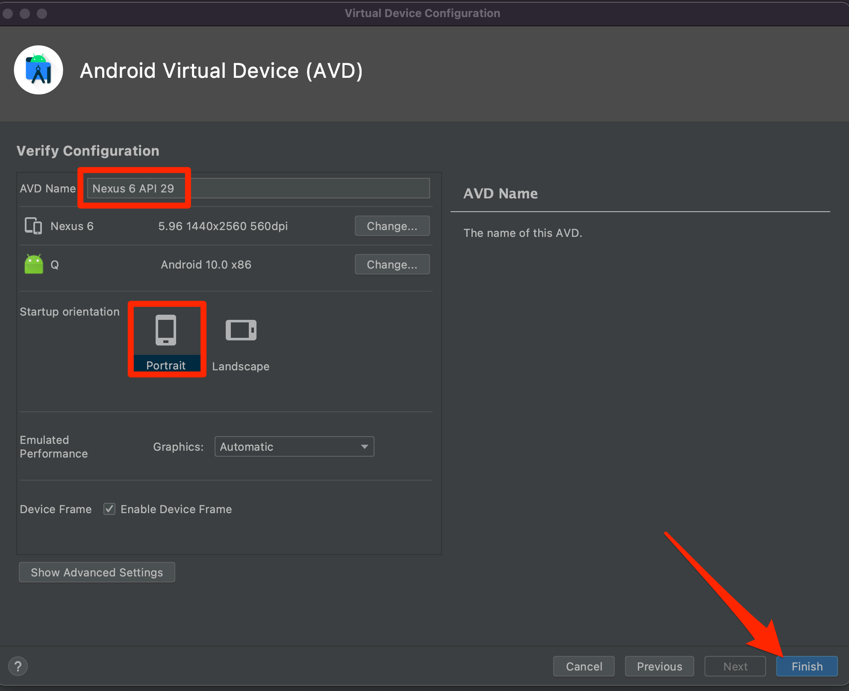

* After verifying the emulator is showing in Your Virtual Devices list, you can click the green Run Arrow under the Actions column to load the Emulator.

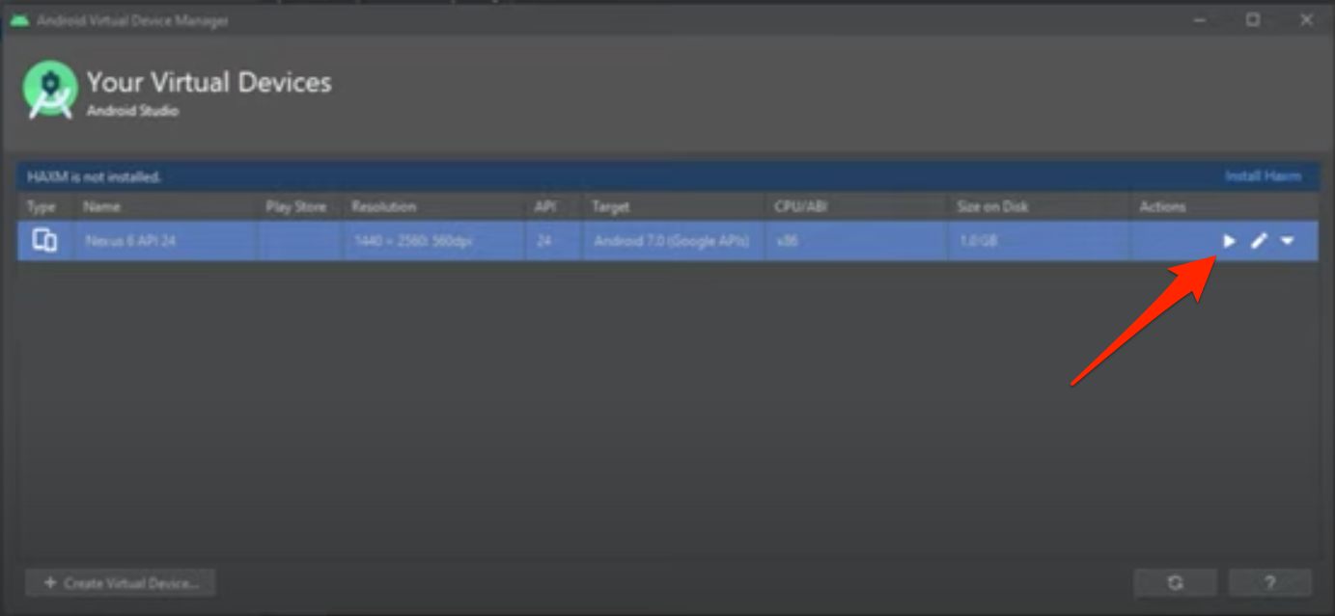

* Your emulator will begin to load

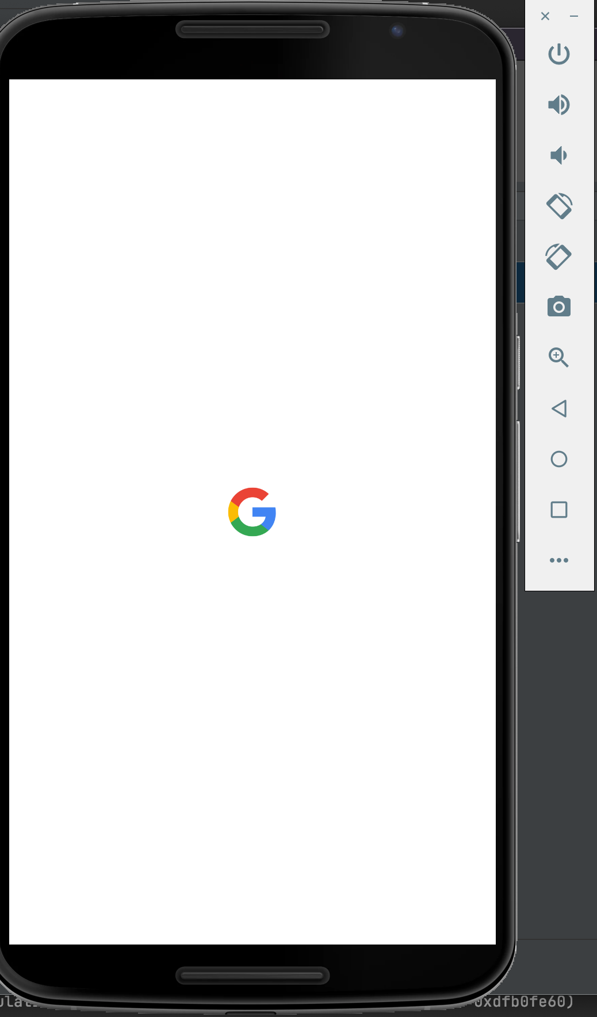

* Once fully running it will look like this:

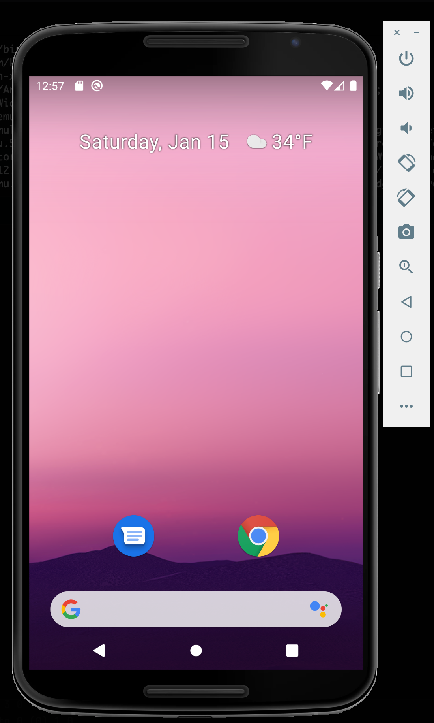

* Return to Android Studio and verify the AVD device is showing.

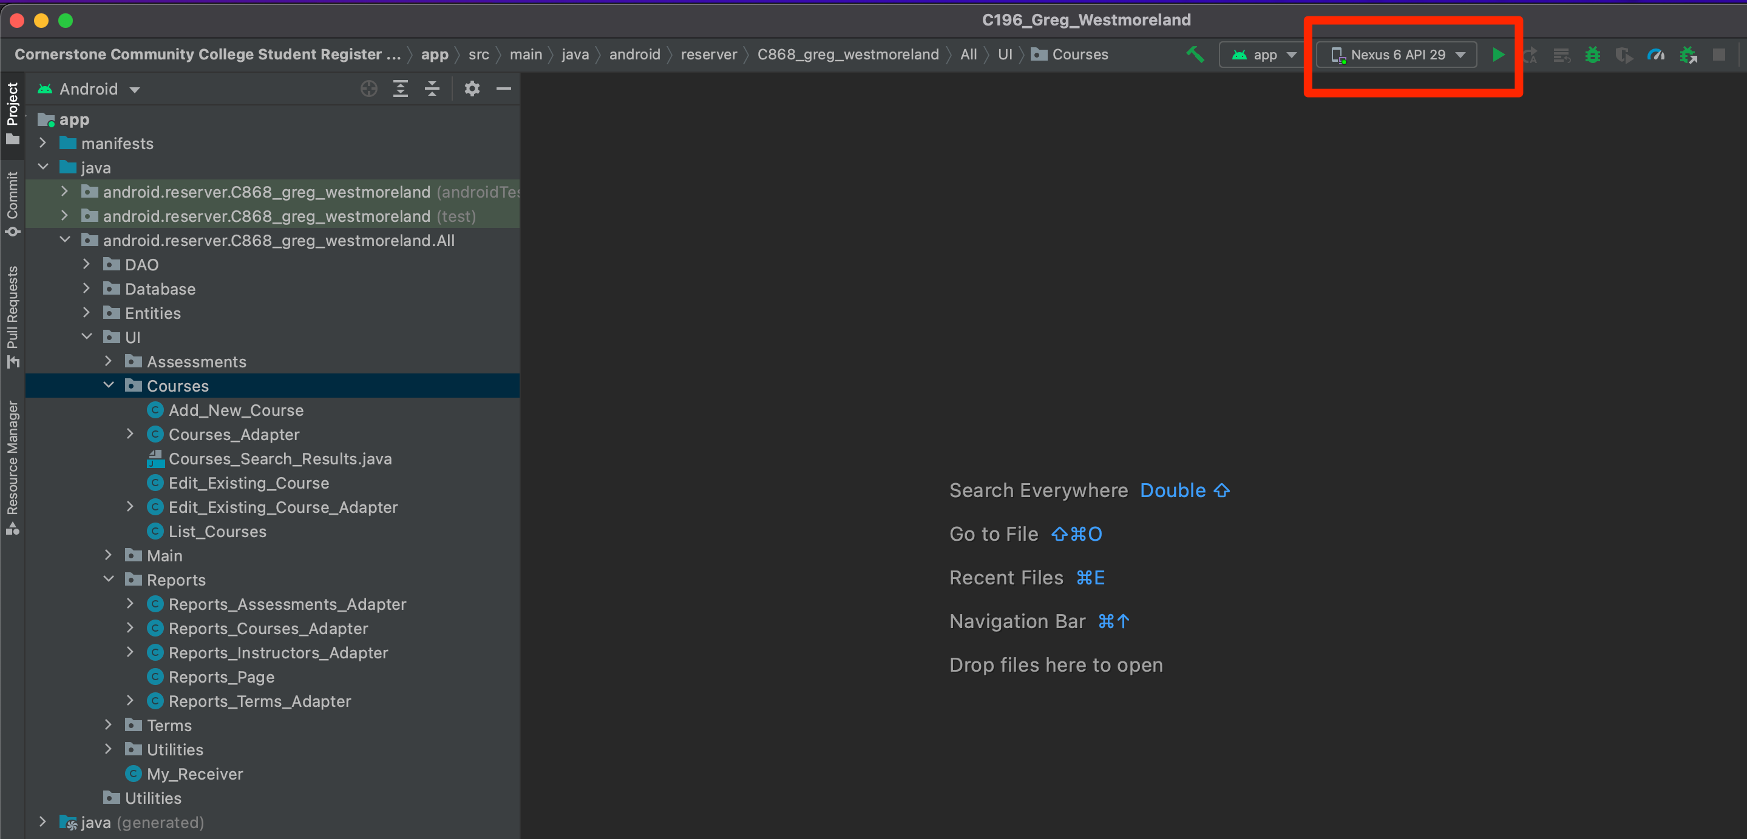

* Select Run from the menu bar, then select Run ‘app’ next to the green arrow

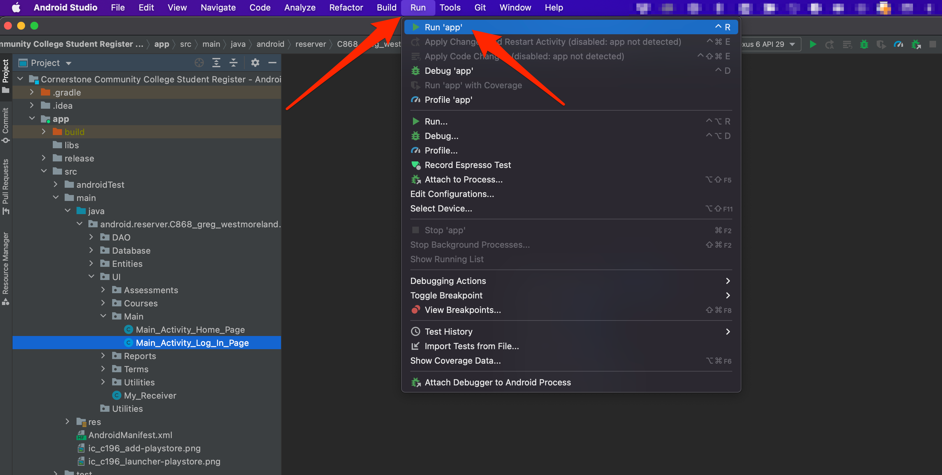

* This will launch the app on your emulator. The first page should look like this:

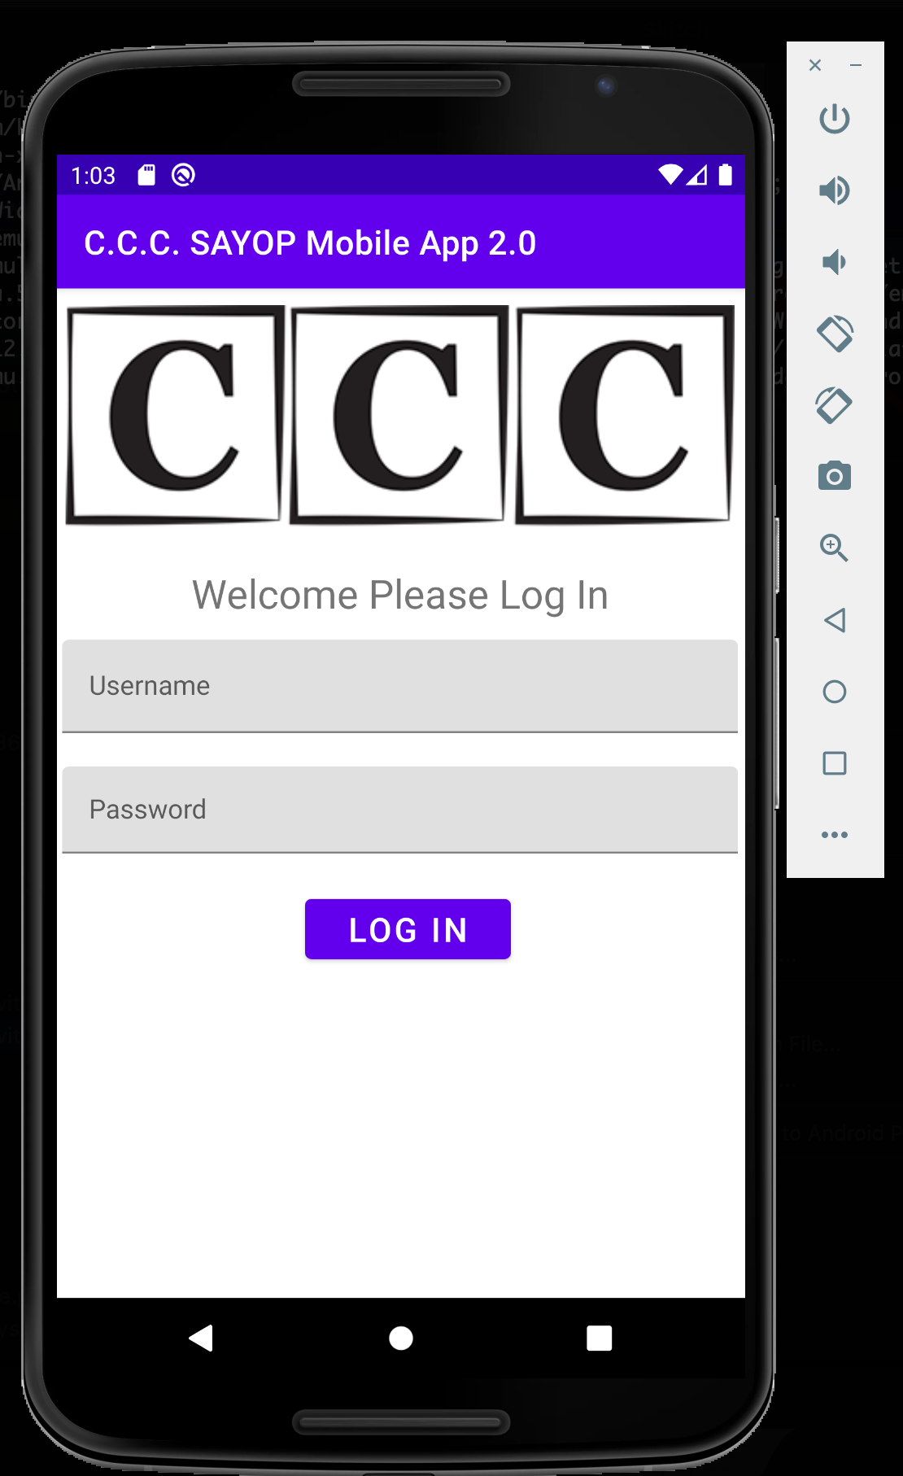

* The bottom of your Android Studio will look like this:

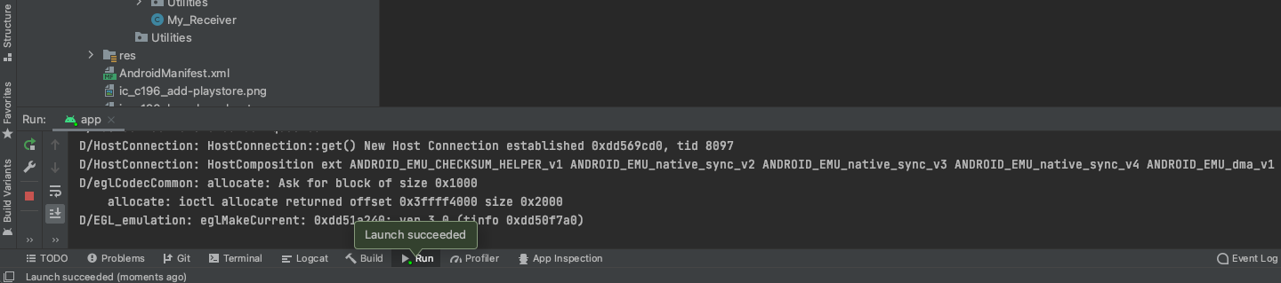

* To stop the mobile app, you can click on the red square at the top of the app. To launch it again you click the green arrow:

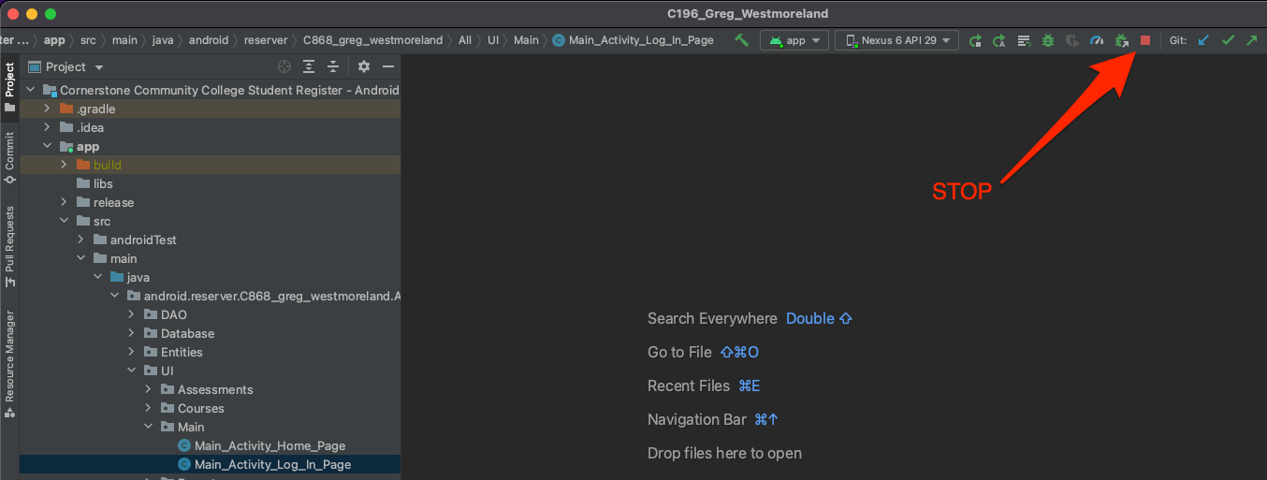

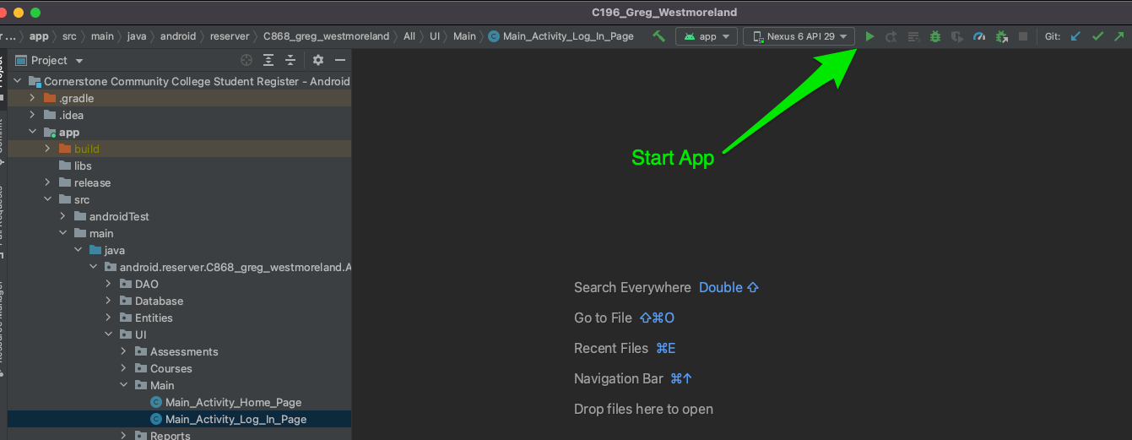

## Login:

1. Enter Username and Password
   1. You can use the following credentials:
      1. Username: student
      2. Password: password
   2. Then click the LOG IN button

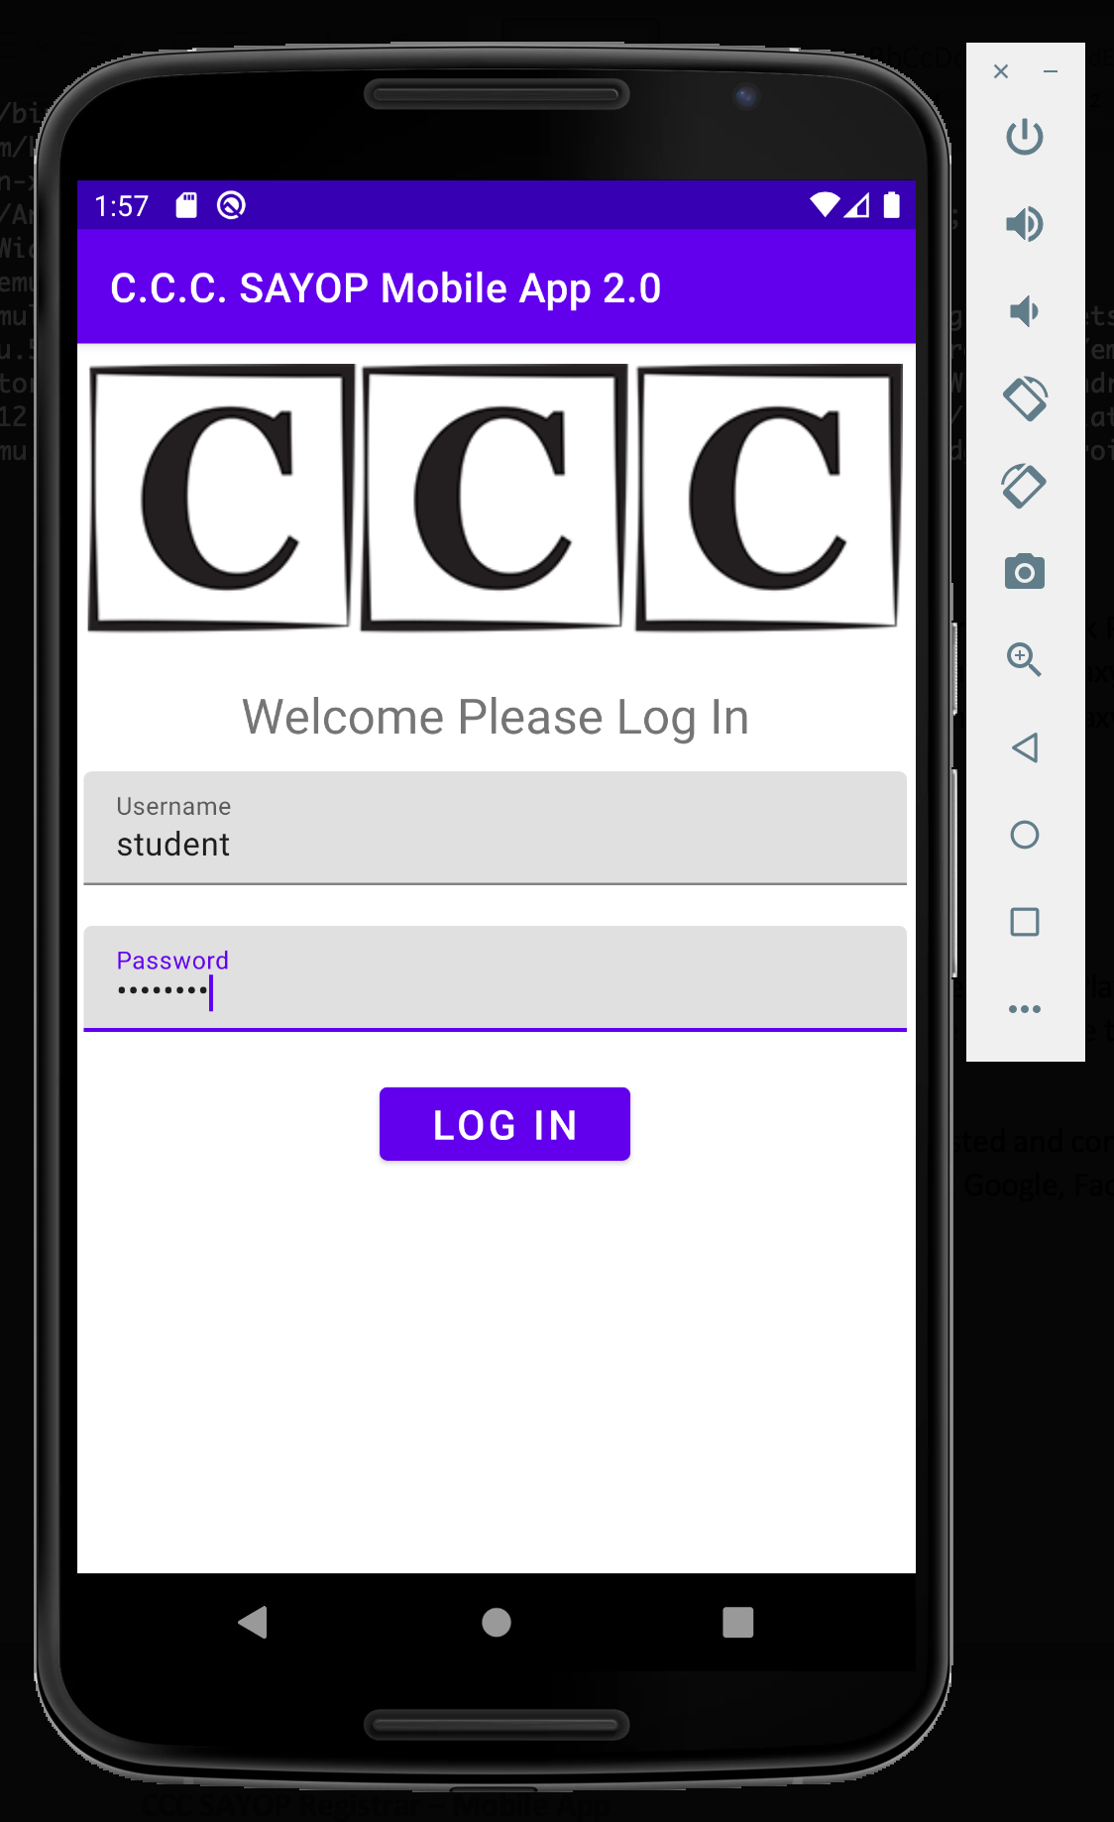

1. After you successfully log in you will see the SAYOP Home Page

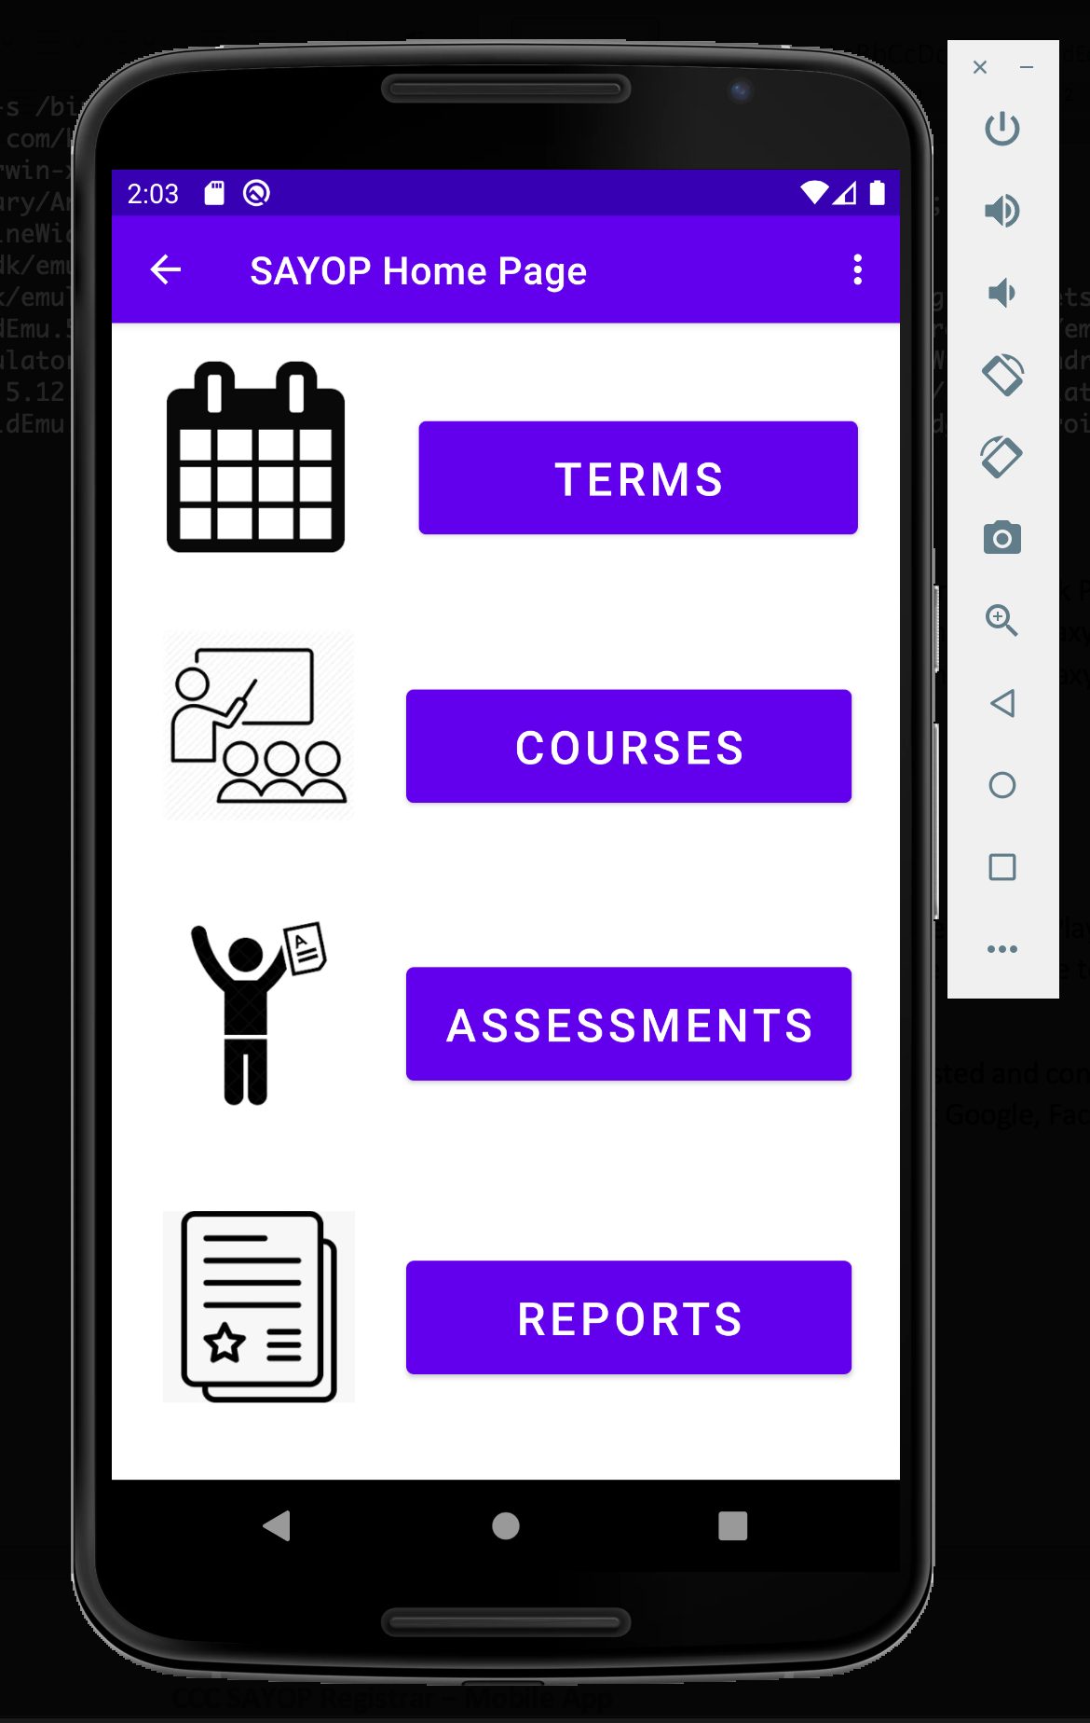

1. If you want to log out, click the three vertical dots  at the top right of the screen and select Log Out

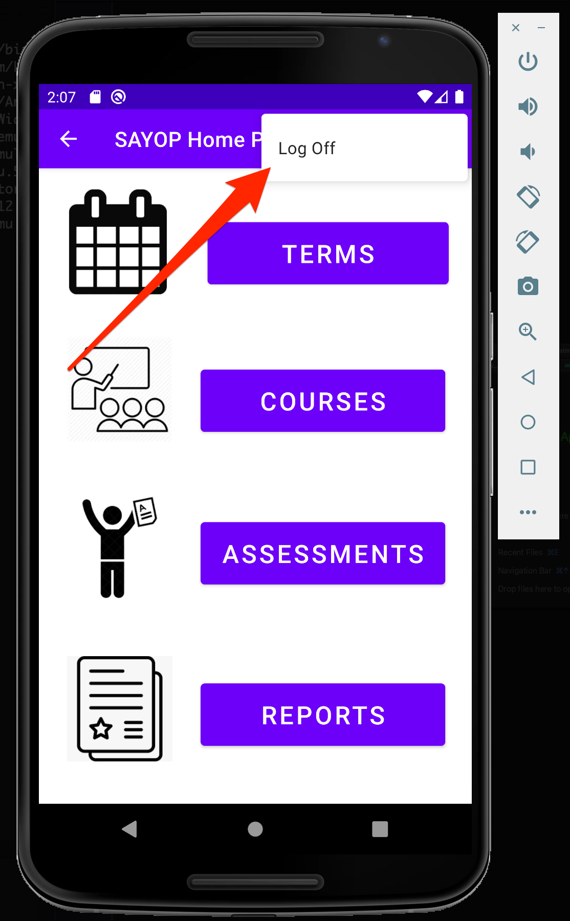

1. This will return you to the log in screen.

## Terms

### See All Terms

1. From the SAYOP Home Page Click the TERMS button.

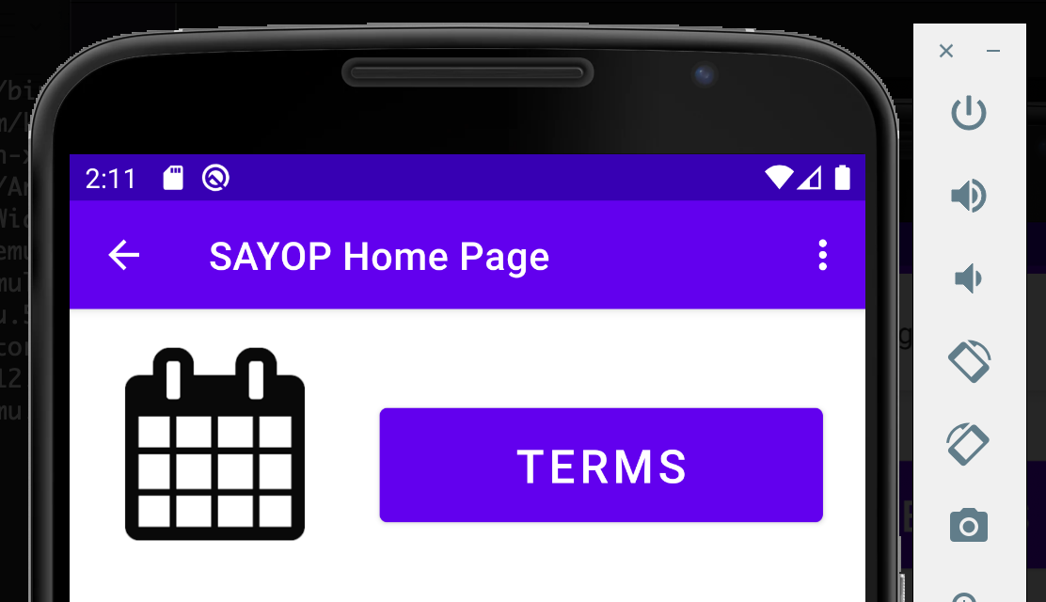

1. This will navigate you to the Terms List Page. Sample data has been loaded into the database showing three terms along with start and end dates of each term.

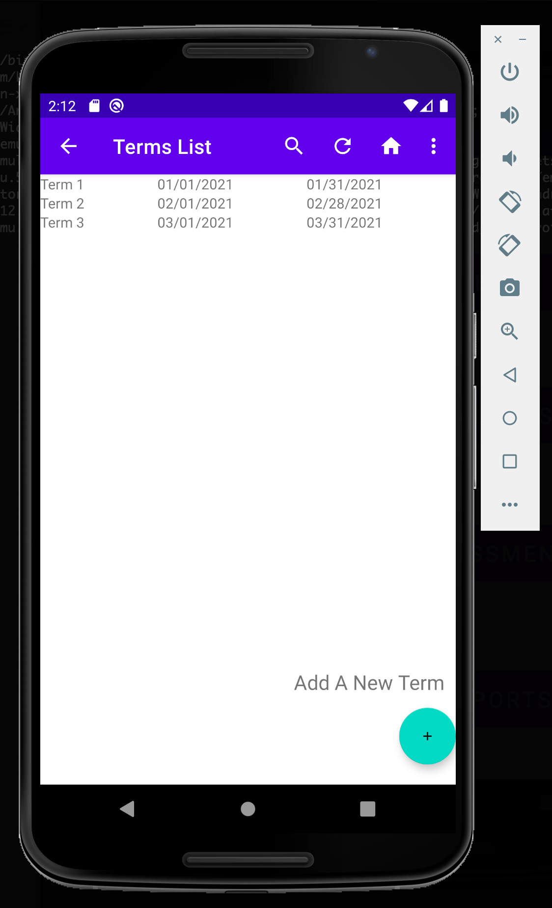

1. You can search by term name, start date, or end date by selecting the magnifying glass  at the top of the navigational bar. To use, begin typing the name of the term. To exit click the X inside the search box.

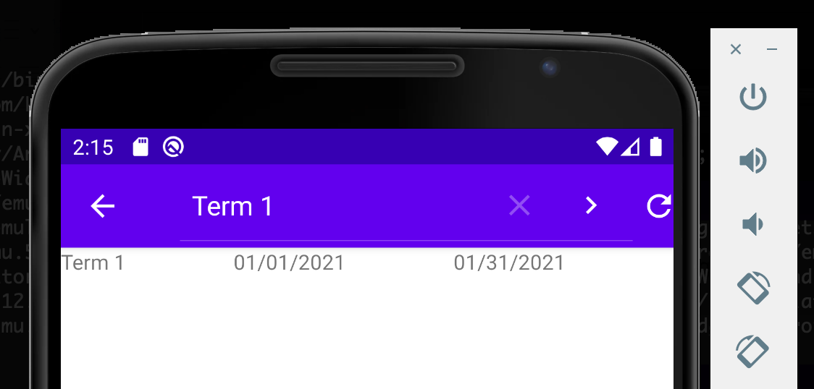

1. To refresh the list of terms, click the refresh icon in the top of the navigational bar 
2. A toast message will appear verifying the terms list has been refreshed:

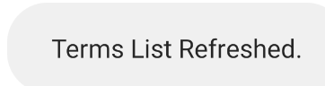

1. To return to the SAYOP Home Page, click the house icon from the top of the navigational bar 
2. By clicking the three vertical dots , you can Add A New Term. The other alternative is clicking the action floating button at the bottom right side Add A New Term

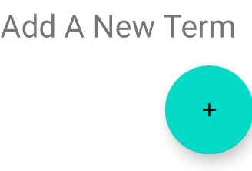

## Add A New Term

1. On the Add New Term page, you can fill in the information for the new term:

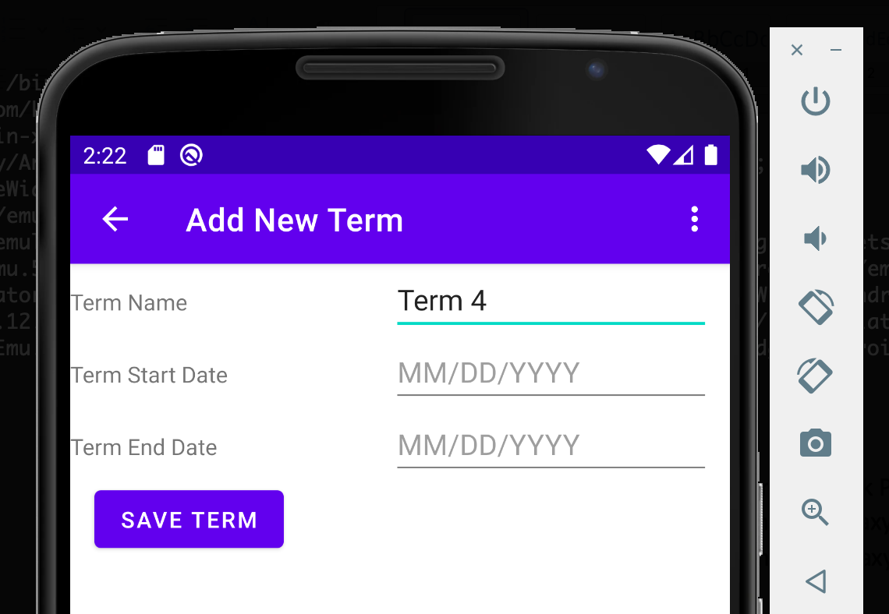

* 1. Term Name
  2. Term Start Date
     1. When selecting the start date, a date picker will open for you to select from.

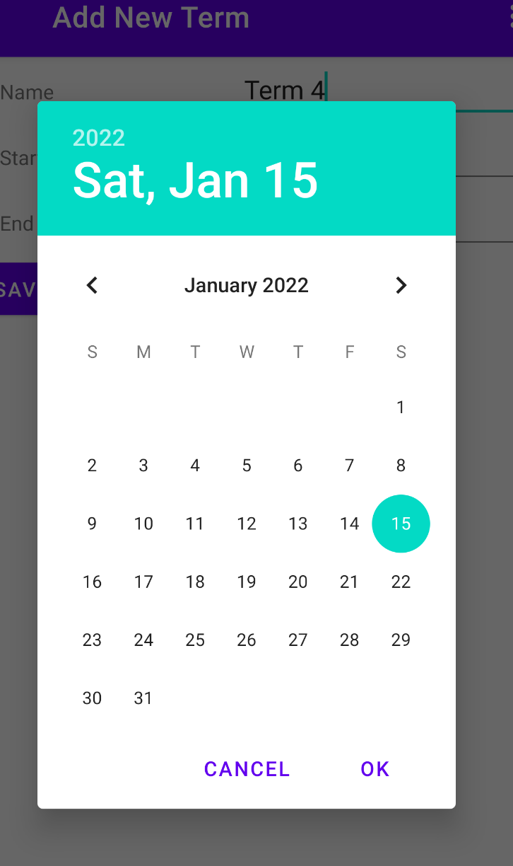

* + 1. Use the Less than Sign  or Greater Than Sign to navigate between months.
    2. Select the start date from the calendar, then press OK to save
    3. Press Cancel to close the box and start again
  1. Term End Date
     1. When selecting the end date, a date picker will open for you to select from
     2. Use the Less than Sign  or Greater Than Sign to navigate between months
     3. Select the end date then from the calendar, then press OK to save
     4. Press Cancel to close the box and start again

1. When you are finished entering your data, select the SAVE TERM button. This will return you to the Terms List Page. You will see the new term you just added.

## Edit Existing Term

1. On the Terms List page, click an existing Term by the name

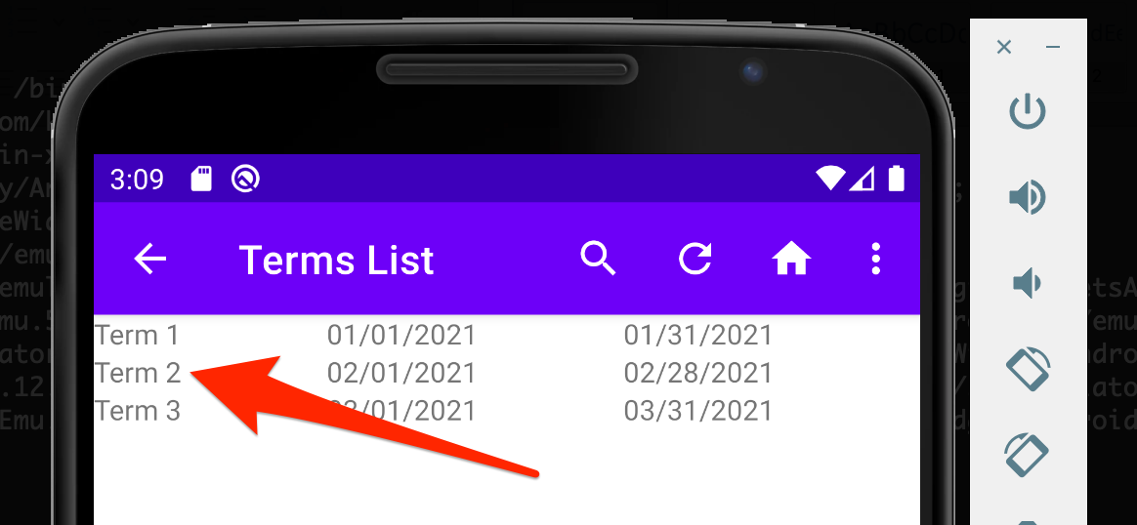

1. This will navigate to the Edit Term page

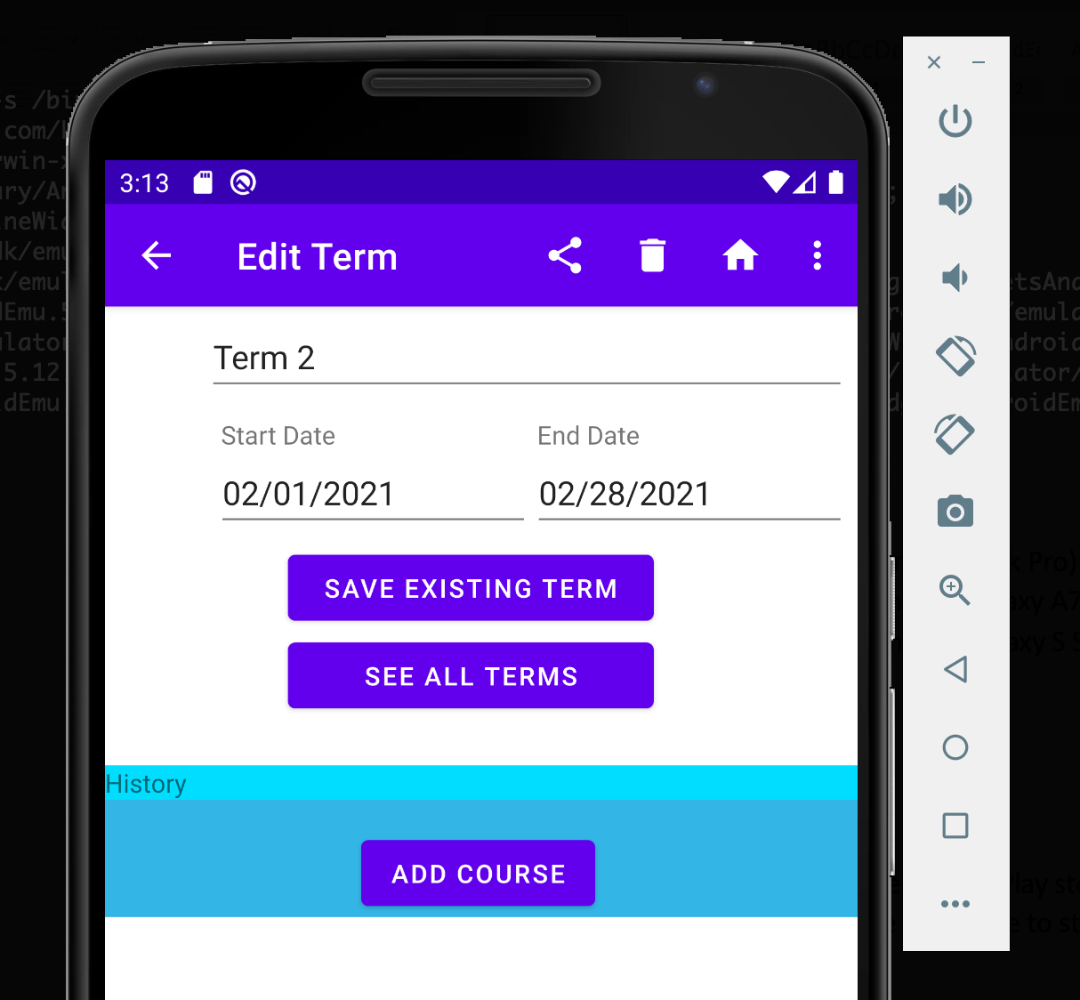

1. You can update the term name, start date, or end date. When you are done editing the term, click the SAVE EXISTING TERM button. This will return you to the Terms List page showing the updated changes.
2. On this page you can share the details about the term by clicking the share icon  in the top navigational bar.
   1. This will share the term name, start date and end date.
   2. Select the sharing mechanism you want to share the information with:

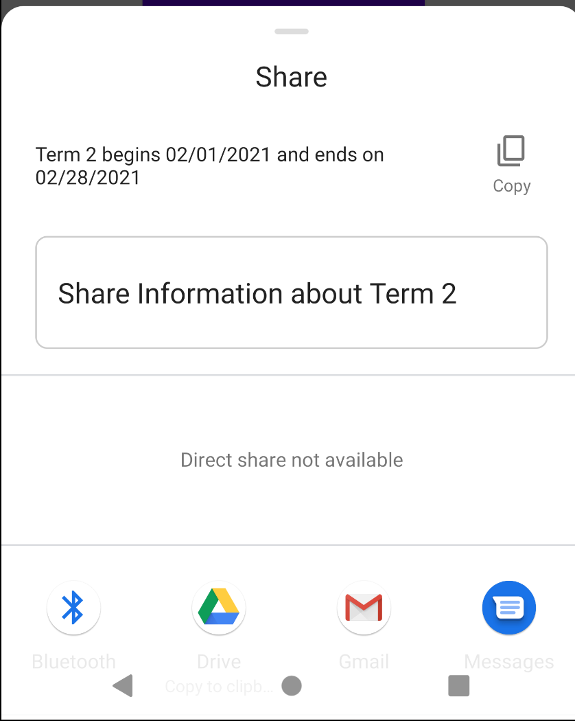

1. Select the Bluetooth Icon  to share it to a Bluetooth Enabled Device
2. Select the Google Drive Icon to create a document on Google Drive
3. Select the Gmail Icon to send an email
4. Select the SMS Icon to send the information via a text
5. You can delete a term by clicking the trash can icon  in the top navigational bar.
   1. **Note:** there can be no associated courses for a term in order to delete the term.

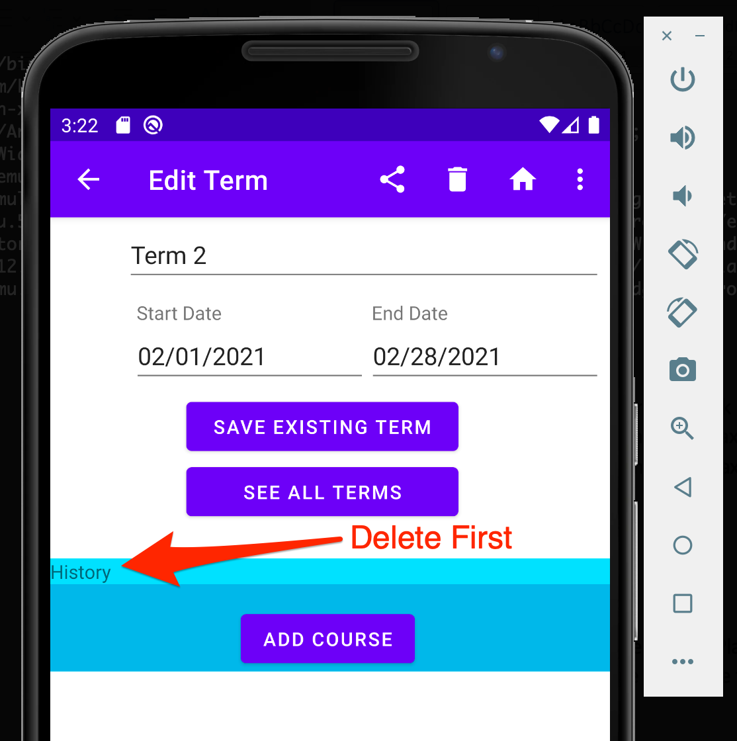

1. You can return to the SAYOP Home Page by clicking the House icon  in the top navigational bar.
2. You can send a notification to your Android device by clicking the three vertical dots icon  in the top navigational bar, then select Notify Term Start or Notify Term End

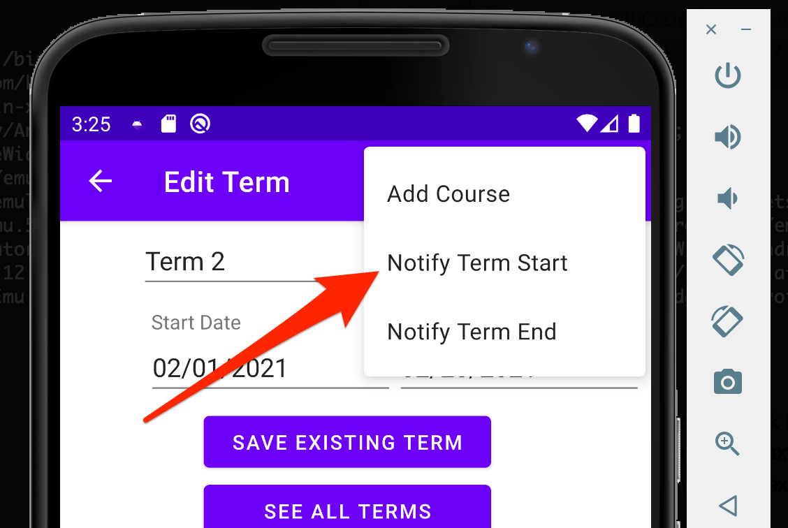

* 1. Notify Term Start will send a notification to the device on the start date for the term
  2. Notify Term End will send a notification to the device on the end date for the term

1. To add a new course to the term, click the three vertical dots  icon in the top navigational bar, then select Add A Course. The other option is to click the Add Course button in the center of the screen.

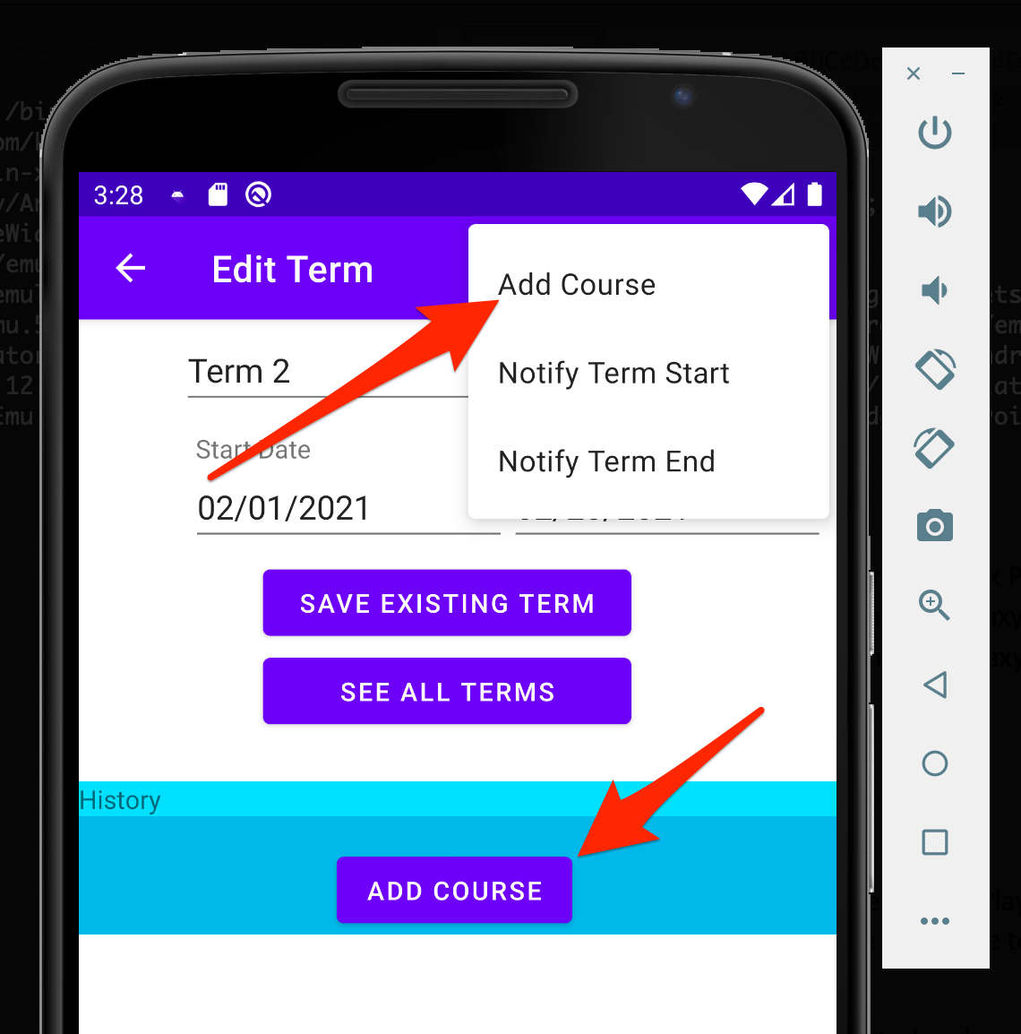

1. To disassociate a course from a term, drag the course from the right side of the screen to the left.

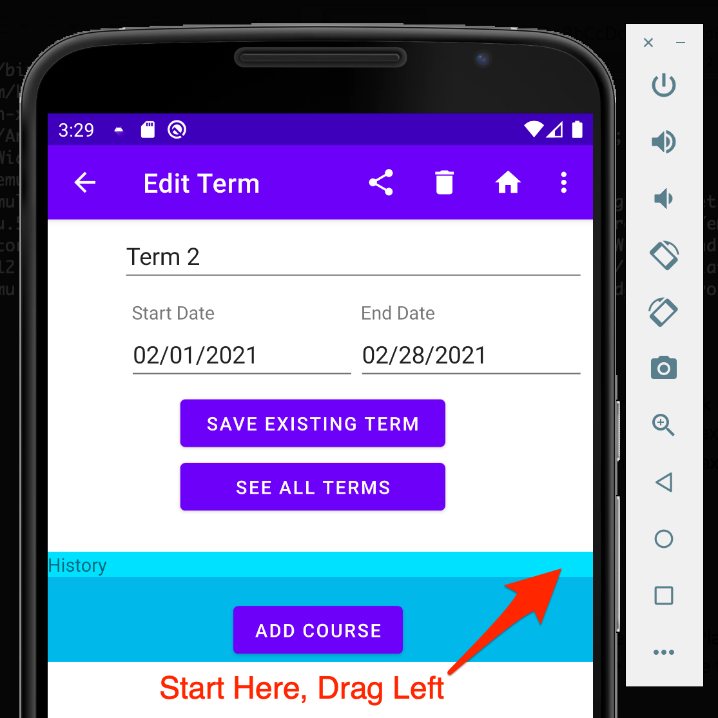

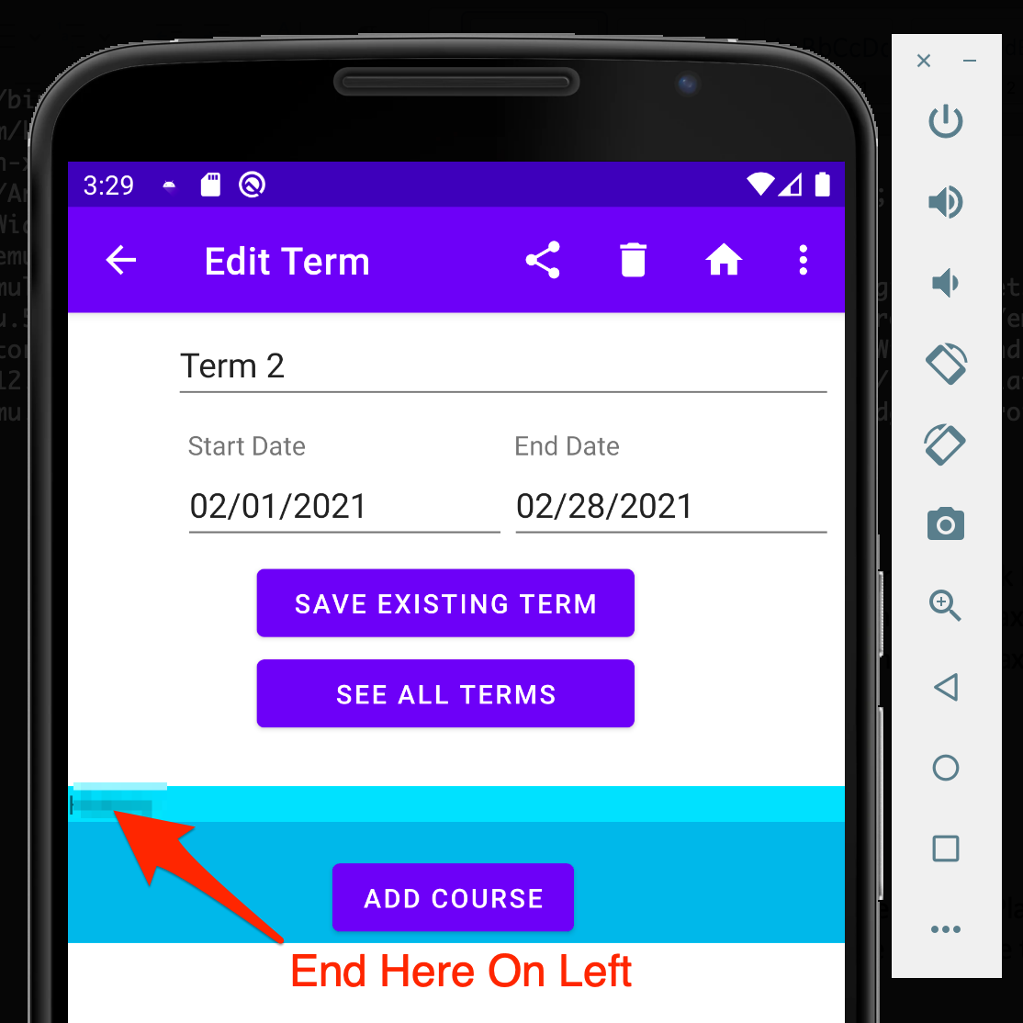

**Courses**

### See All Courses

1. From the SAYOP Home Page Click the COURSES button.



1. This will navigate you to the Courses List Page. Sample data has been loaded into the database showing three courses associated with existing terms.

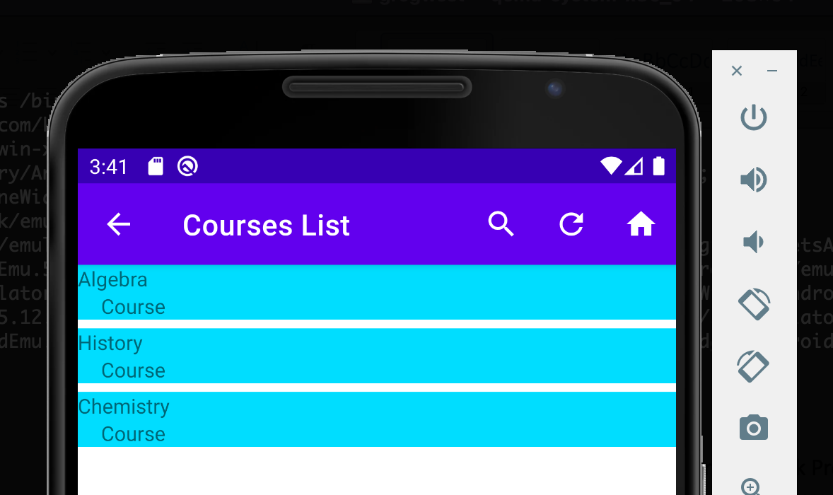

1. You can search for a course name by selecting the magnifying glass  at the top of the navigational bar. Begin typing the name of the course. To exit, click the X inside the search box.

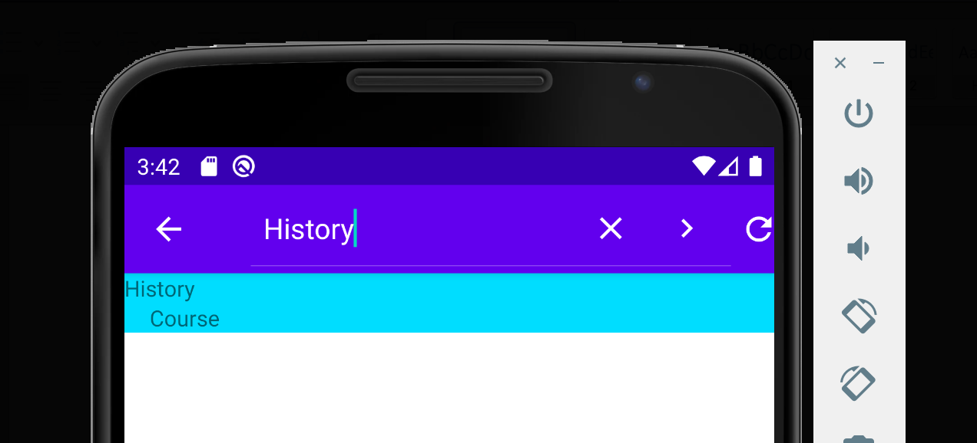

1. To refresh the list of courses, click the refresh icon in the top of the navigational bar 
2. A toast message will appear verifying the courses list has been refreshed:

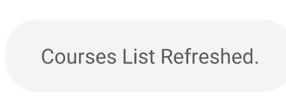

1. To return to the SAYOP Home Page click the house icon from the top of the navigational bar 

## Add A New Course

1. On the Edit Existing Term page, click the three vertical dots  icon in the top navigational bar, then select Add A Course. The other option is to click the Add Course button in the center of the screen.



1. On the Add New Course page you can fill in the information for the new course:

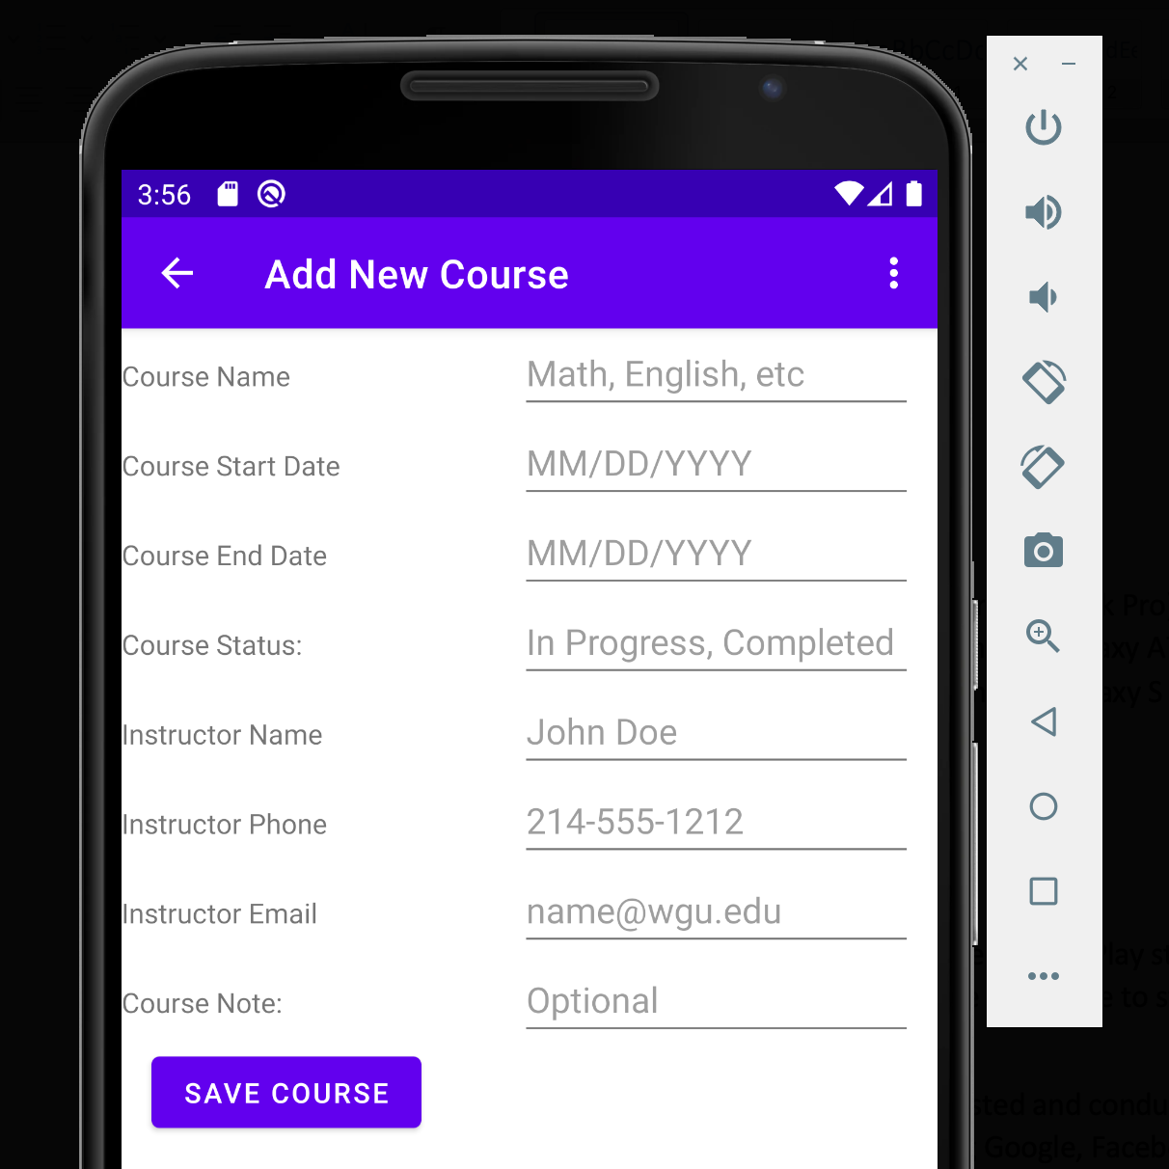

* 1. Course Name
  2. Course Start Date
     1. When selecting the start date, a date picker will open for you to select from.



* + 1. Use the Less than Sign  or Greater Than Sign to navigate between months.
    2. Select the start date from the calendar, then press OK to save
    3. Press Cancel to close the box and start again
  1. Course End Date
     1. When selecting the end date, a date picker will open for you to select from
     2. Use the Less than Sign  or Greater Than Sign to navigate between months
     3. Select the end date then from the calendar, then press OK to save
     4. Press Cancel to close the box and start again
  2. Course Status
  3. Instructor Name
  4. Instructor Phone
  5. Instructor Email
  6. Course Note

1. When you are finished entering your data select the SAVE COURSE button. This will return you to the Edit Term page. From here you will see the new course you just added to the associated term.

## Edit Existing Course

1. On the Course List page, click an existing Course by the name

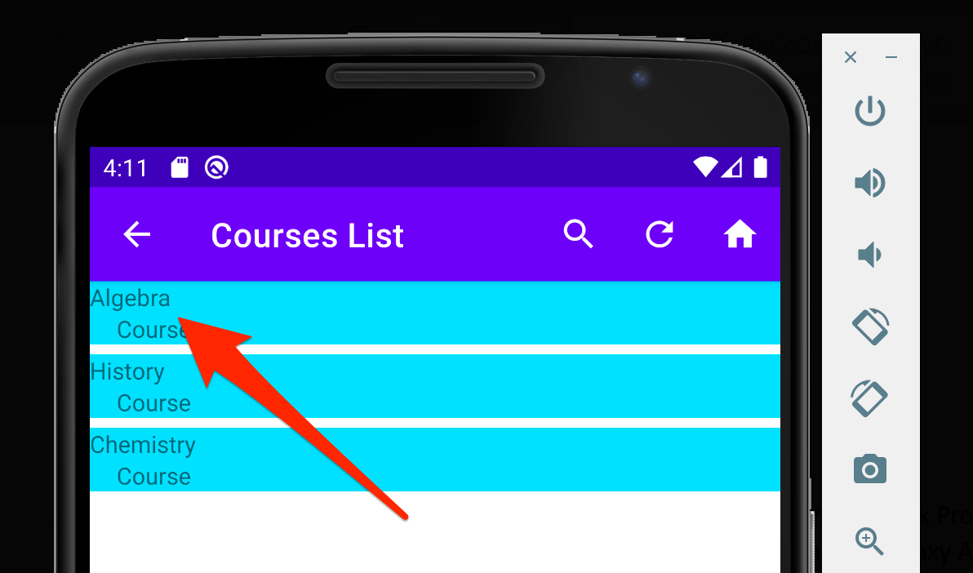

1. This will navigate you to the Edit Course page

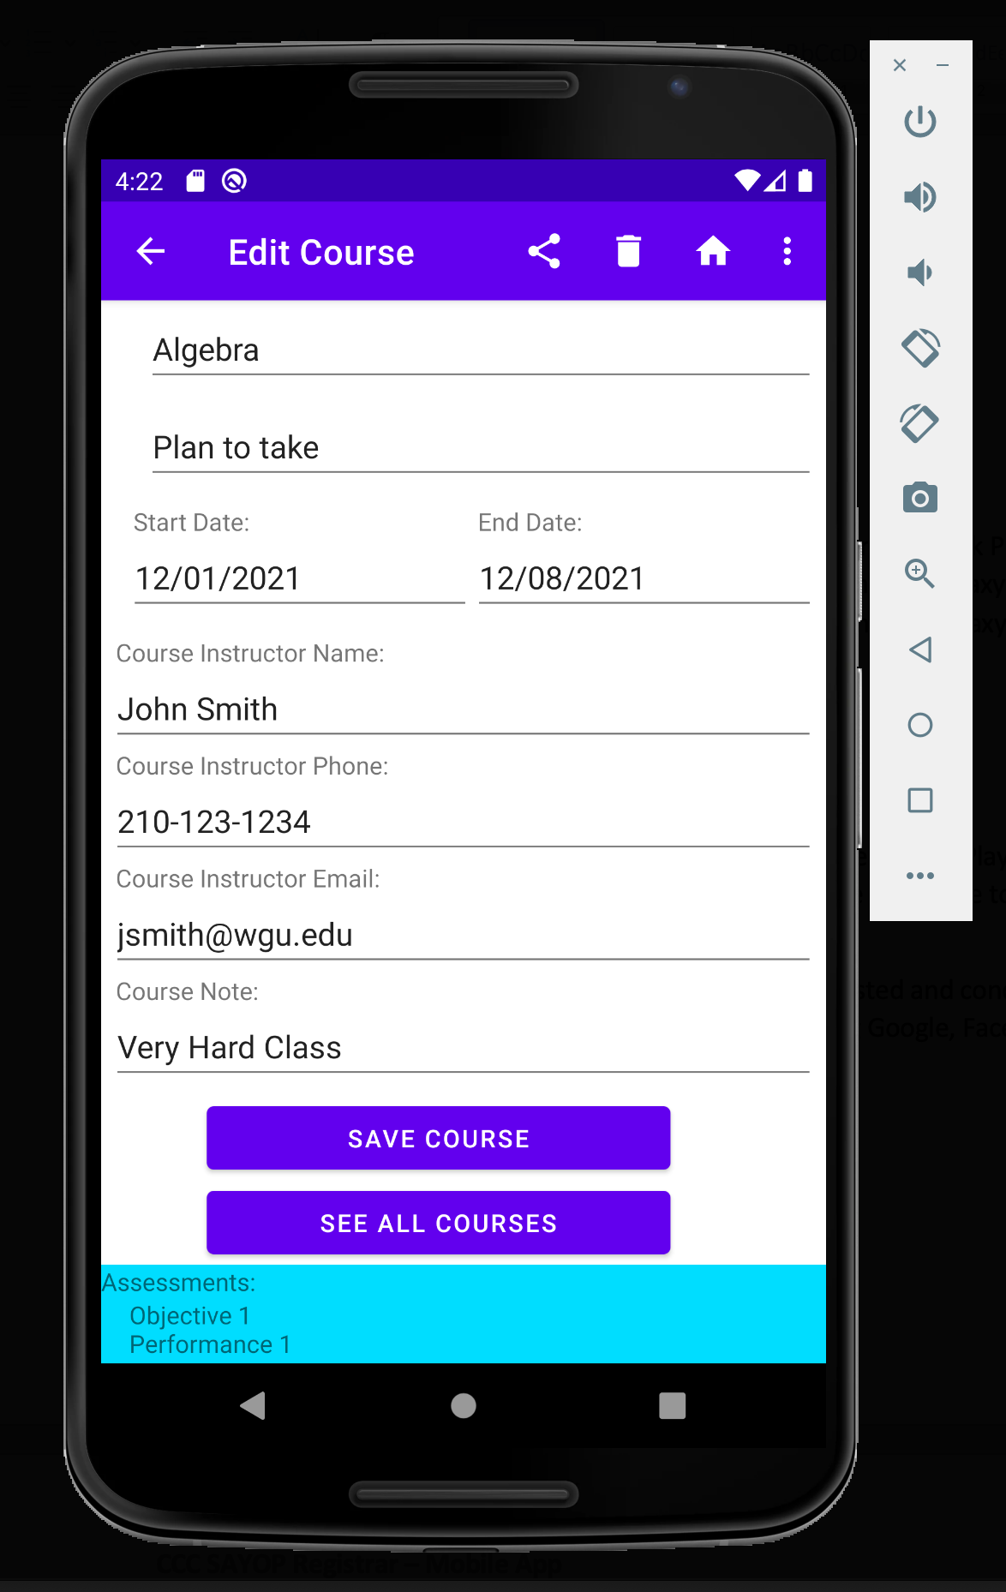

1. You can update the course name, status, start date, end date, instructor name, instructor phone, instructor email, and note. When you are done editing the course, click the SAVE COURSE button which will return you to the Course List page showing your updated changes.
2. On this page you can share the details about the course by clicking the share icon  in the top navigational bar.
   1. This will share the course name, start date, end date, and note.
   2. Select the sharing mechanism you want to share the information with:

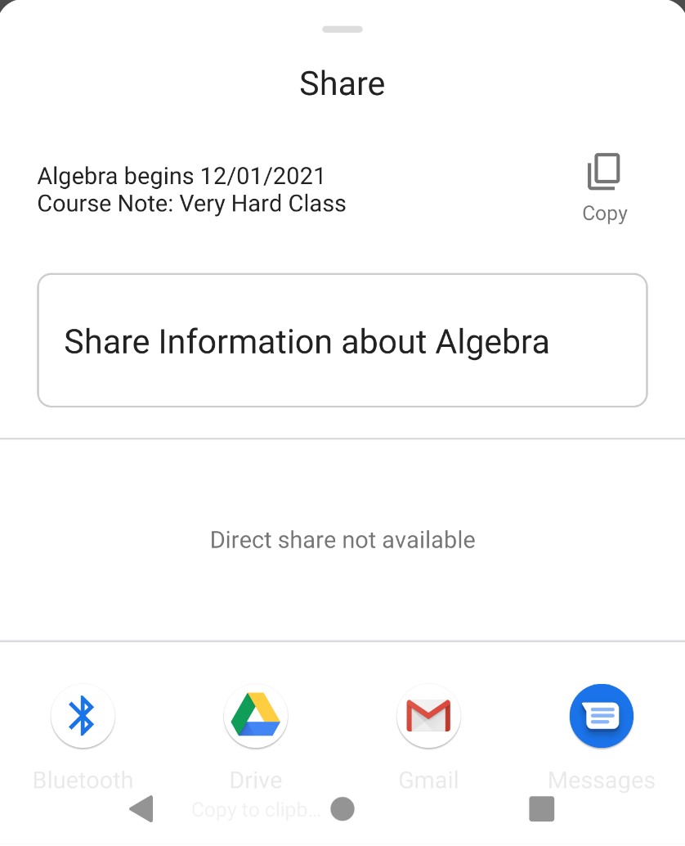

1. Select the Bluetooth Icon  to share it to a Bluetooth Enabled Device
2. Select the Google Drive Icon to create a document on Google Drive
3. Select the Gmail Icon to send an email
4. Select the SMS Icon to send the information via a text
5. You can delete a course by clicking the trash can icon  in the top navigational bar.
   1. **Note:** there can be no associated assessments for a course in order to delete the course.

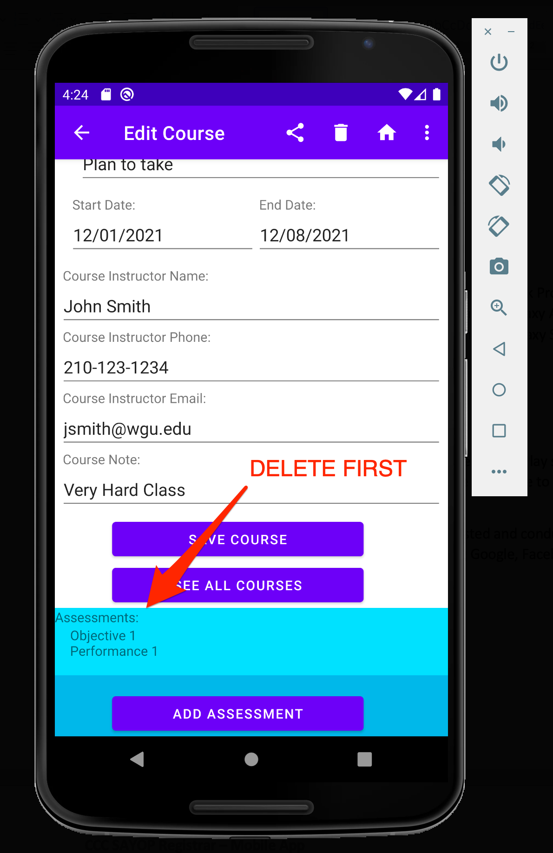

1. You can return to the SAYOP Home Page by clicking the House icon  in the top navigational bar.
2. You can send a notification to your Android device by clicking the three vertical dots icon  in the top navigational bar, then select Notify Course Start or Notify Course End

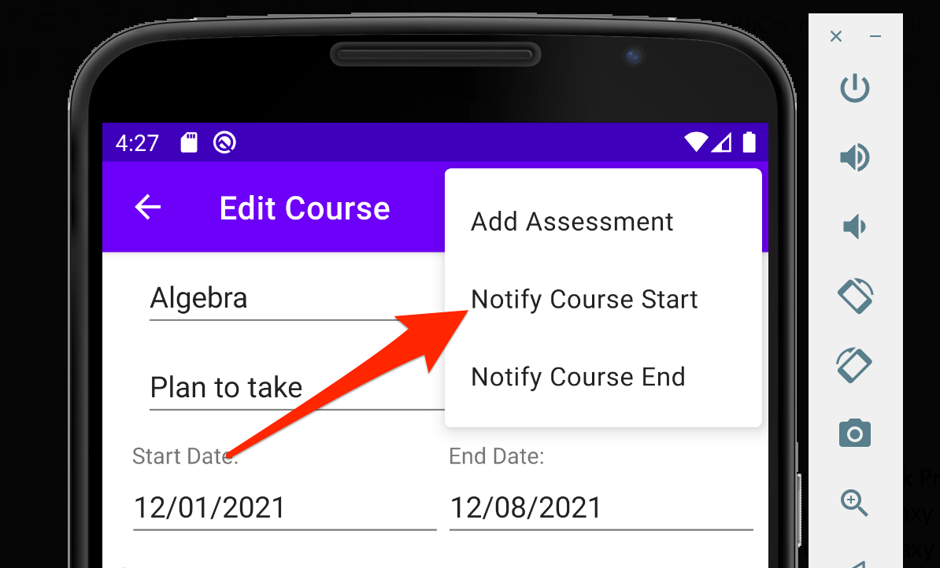

* 1. Notify Course Start will send a notification to the device on the start date for the course
  2. Notify Course End will send a notification to the device on the end date for the course

1. To add a new assessment to the course, click the three vertical dots  icon in the top navigational bar, then select Add Assessment. The other option is to click the Add Assessment button at the bottom of the screen (you will need to scroll up to see this).

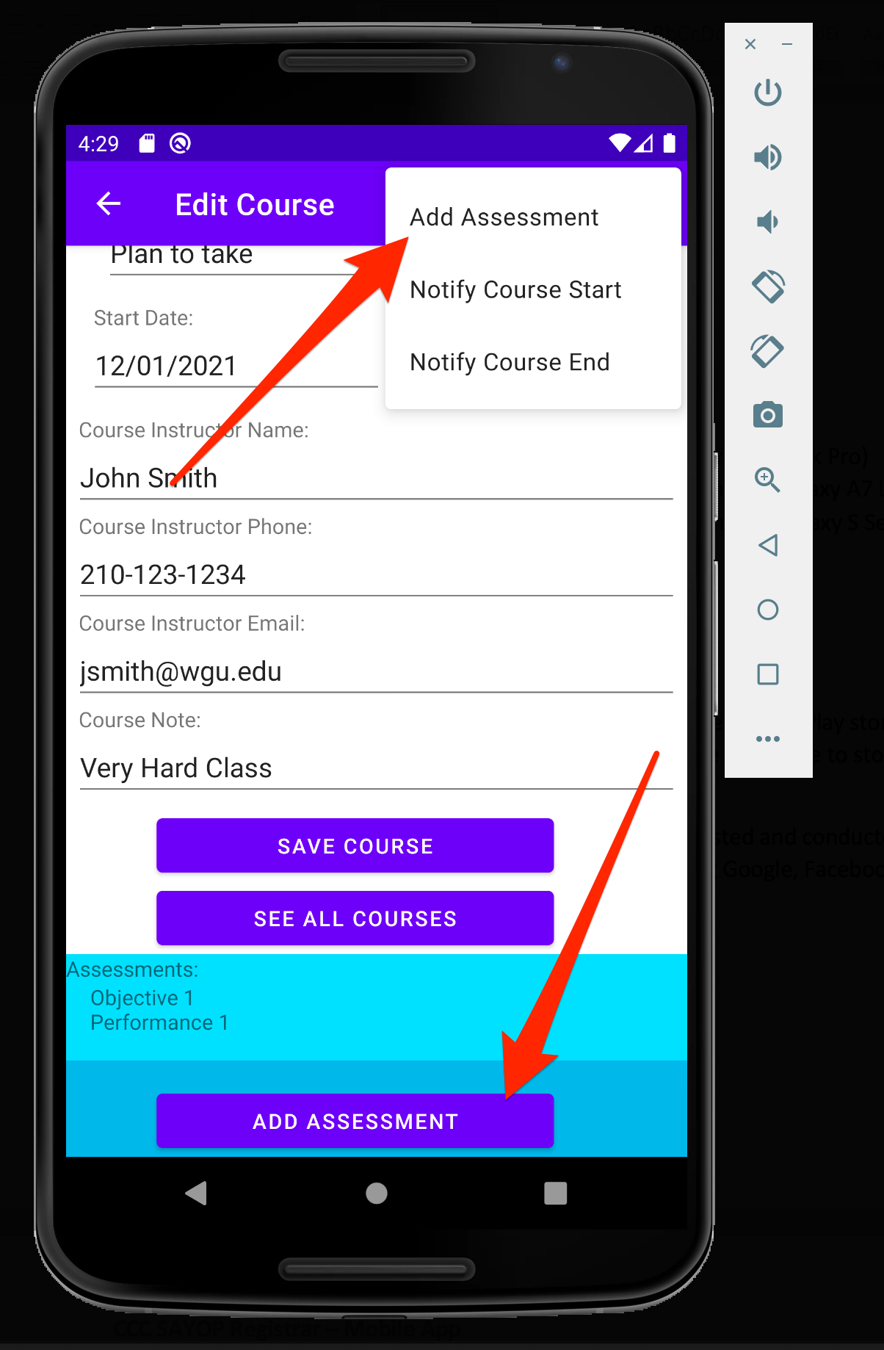

1. To disassociate an assessment from a term, drag the assessment from the right side of the screen to the left.

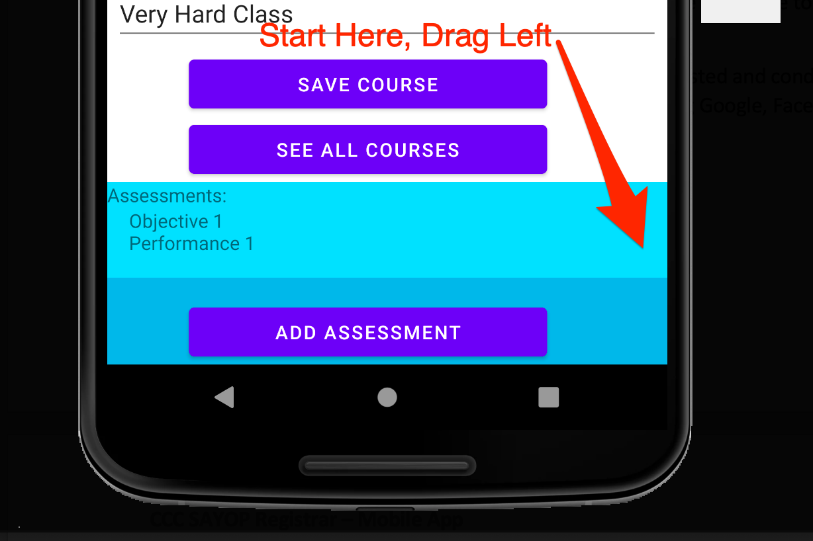

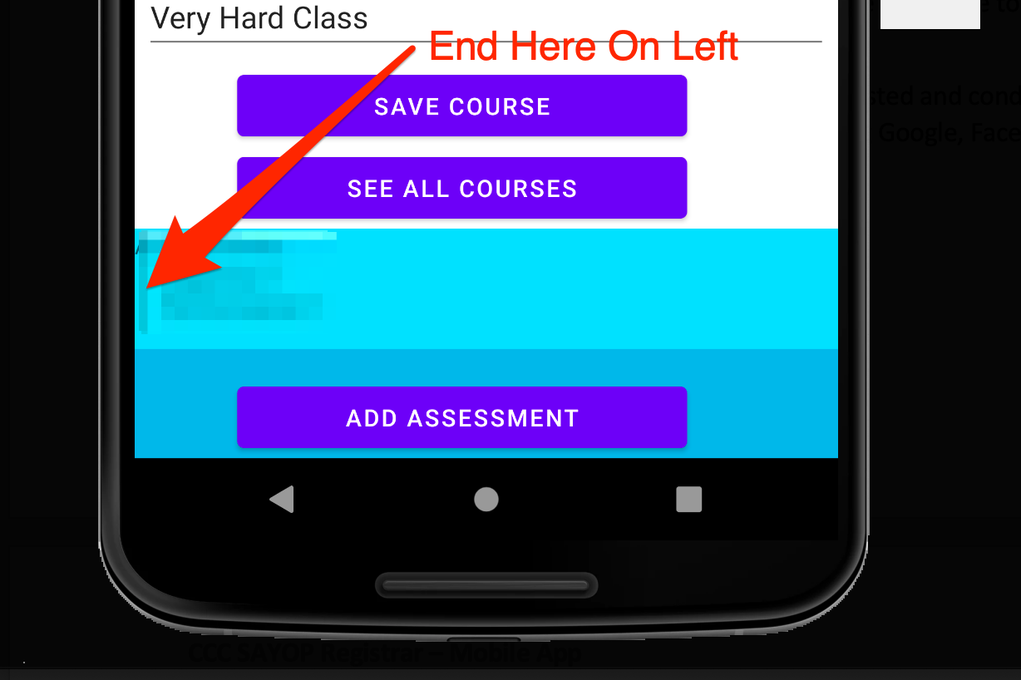

**Assessments**

### See All Assessments

1. From the SAYOP Home Page Click the ASSESSMENTS button.



1. This will navigate you to the Assessments List Page. Sample data has been loaded into the database showing six assessments associated with existing courses.

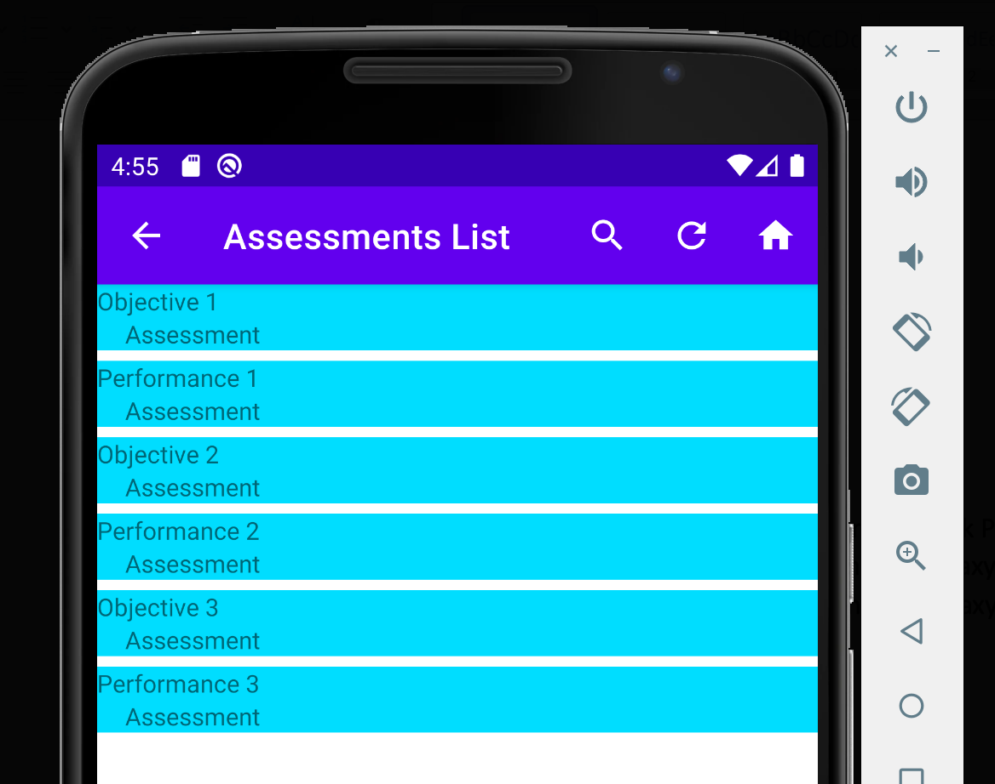

1. You can search for an assessment name by selecting the magnifying glass  at the top of the navigational bar. Begin typing the name of the assessment. To exit, click the X inside the search box.

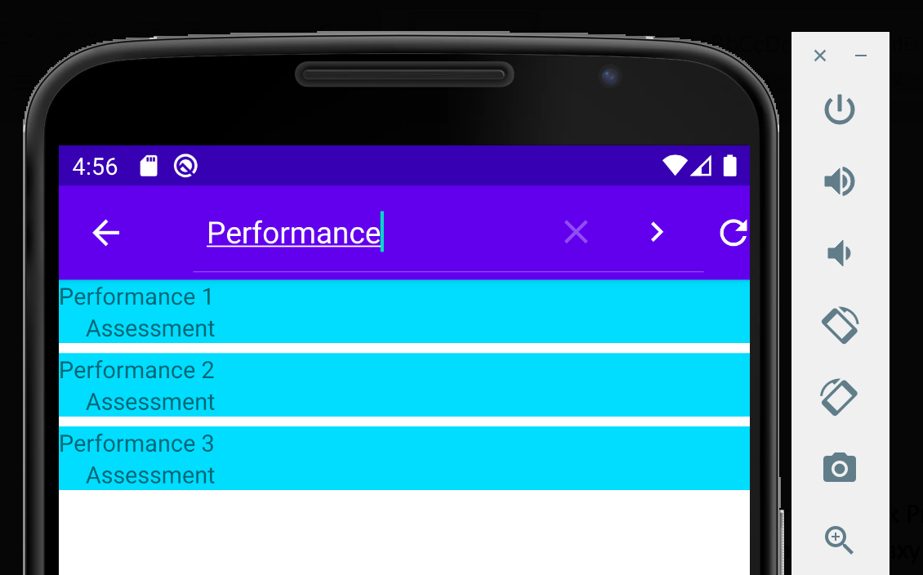

1. To refresh the list of assessments, click the refresh icon in the navigational bar 
2. A toast message will appear verifying the assessments list has been refreshed:

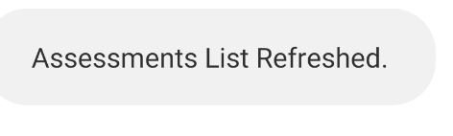

1. To return to the SAYOP Home Page click the house icon from the top of the navigational bar 

## Add A New Assessment

1. On the Edit Existing Course page, click the three vertical dots  icon in the top navigational bar, then select Add Assessment. The other option is to click the Add Assessment button at the bottom of the screen (you will need to scroll up to see this).

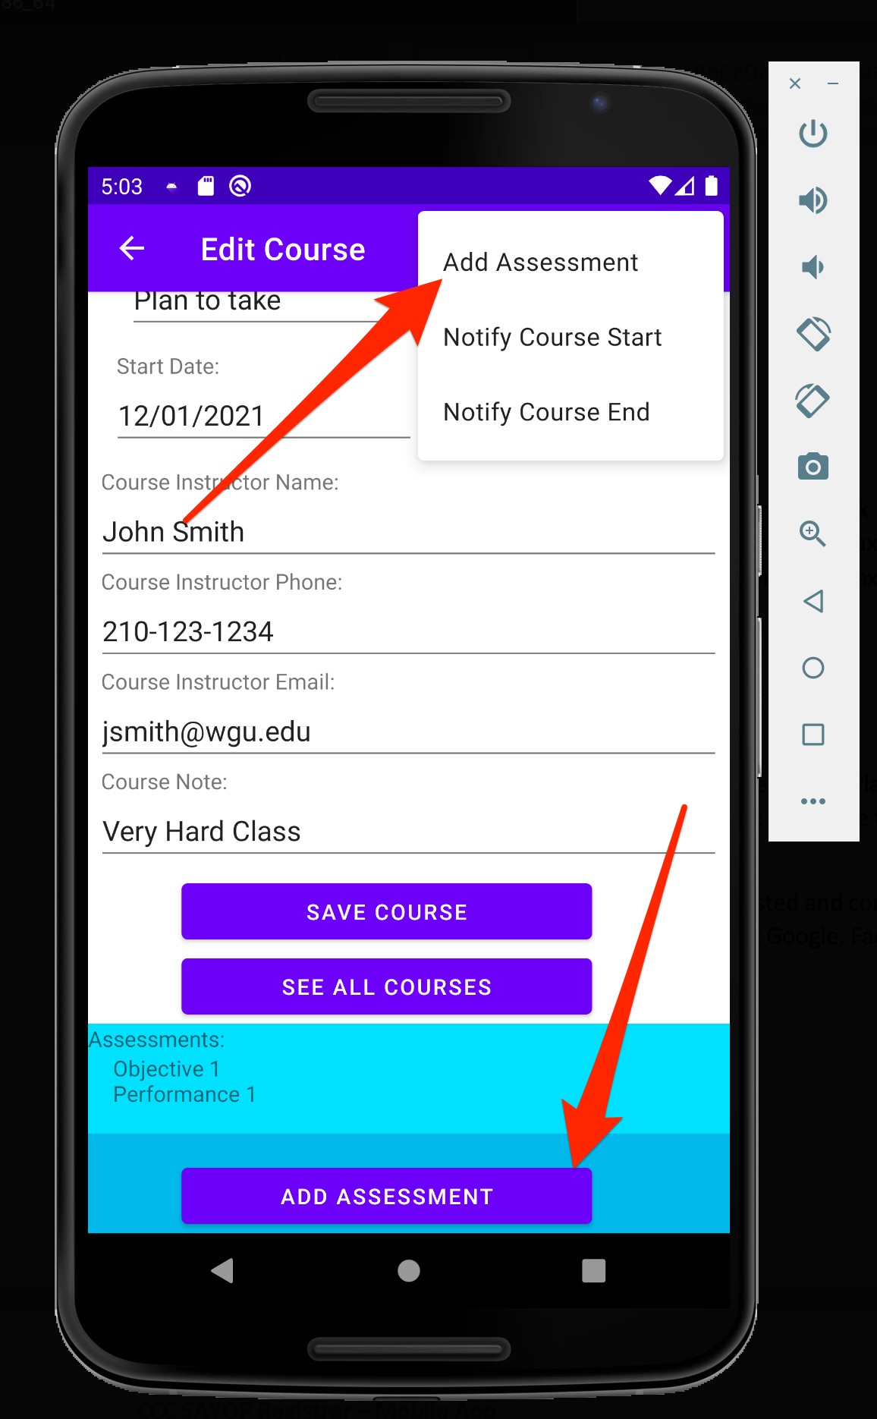

1. On the Add New Assessment page you can fill in the information for the new assessment:

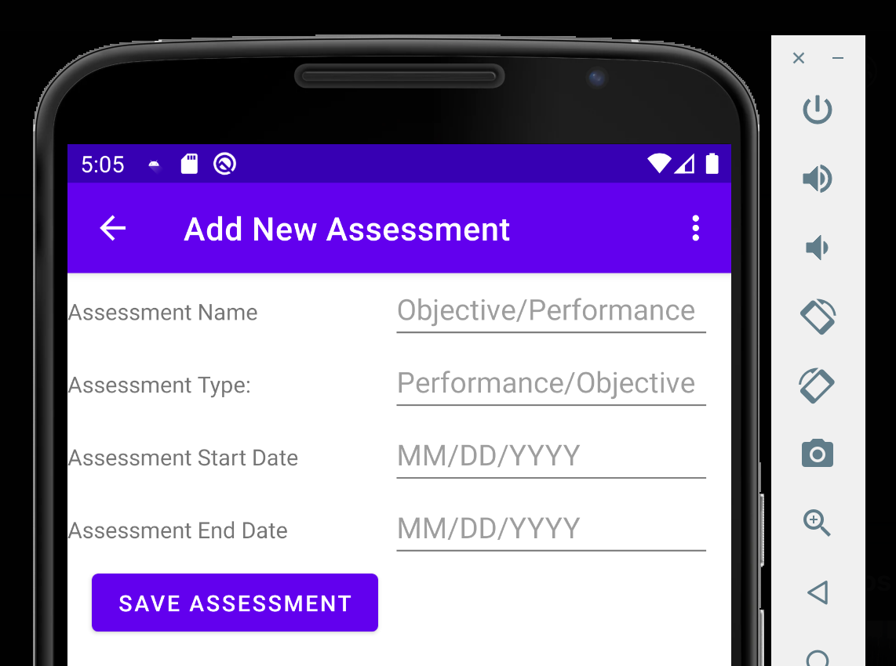

* 1. Assessment Name
  2. Assessment Type
  3. Assessment Start Date
  4. Assessment End Date
     1. When selecting the start date, a date picker will open for you to select from.



* + 1. Use the Less than Sign  or Greater Than Sign to navigate between months.
    2. Select the start date from the calendar, then press OK to save
    3. Press Cancel to close the box and start again
  1. Assessment End Date
     1. When selecting the end date, a date picker will open for you to select from
     2. Use the Less than Sign  or Greater Than Sign to navigate between months
     3. Select the end date from the calendar, then press OK to save
     4. Press Cancel to close the box and start again

1. When you are finished entering your data, select the SAVE ASSESSMENT button. This will return you to the Edit Course page. You will see the new assessment you added to the associated course.

## Edit Existing Assessment

1. On the Assessment List page, click an existing assessment by the name

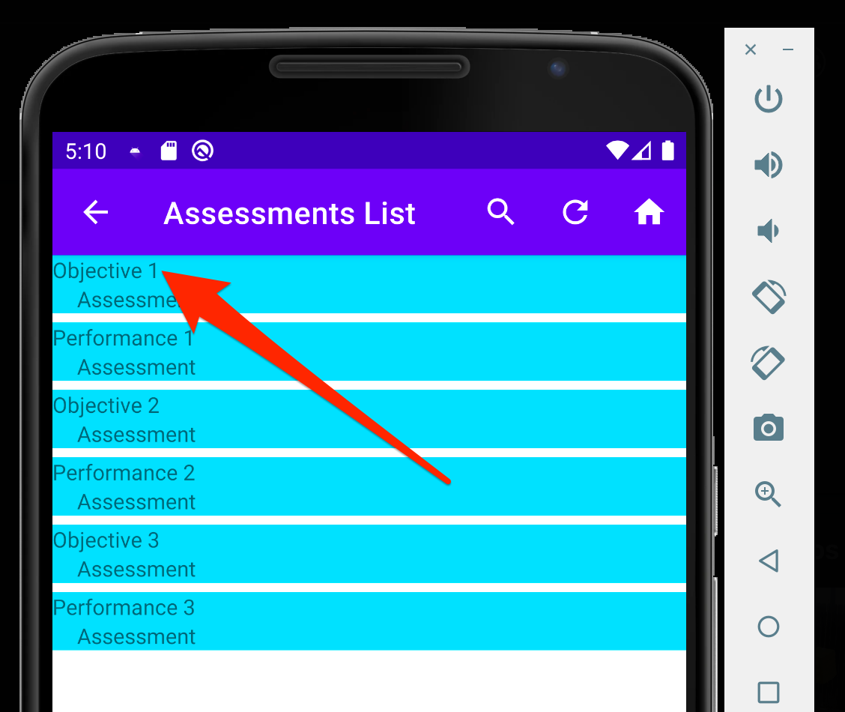

1. This will navigate you to the Edit Assessment page

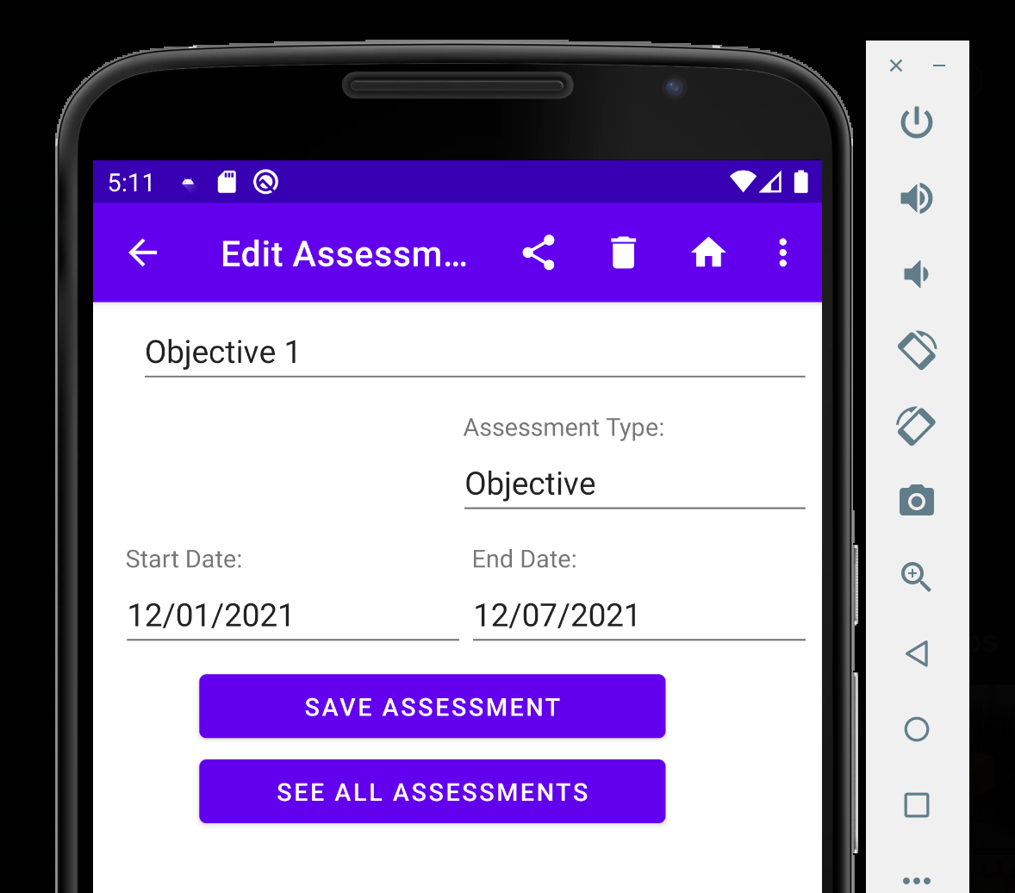

1. You can update the assessment name, type, start date, and end date. When you are done editing the assessment, click the SAVE ASSESSMENT button. This will return you to the Assessment List page showing the updated changes.
2. On this page you can share the details about the assessment by clicking the share icon  in the top navigational bar.
   1. This will share the assessment name, start date, and end date.
   2. Select the sharing mechanism you want to share the information with:

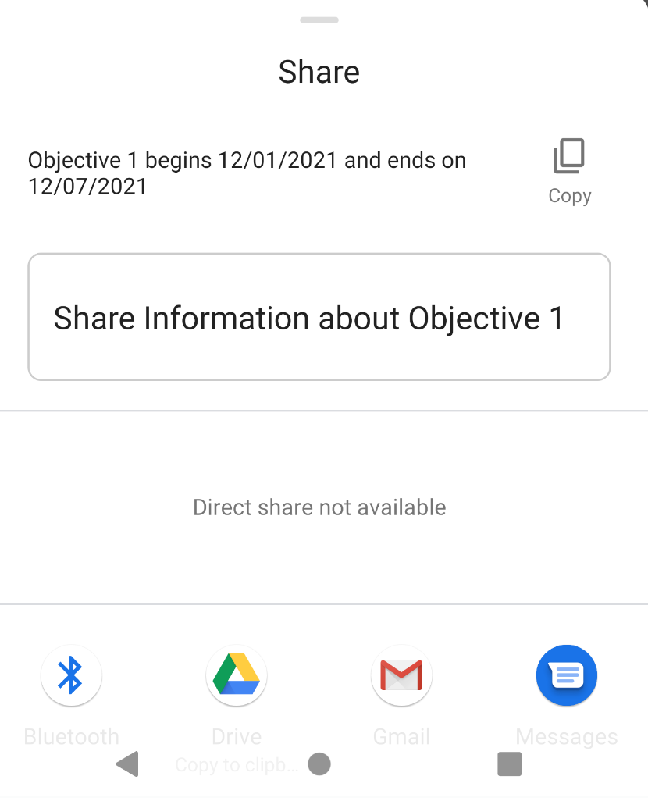

1. Select the Bluetooth Icon  to share it to a Bluetooth Enabled Device
2. Select the Google Drive Icon to create a document on Google Drive
3. Select the Gmail Icon to send an email
4. Select the SMS Icon to send the information via a text
5. You can delete an assessment by clicking the trash can icon  in the top navigational bar.
6. You can return to the SAYOP Home Page by clicking the House icon  in the top navigational bar.
7. You can send a notification to your Android device by clicking the three vertical dots icon  in the top navigational bar, then select Notify Assessment Start or Notify Assessment End

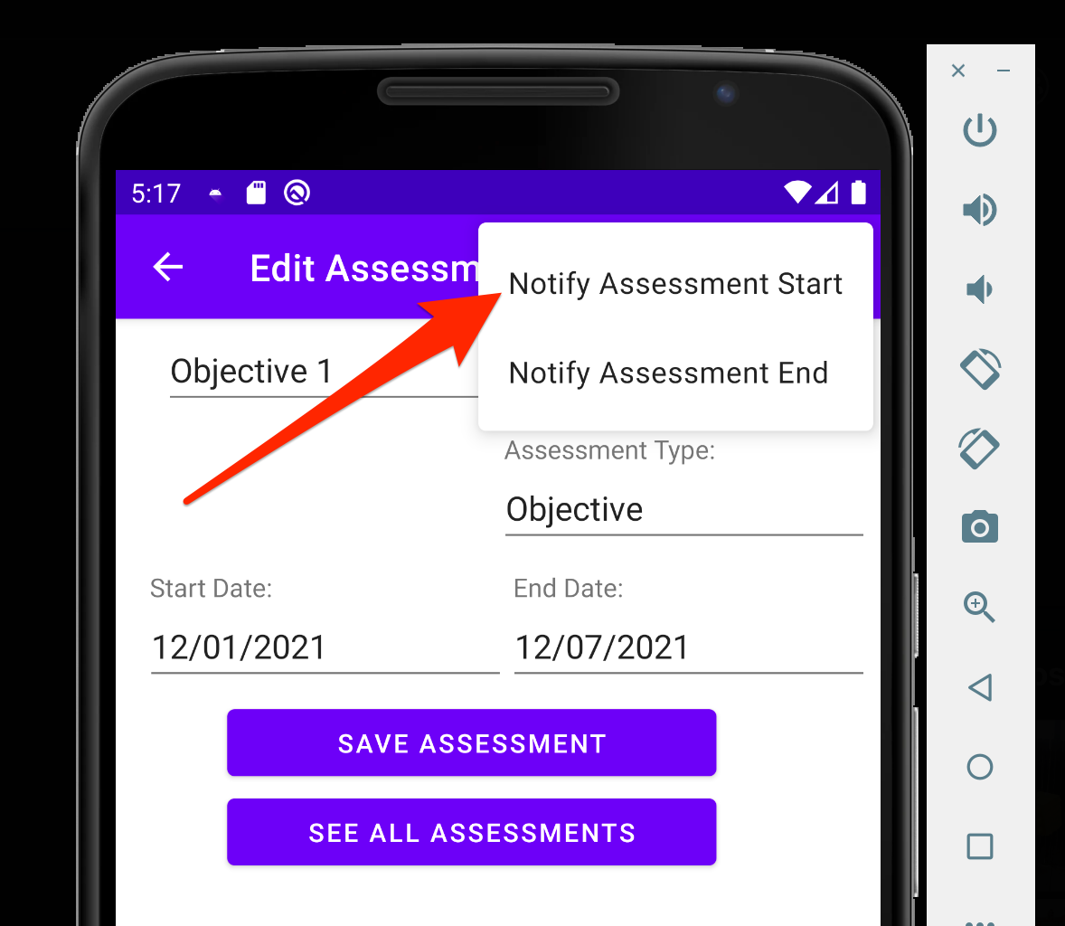

* 1. Notify Assessment Start will send a notification to the device on the start date for the assessment.
  2. Notify Assessment End will send a notification to the device on the end date for the assessment.

**Reports**

### See All Reports

1. From the SYAOP Home Page click the REPORTS button.

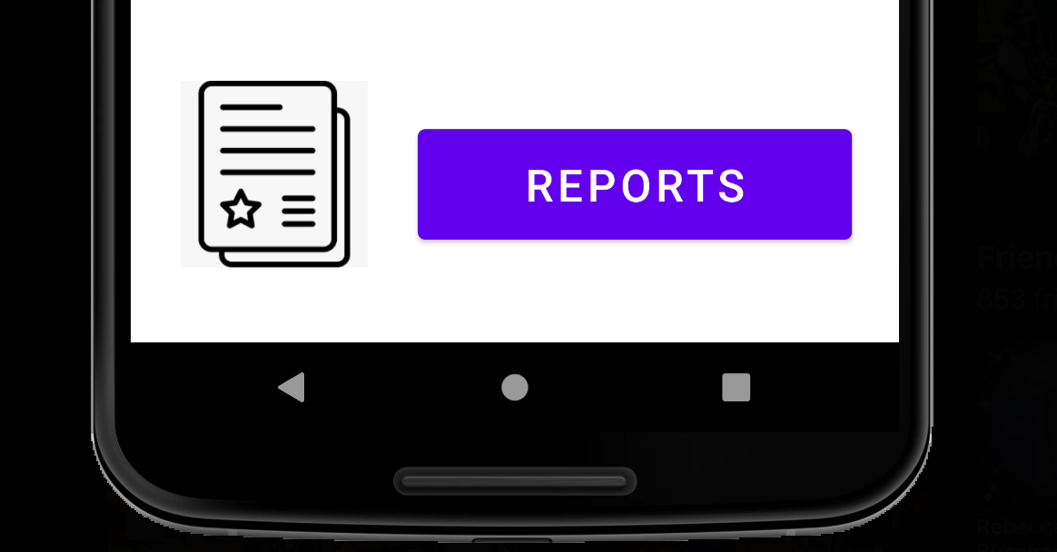

1. This will navigate you to the SAYOP Reports Page.

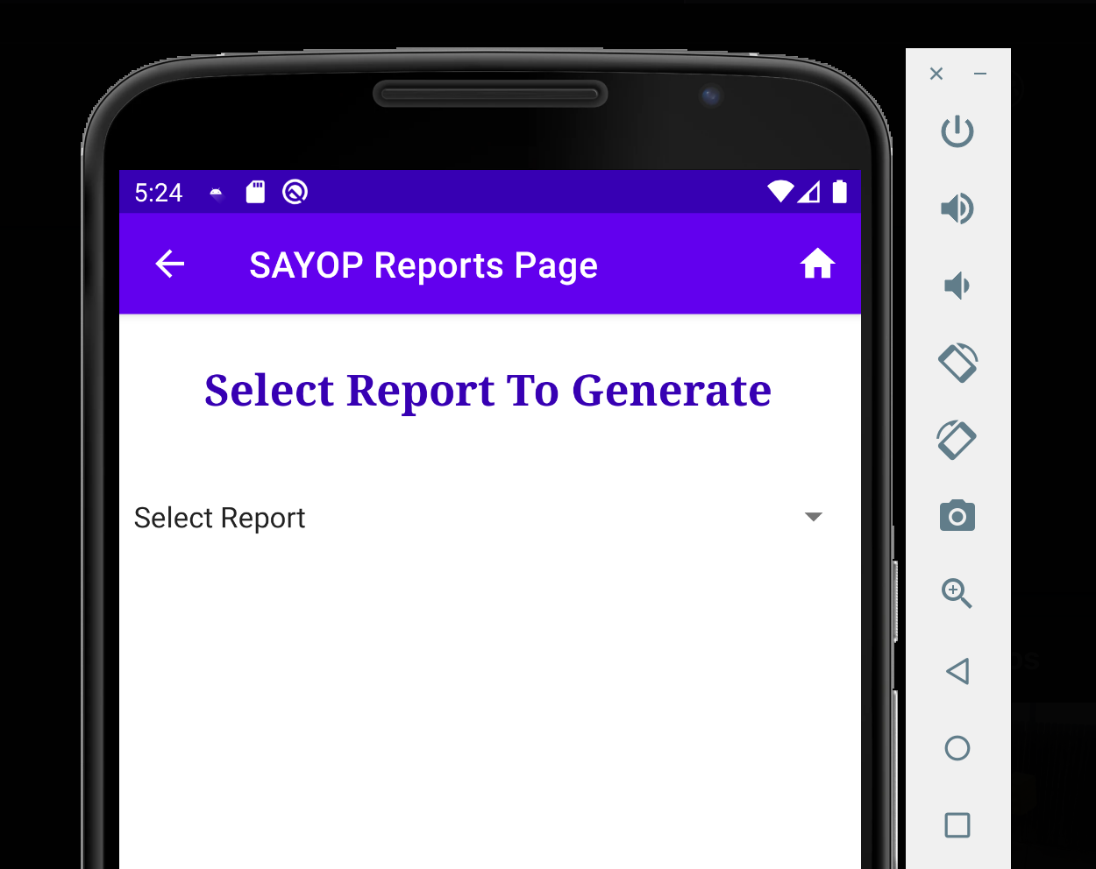

1. You can return to the SAYOP Home Page by clicking the House icon  in the top navigational bar.
2. Select Report drop-down menu by clicking the grey down arrow, then selecting which report you want to generate.

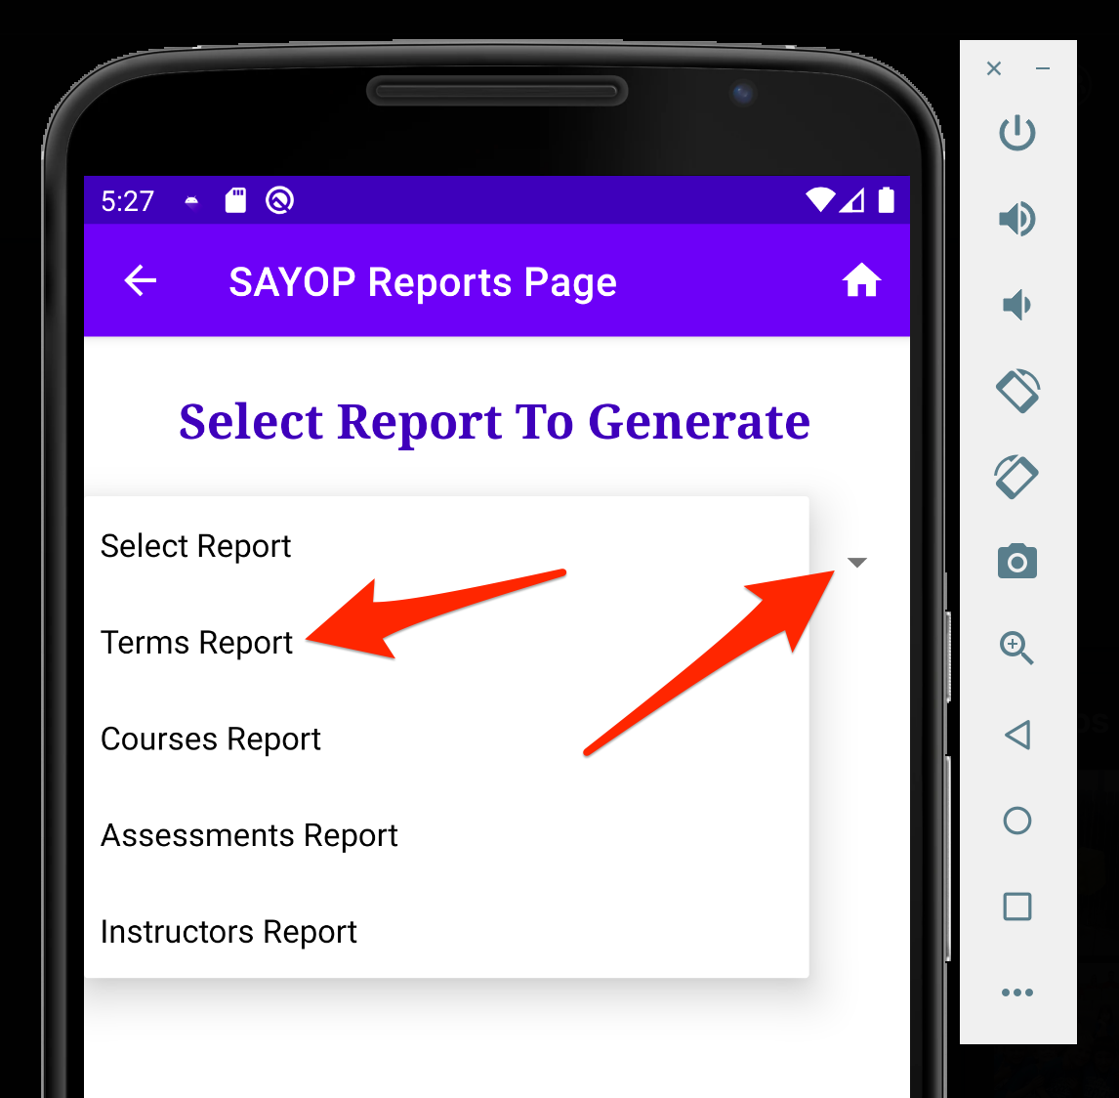

* 1. Terms Report will generate all terms the student is enrolled in.

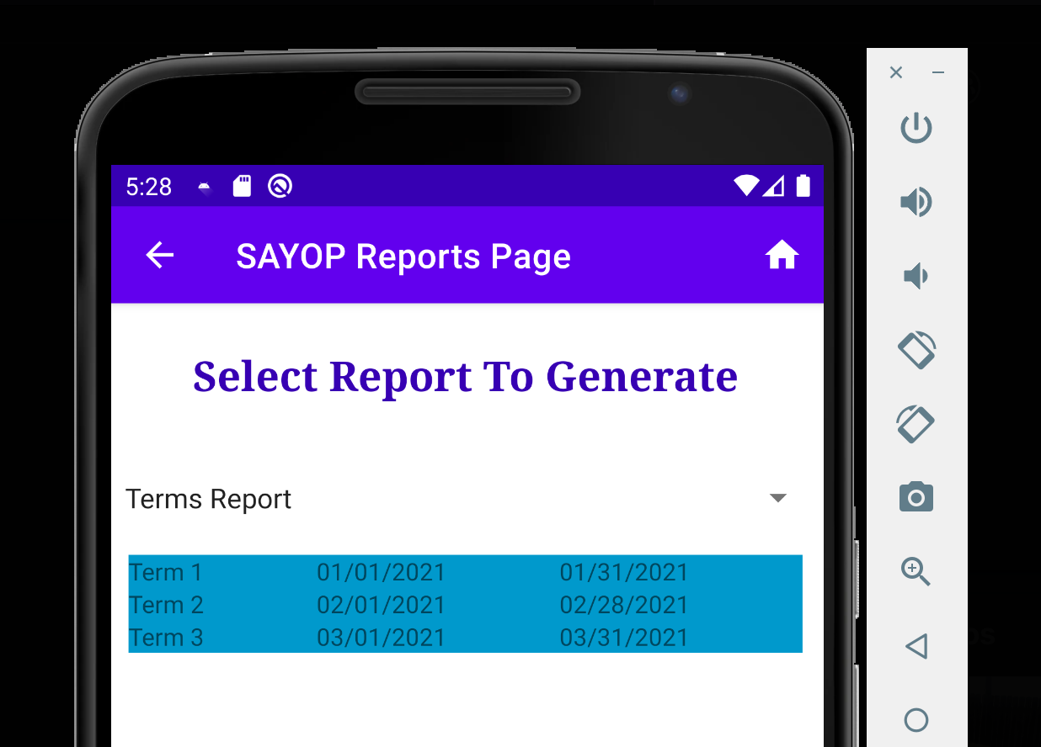

* 1. Courses Report will generate all courses the student is enrolled in.

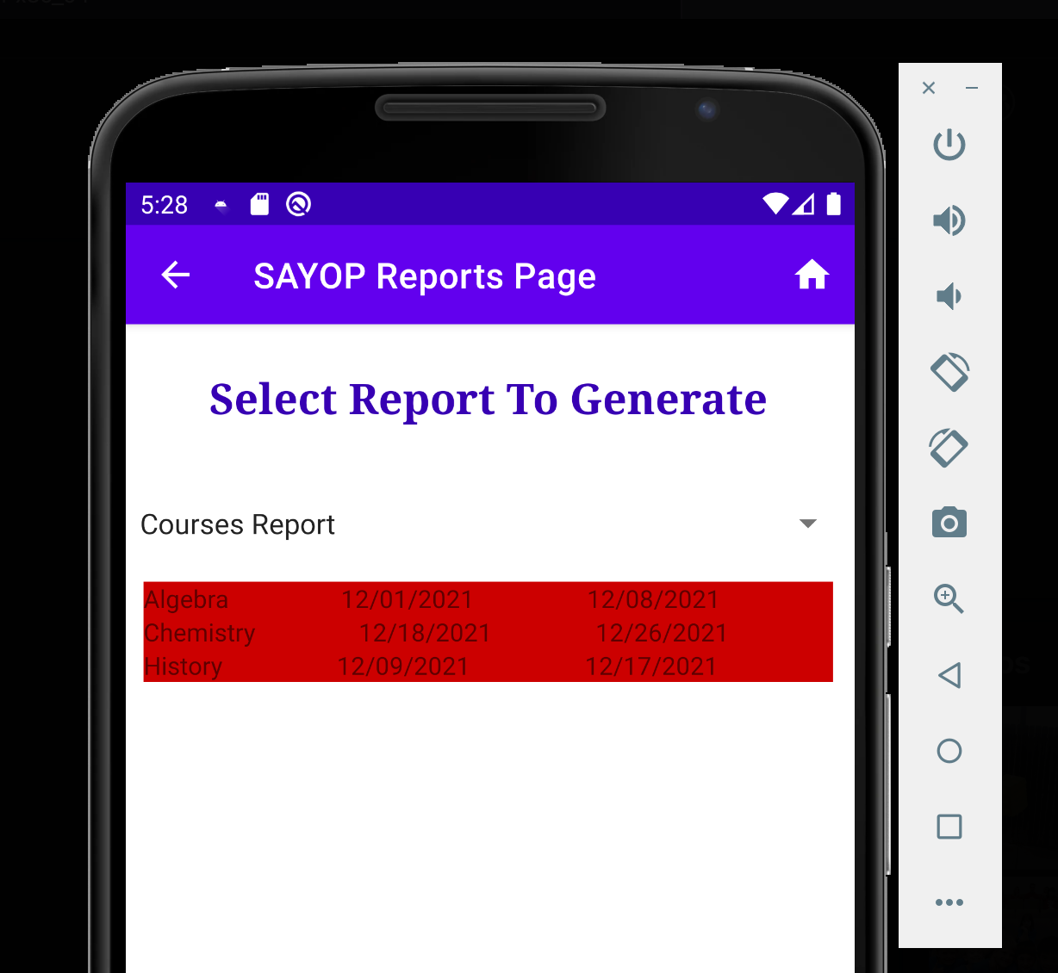

* 1. Assessments Report will generate all assessments the student is enrolled in.

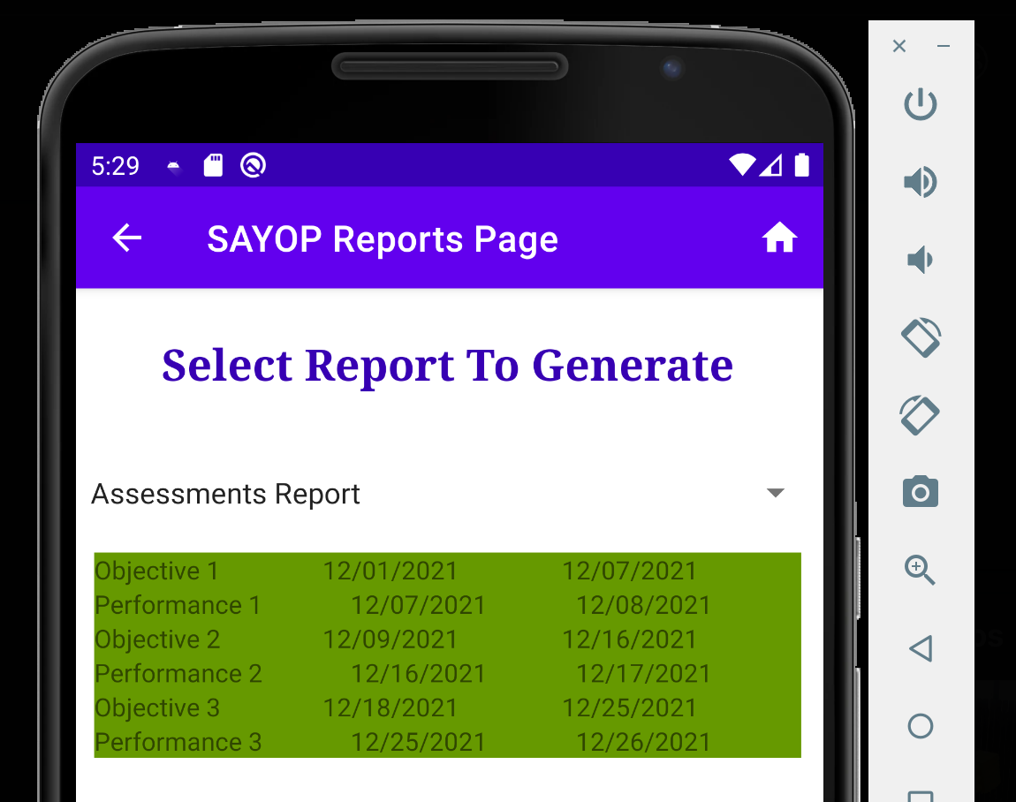

* 1. Instructors Report will generate all instructors information for the courses the student is enrolled in.

